
H.C.B-B1767
HOSE CLAMP KIT
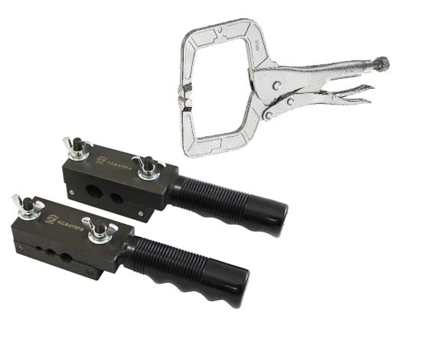

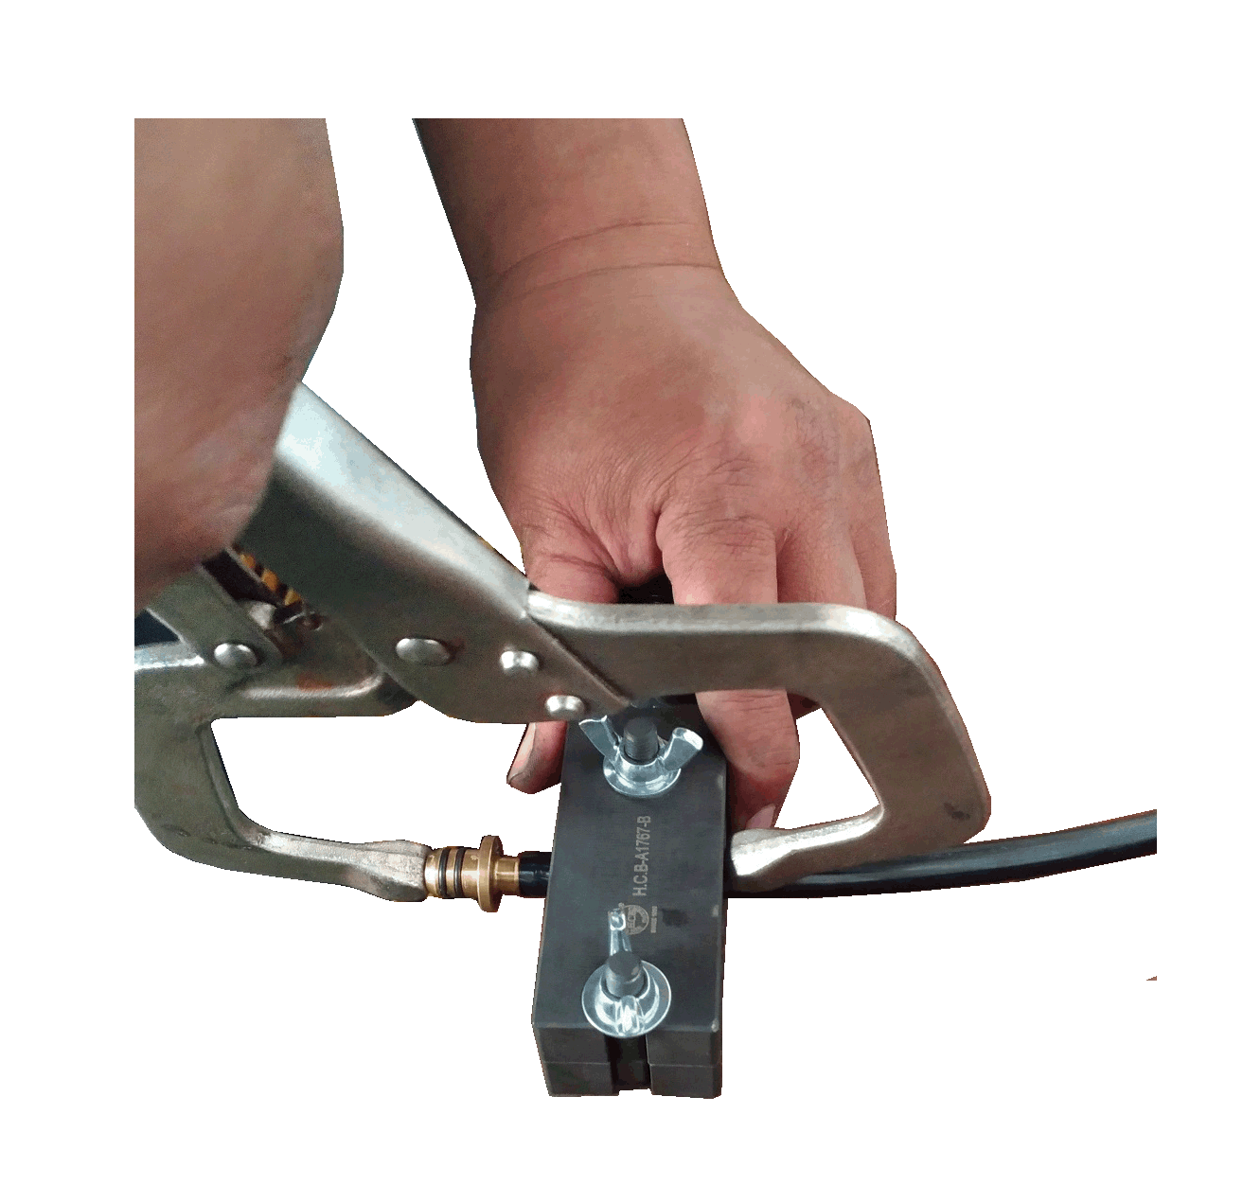
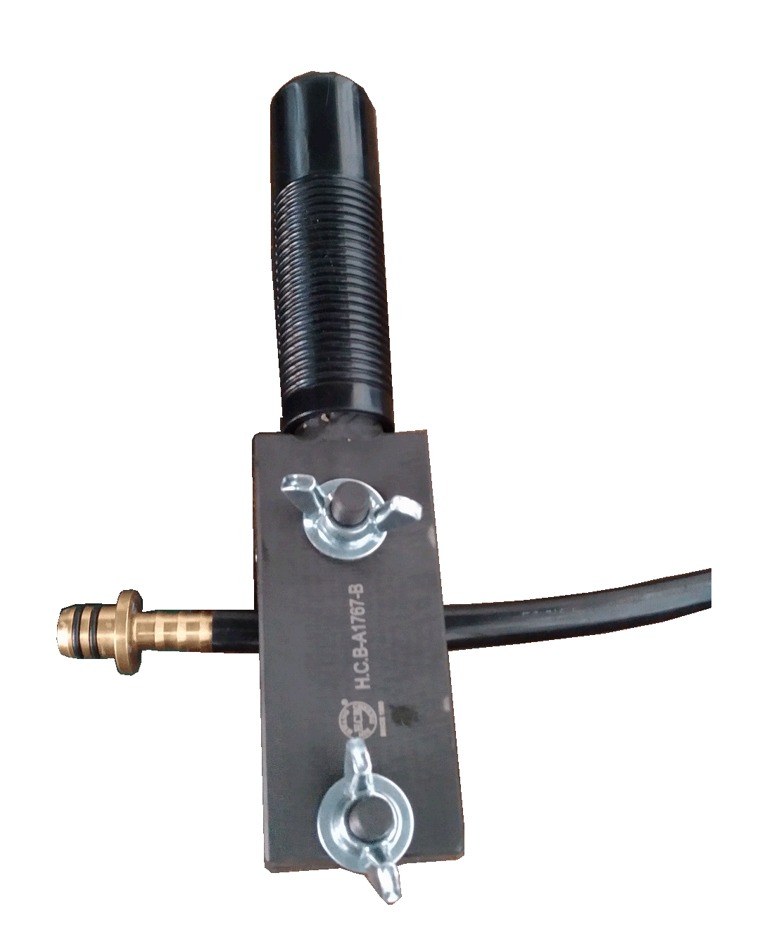

■ Choose the appropriate clamp to fix the hose, then use the pliers install the adaptor into the hose.
■ Applicable size: Ø 6mm, Ø9 mm, Ø12 mm, Ø14 mm, Ø18mm

