
H.C.B-B1766
FRONT CRANKSHAFT SEAL REMOVER/INSTALLER KIT - CUMMINS ISB (*3164659)

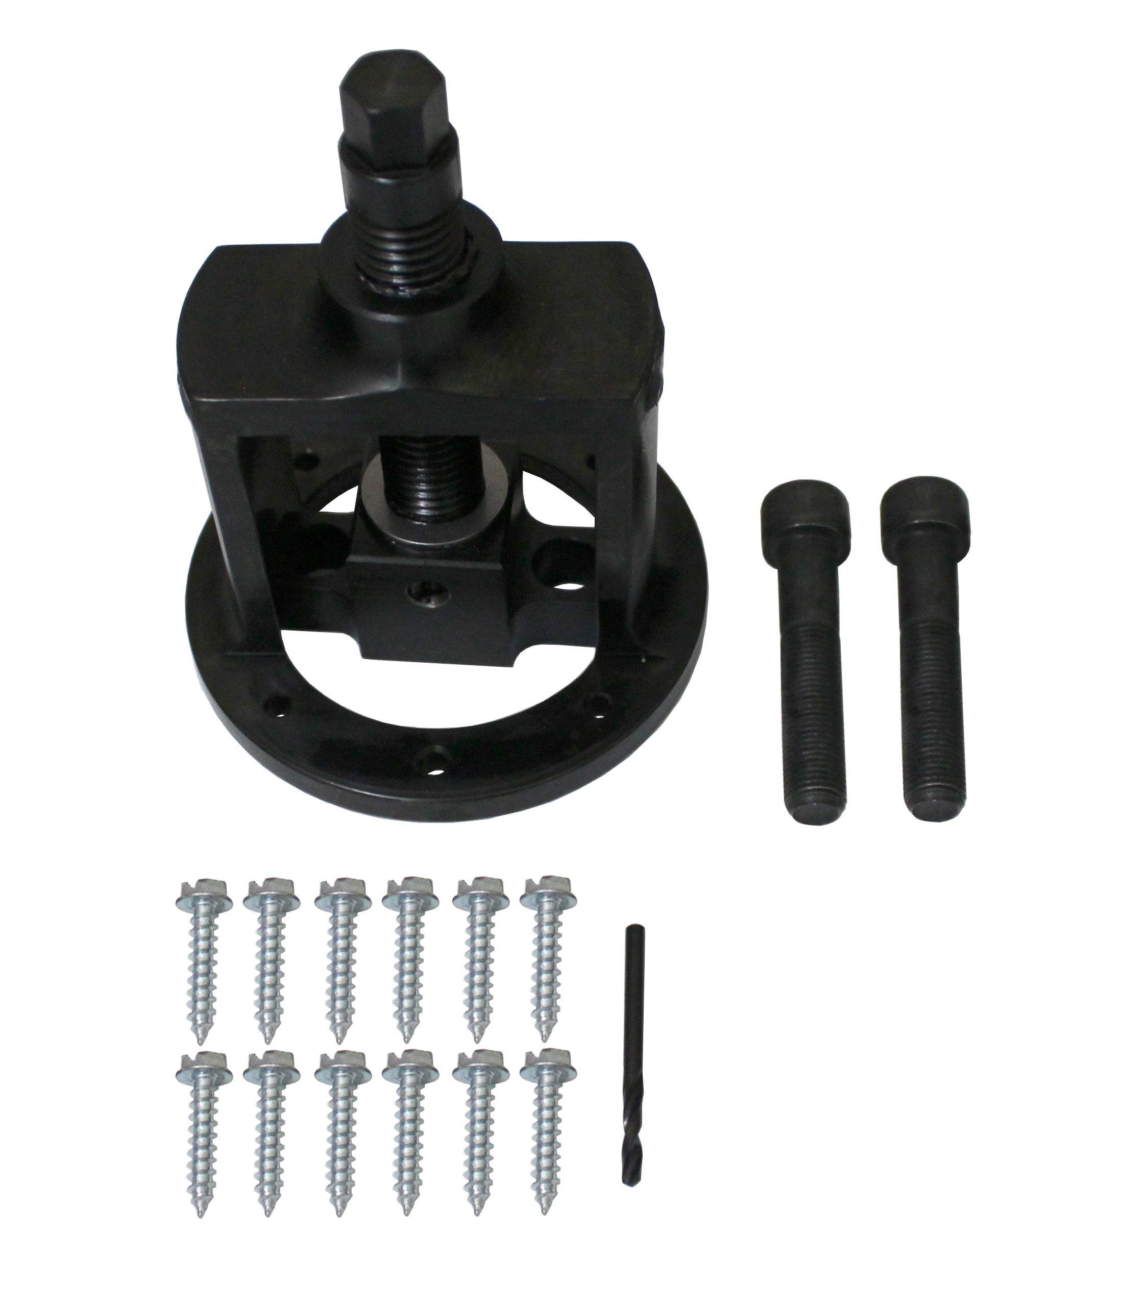

- Applications: Paccar PX-6
- 3164659 Includes the Following:
3164667 Replace screw assembly
3164661 Crankshaft seal replacer
x2 3164239 Socket head cap screw, M12 x 1.25
x25 3164217 Sheet metal screw
3164218 Drill Bit
H.C.B-A1766

Cummins 3.5L ,3.9L, 5.9L & 6.7L Rear Crankshaft Seal Remover & Installer Tool

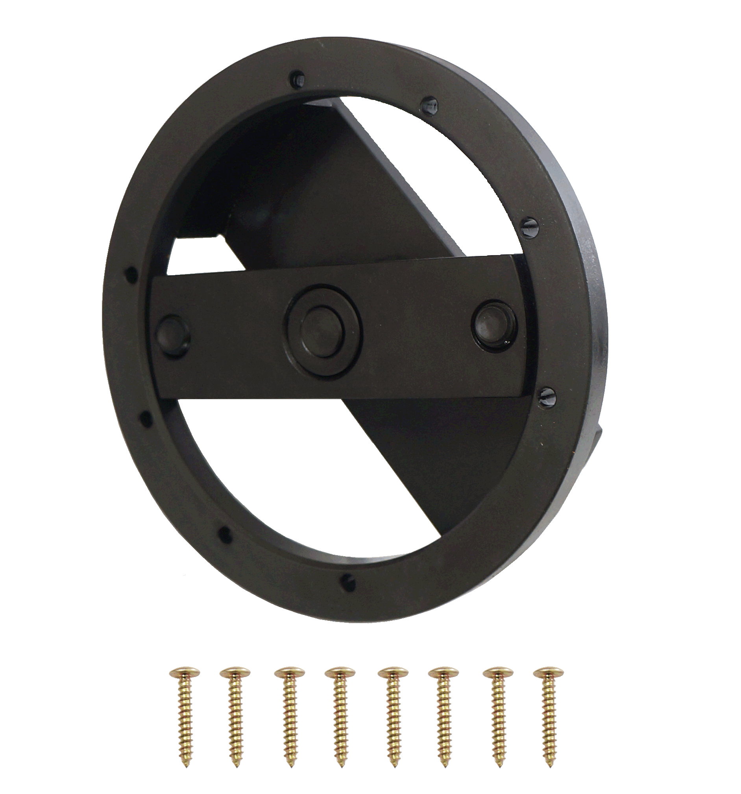
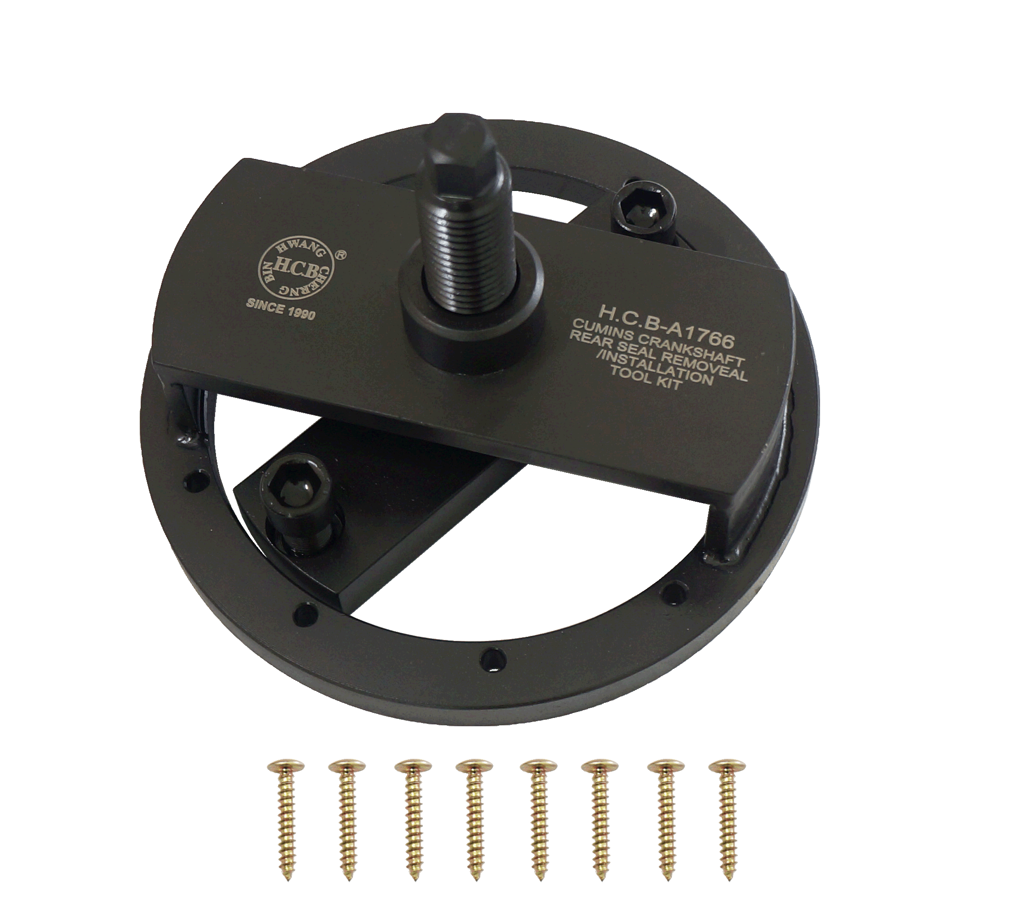

- 3164660 Cummins Rear Crankshaft Seal Remover & Installer Tool
- Applications include 1989-2016 Cummins 4BT 3.9L, B Series 5.9L, ISB 5.9L 6.7L and QSB 5.9L 6.7L, also Paccar engines PX-6.
- Seal # 5259499
- Use to remove and install seals without a wear sleeve such as 3934486 & 3926126.
- Use to install seals with or without a wear sleeve such as 3925529, 3934486 & 3926126 but it can not remove. There is no tool to remove the wear sleeve.

