

**H.C.B-B1715**

**VW/ AUDI SENSOR MODULE TOOL**

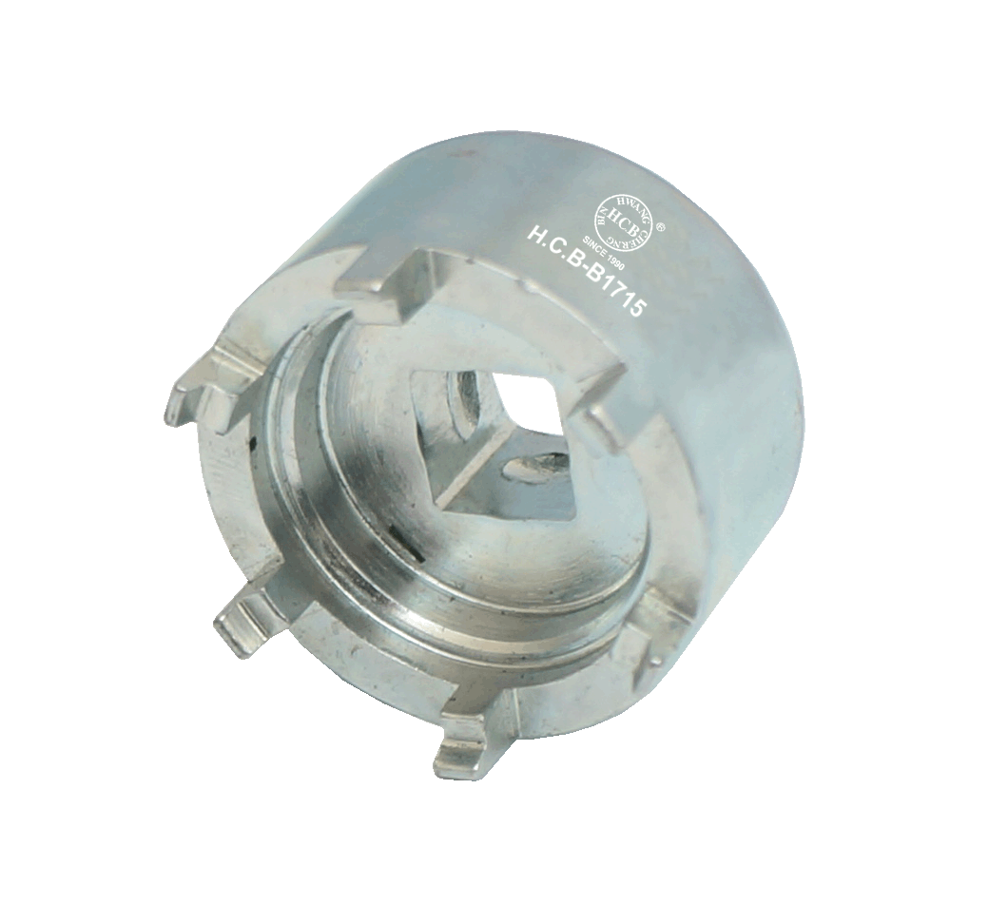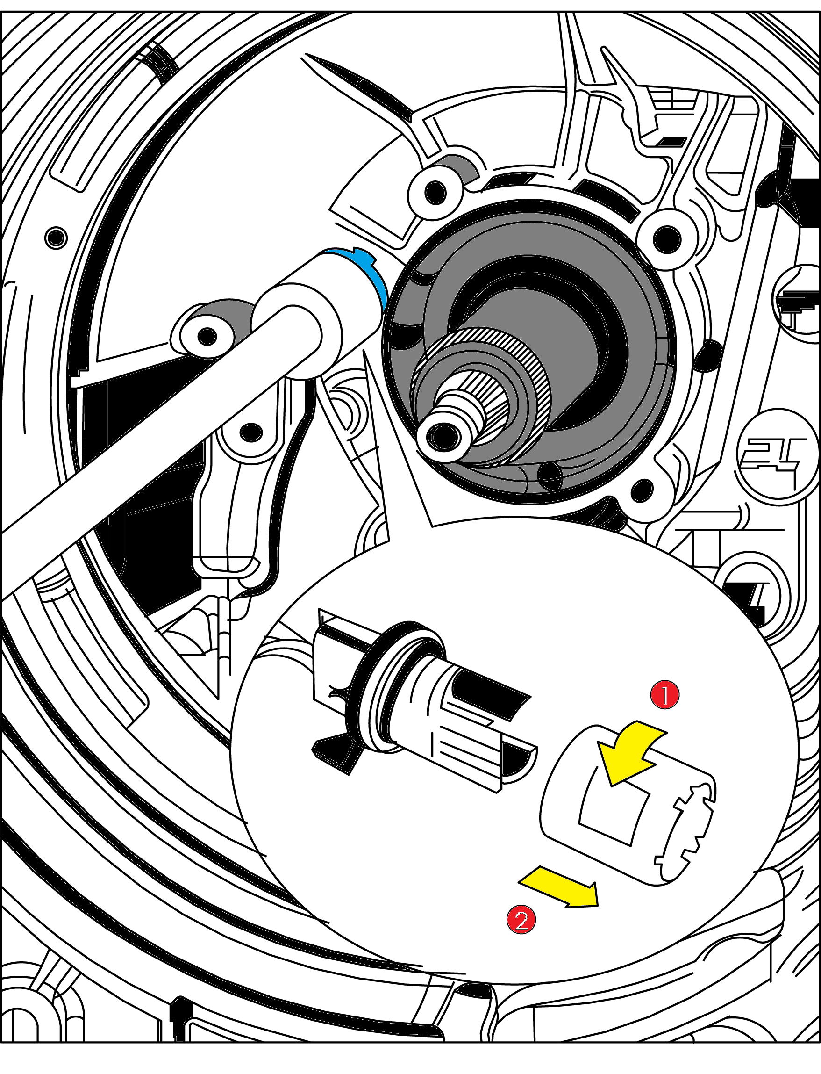

* Releasing connector on sensor module
* **Application:**

Type / model: Audi A4 2008 >, Audi A5 Cabriolet 2009 >, Audi Q5 2008 >,

Audi A5 Coupe 2008 >, Audi A5 Sportback 2008 >,

Audi A7 Sportback 2011 >

Assembly group: Maintenance 7-speed dual clutch gearbox 0B5 (s tronic)

* **VW OEM no. ref.: T40228**



**H.C.B-B1715**

**VW/ AUDI SENSOR MODULE TOOL**



* Releasing connector on sensor module
* **Application:**

Type / model: Audi A4 2008 >, Audi A5 Cabriolet 2009 >, Audi Q5 2008 >,

Audi A5 Coupe 2008 >, Audi A5 Sportback 2008 >,

Audi A7 Sportback 2011 >

Assembly group: Maintenance 7-speed dual clutch gearbox 0B5 (s tronic)

* **VW OEM no. ref.: T40228**