

**H.C.B-B1675**

**VOLVO (FH/FM/NH) TRUCK OIL SEAL REMOVAL SLIDE HAMMER**

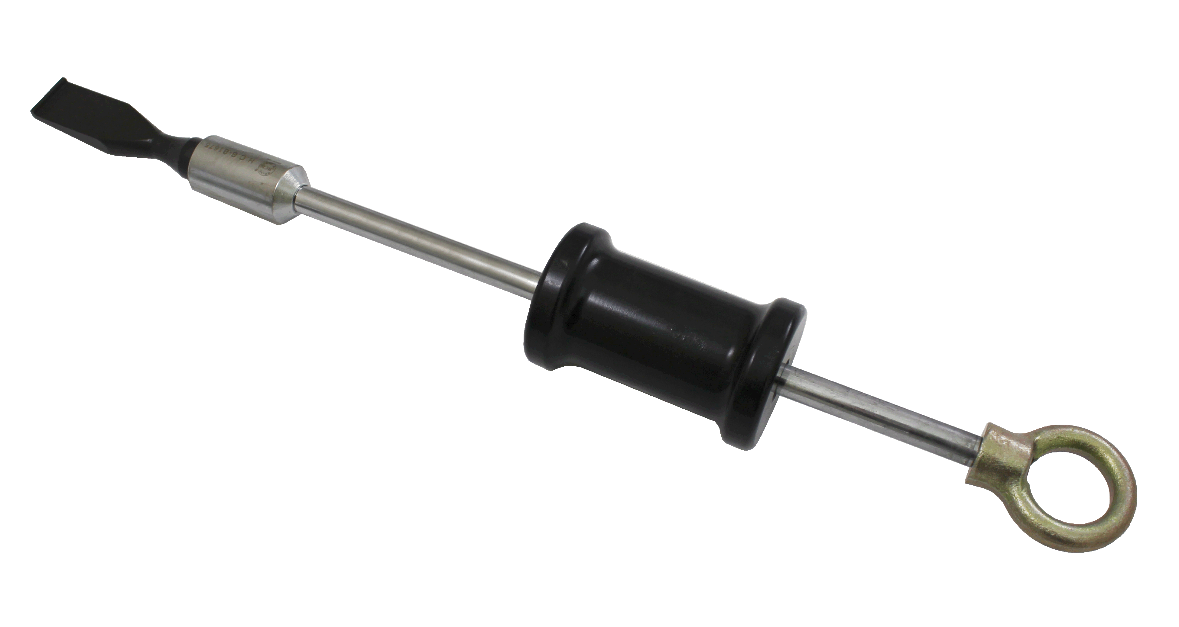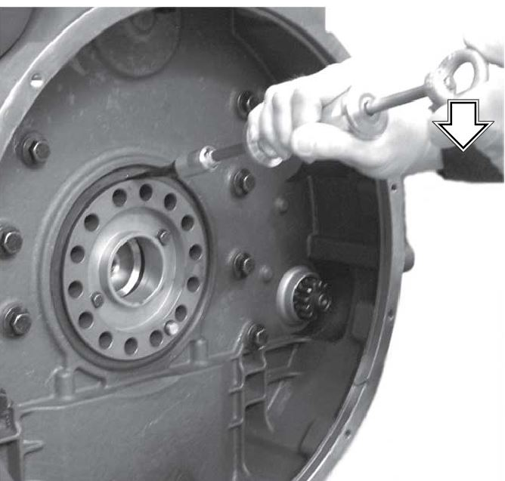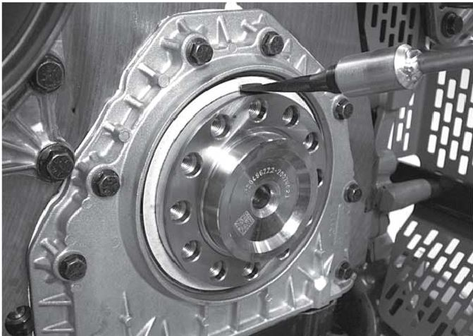

* Remove the old seal by tapping in a puller inside the seal and pulling it out with a slide hammer.
* Note: Make sure not to damage the crankshaft. Slant the puller inwards to get a good grip on the seal.
* Application: VOLVO TAD1343GE TAD1344GE TAD1345GE ENGINE
* Models: DAILY
* VOLVO OEM no.ref.:9996400.9990192