
H.C.B-B1627
VOLVO (FM) TRUCK FRONT WHEEL AXLE BEARING/ OIL SEAL INSTALLER

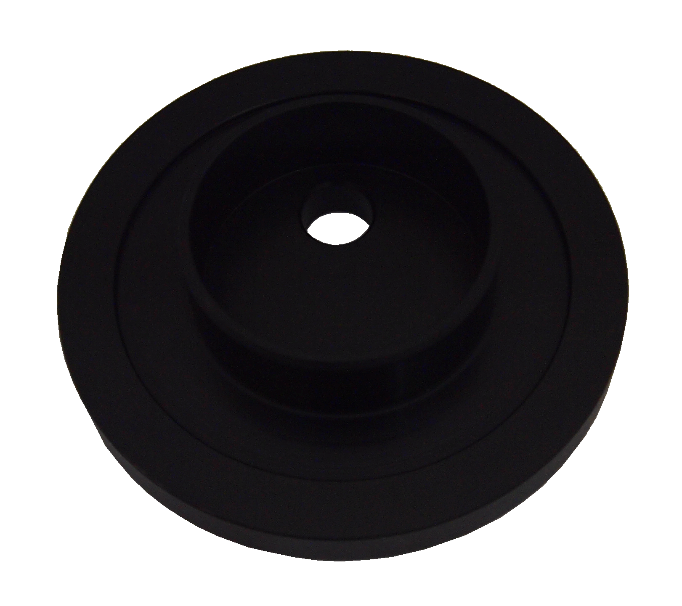

■ Instruction：This tool can help you install the front axle bearing or oil seal with even force. Avoid bad installation.

■ Appication：VOLVO(FM) truck.

■ OEM no. ref: F-566426

H.C.B-B1627
VOLVO (FM) TRUCK FRONT WHEEL AXLE BEARING/ OIL SEAL INSTALLER

■ Instruction：This tool can help you install the front axle bearing or oil seal with even force. Avoid bad installation.

■ Appication：VOLVO(FM) truck.

■ OEM no. ref: F-566426

