
H.C.B-B1610
VOLVO (FM) CRANKSHAFT REAR OIL SEAL INSTALLER

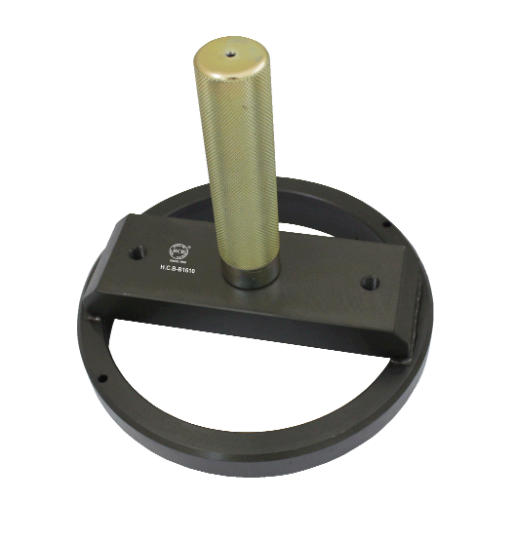

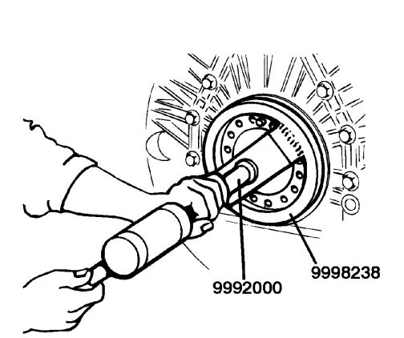
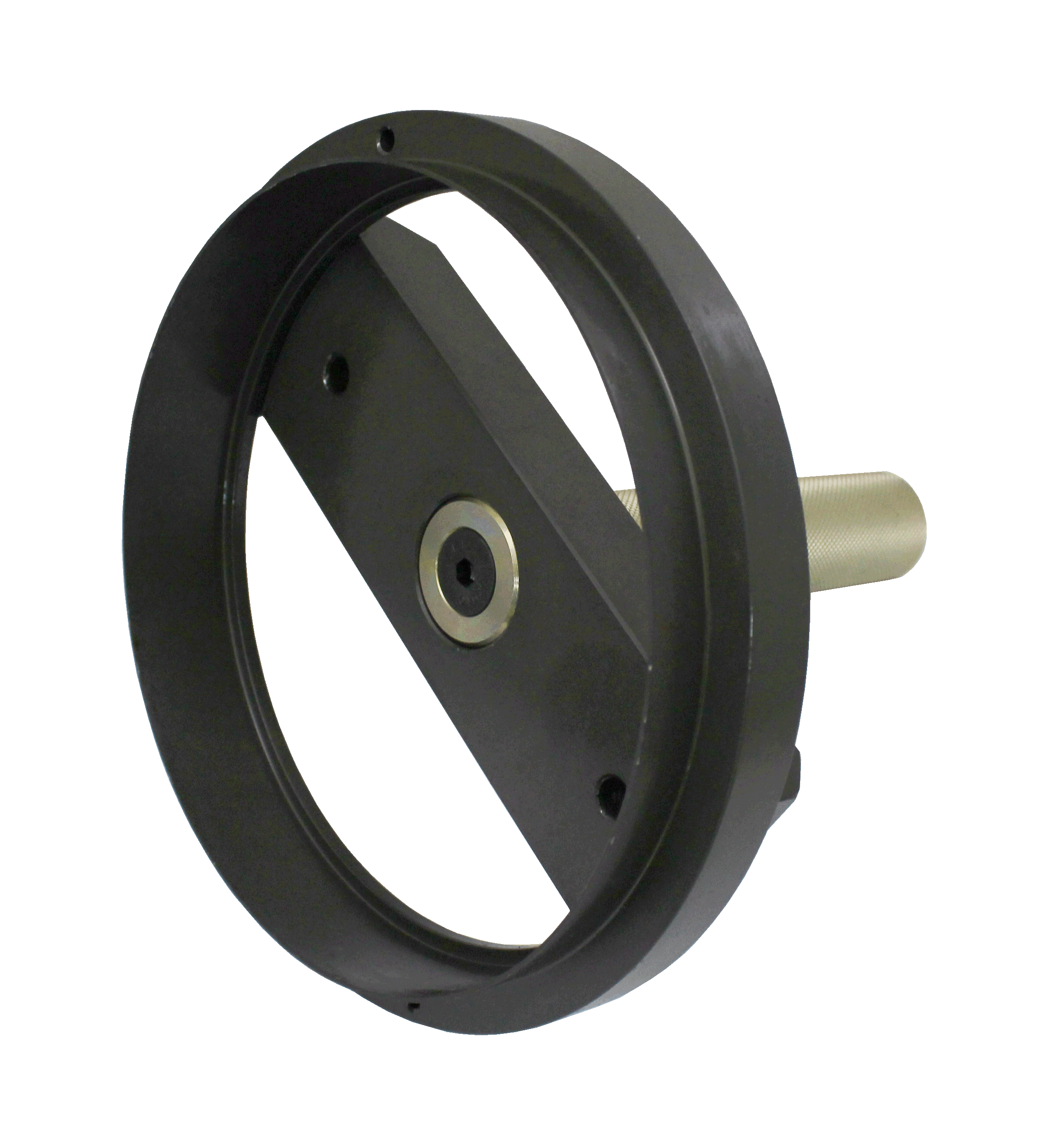

- Applications: Volvo Engines D12 D13 D16

- Volvo Rear Seal Installer Alternative to 9998238 and 9992000.

