
H.C.B-B1465
DAF PISTON RING INSTALLATION SLEEVE TOOL
(460P) (EURO 4/5)
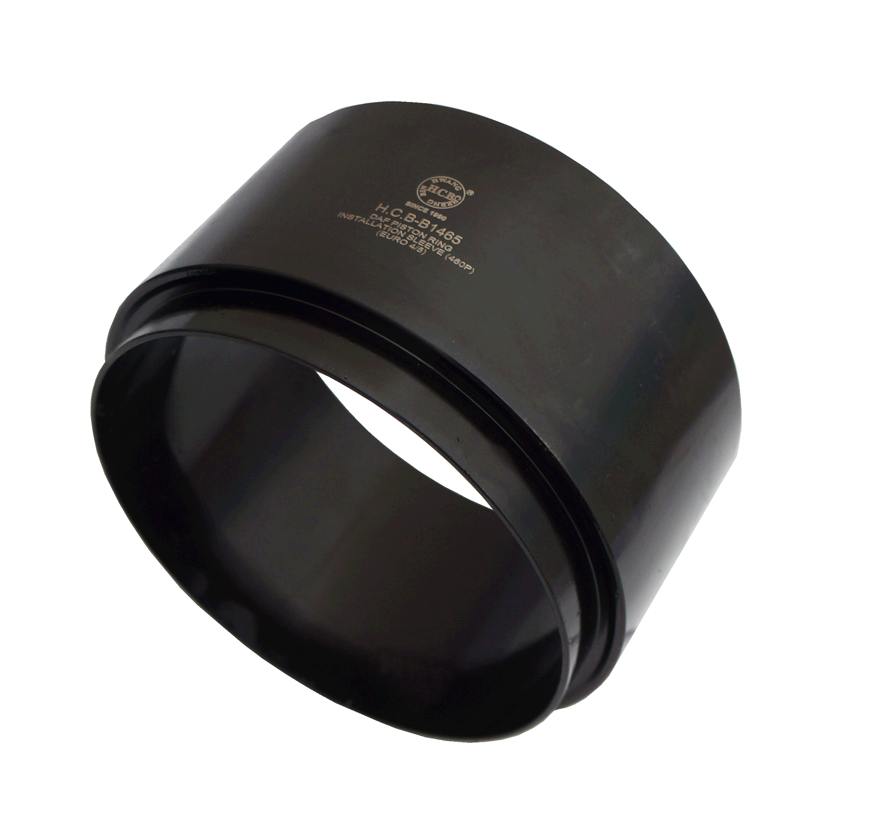

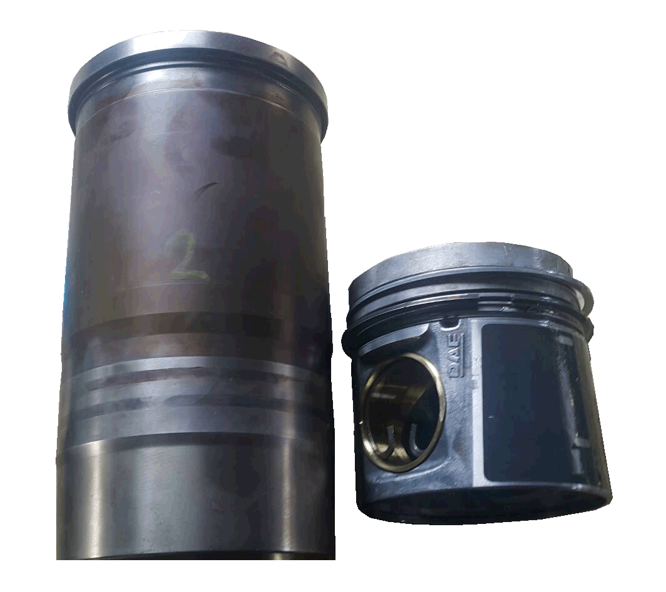
■ Special design of cone tool make piston ring into cylinder sleeve easily ,save time and labor!
■ Used to guide the piston into the cylinder sleeve during piston installation.
■ Application: DAF (460P) (EURO 4/5)

