
H.C.B-B1461
BENZ (W221) WHEEL LUG SOCKET (17 mm) WITH PROTECTIVE SLEEVE
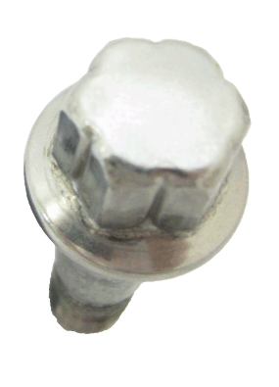
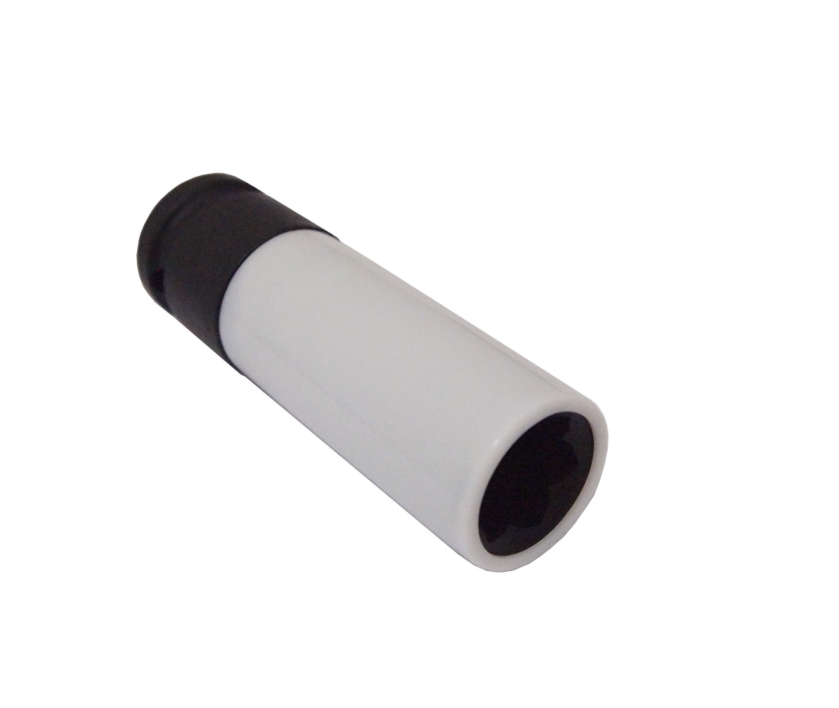
Mercedes # 000 990 5407
Dr. 1/2”

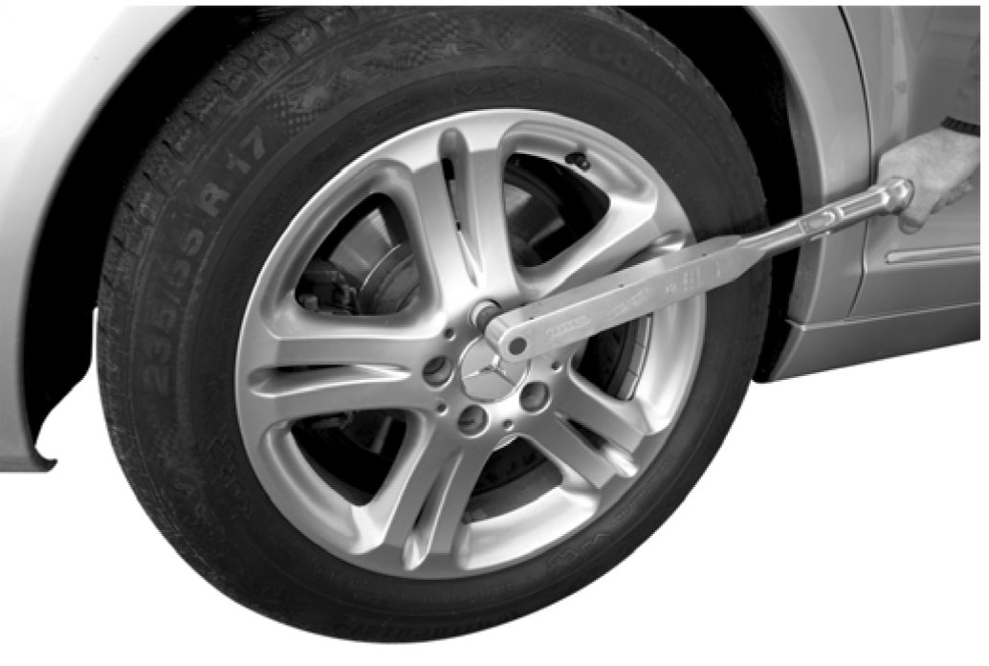

- Material:CR-V
- Size: Dr. 1/2” x 88 mm(L)
- Application: Maybach and Mercedes C-Class (W204),E-Class (W211/W212/W207), SLK(W172), M-Class (W164/W166), CL-Class(W216), S-Class(W221/W222) which came installed with unique convex lug bolts (Mercedes # 000 990 5407). .

H.C.B-B1461
BENZ (W221) WHEEL LUG SOCKET (17 mm) WITH PROTECTIVE SLEEVE
Mercedes # 000 990 5407
Dr. 1/2”

- Material:CR-V
- Size: Dr. 1/2” x 88 mm(L)
- Application: Maybach and Mercedes C-Class (W204),E-Class (W211/W212/W207), SLK(W172), M-Class (W164/W166), CL-Class(W216), S-Class(W221/W222) which came installed with unique convex lug bolts (Mercedes # 000 990 5407). .

