
H.C.B-B1387
IVECO AXLE NUT SOCKET
(H36, 12 POINTS, 110 mm)
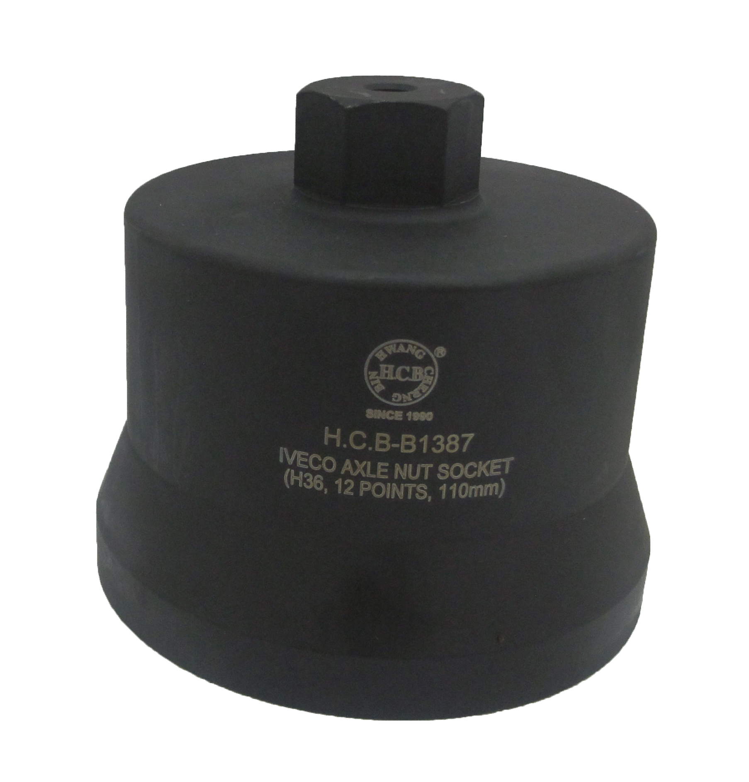

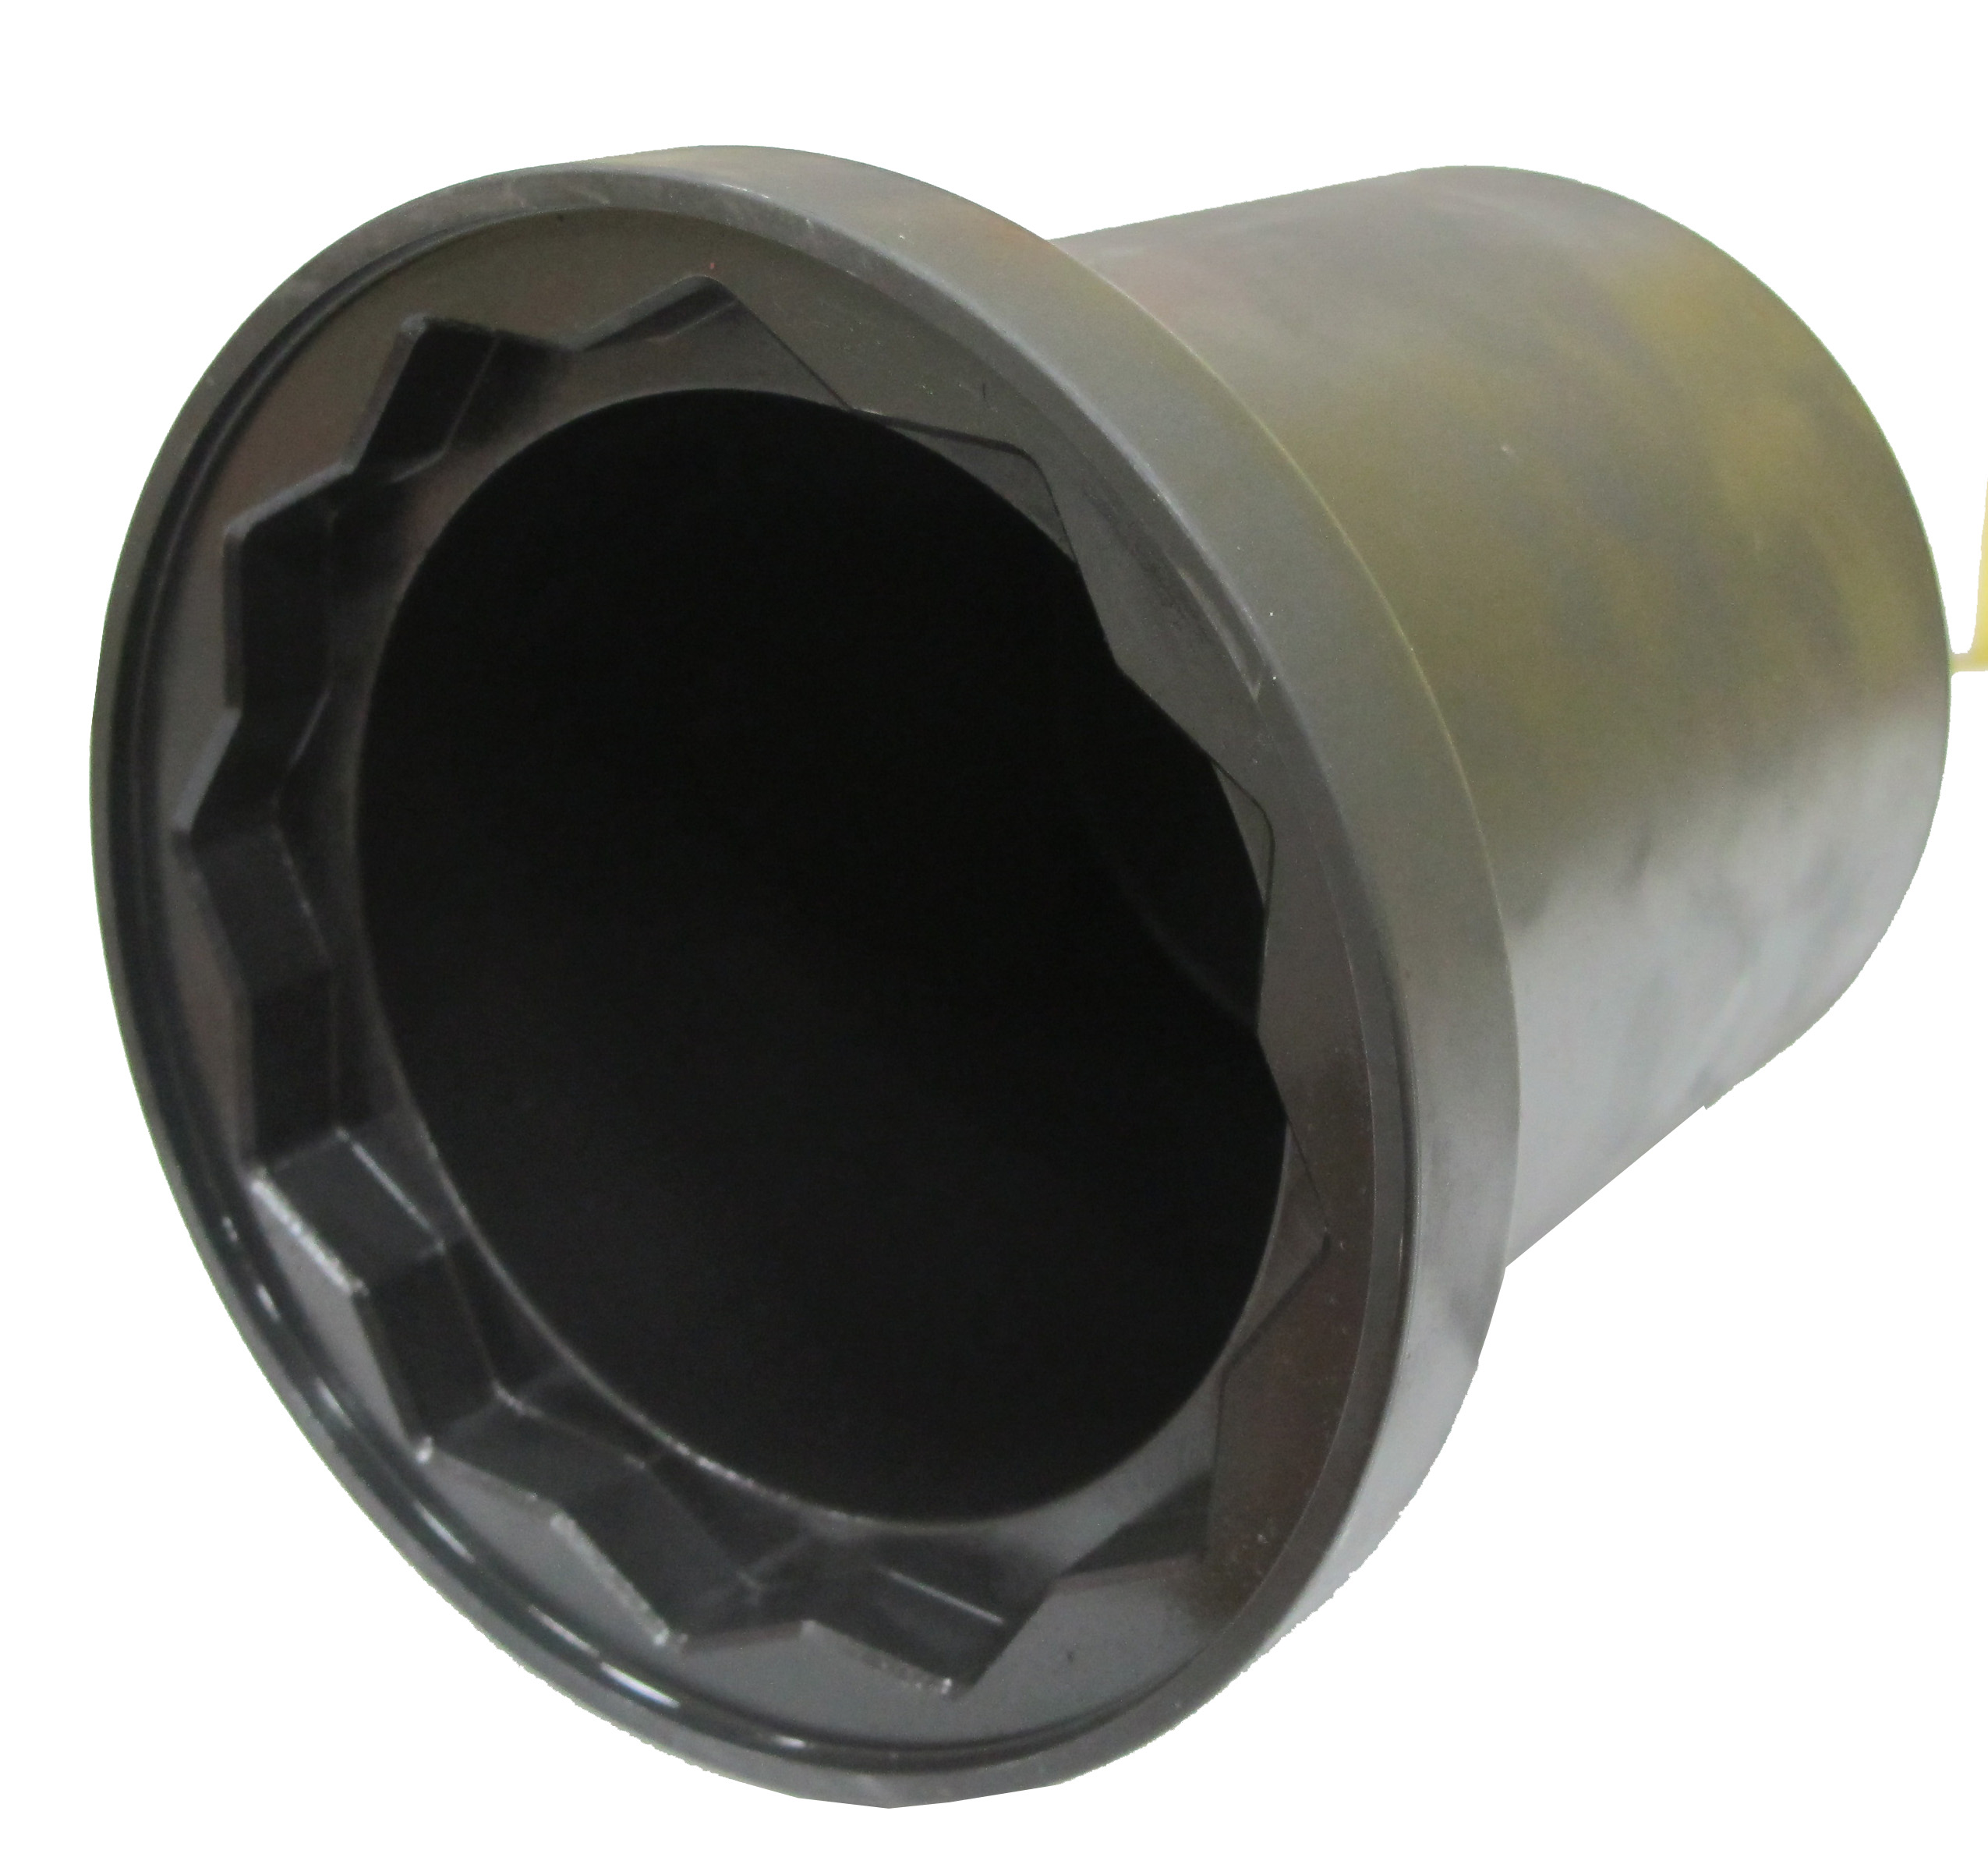

- The size of drive nut is 6 points, 36mm.
- Suited to male nut in the axle.
- It can be used with impact wrench or torque wrench.
- Size: H36, 12 points, 110mm
- Applicable: IVECO Eurotech-Cursor

H.C.B-B1387
IVECO AXLE NUT SOCKET
(H36, 12 POINTS, 110 mm)

- The size of drive nut is 6 points, 36mm.
- Suited to male nut in the axle.
- It can be used with impact wrench or torque wrench.
- Size: H36, 12 points, 110mm
- Applicable: IVECO Eurotech-Cursor

