
H.C.B-B1353
CALLIPER ADJUSTER SOCKET (H24, 5 TEETH)
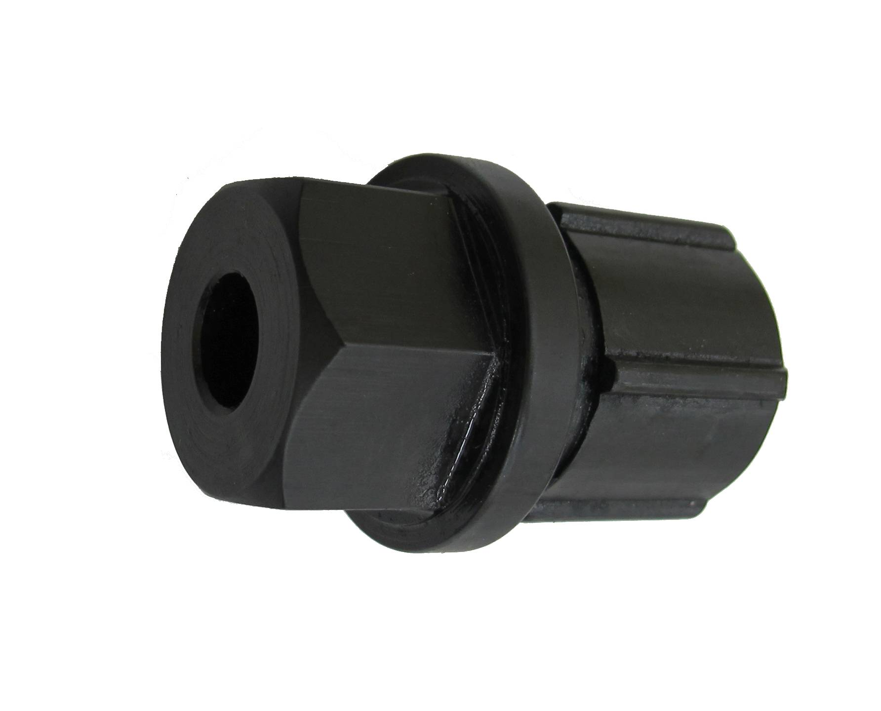

H24

46mm

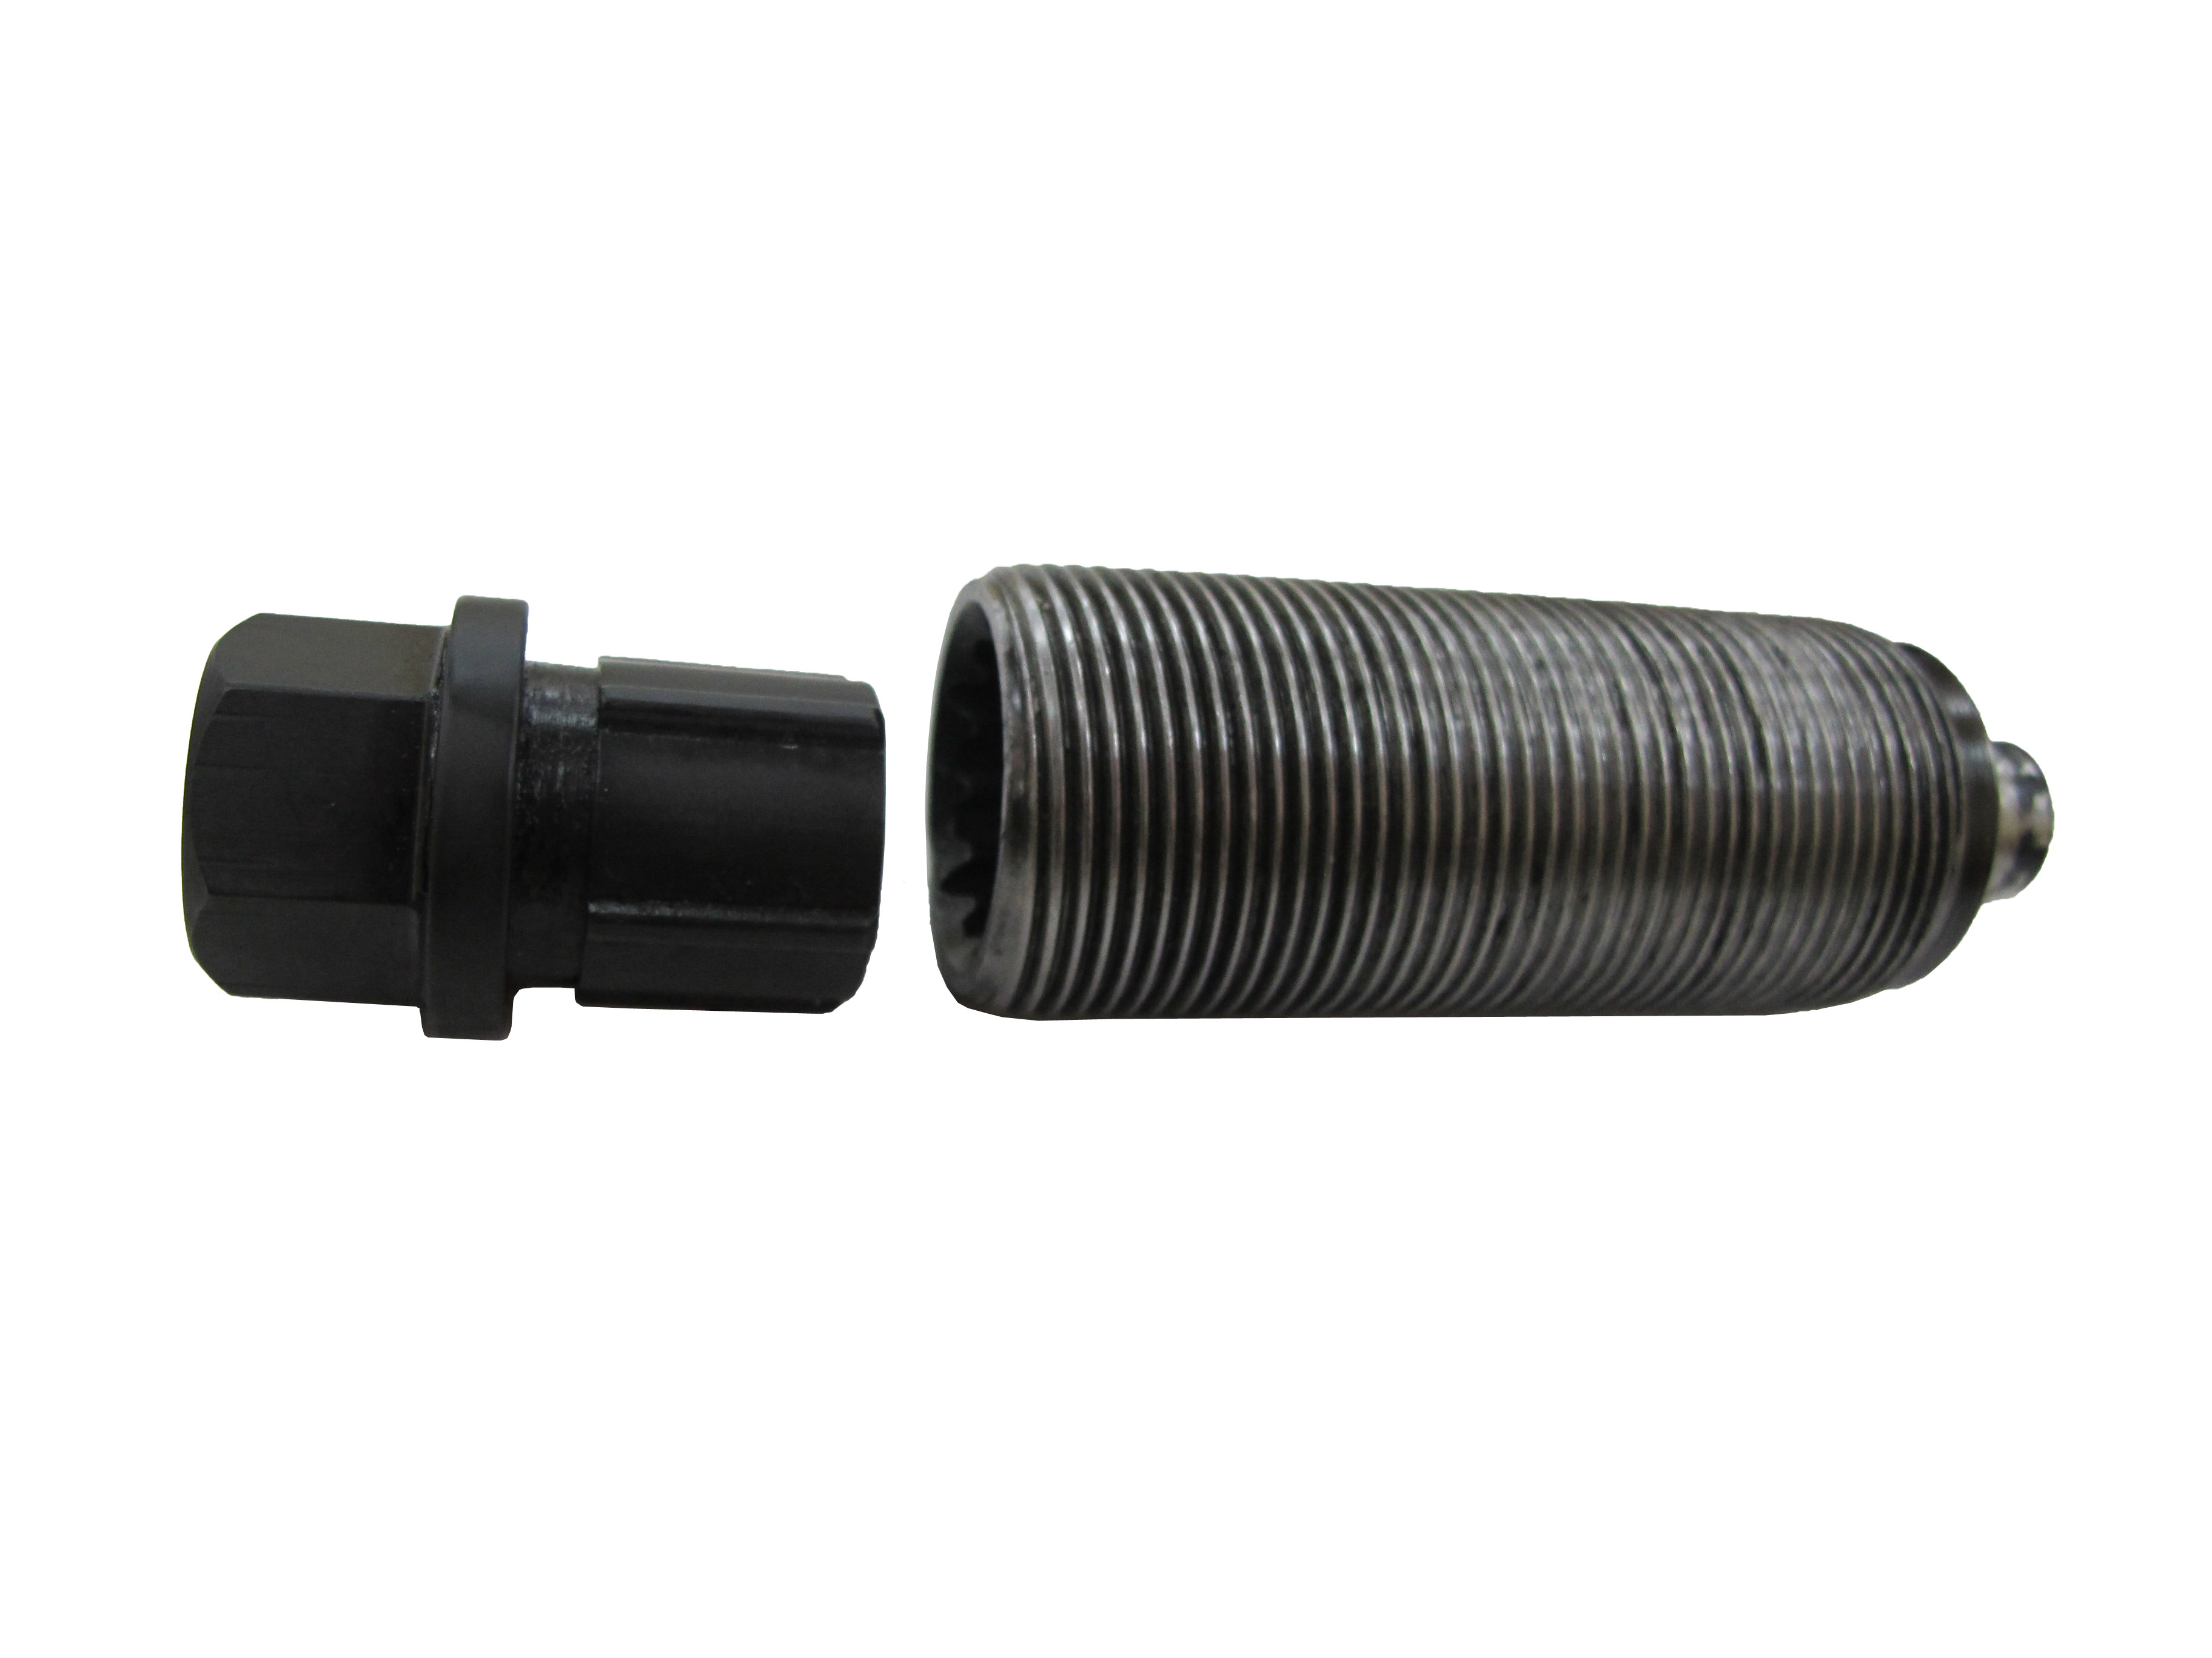

- To combine with A1353.
- Size: H24, 5 teeth, 46mm/L
- Material: SCM440

H.C.B-B1353
CALLIPER ADJUSTER SOCKET (H24, 5 TEETH)

H24

46mm

- To combine with A1353.
- Size: H24, 5 teeth, 46mm/L
- Material: SCM440

