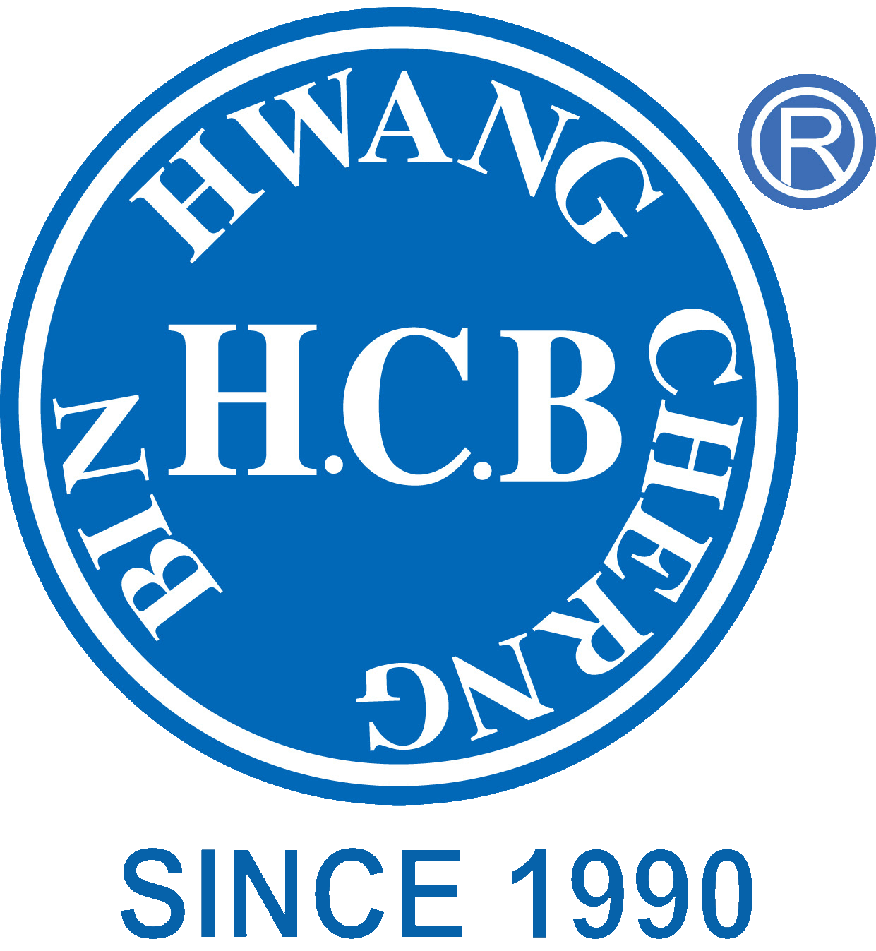
H.C.B-B1337
TRUCK K/D RACK - ELECTRICAL PAT.I380921
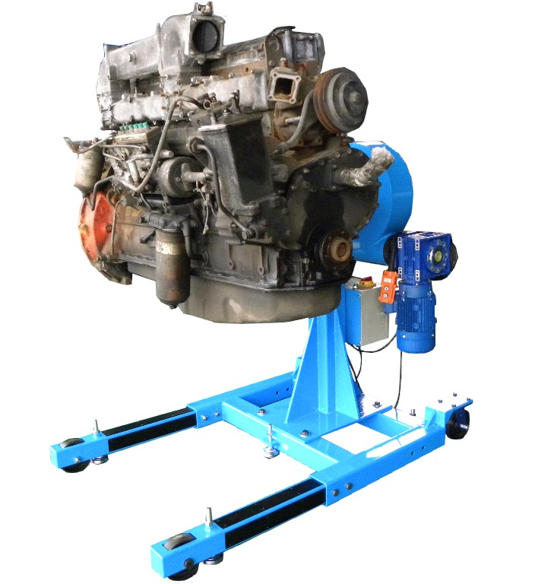

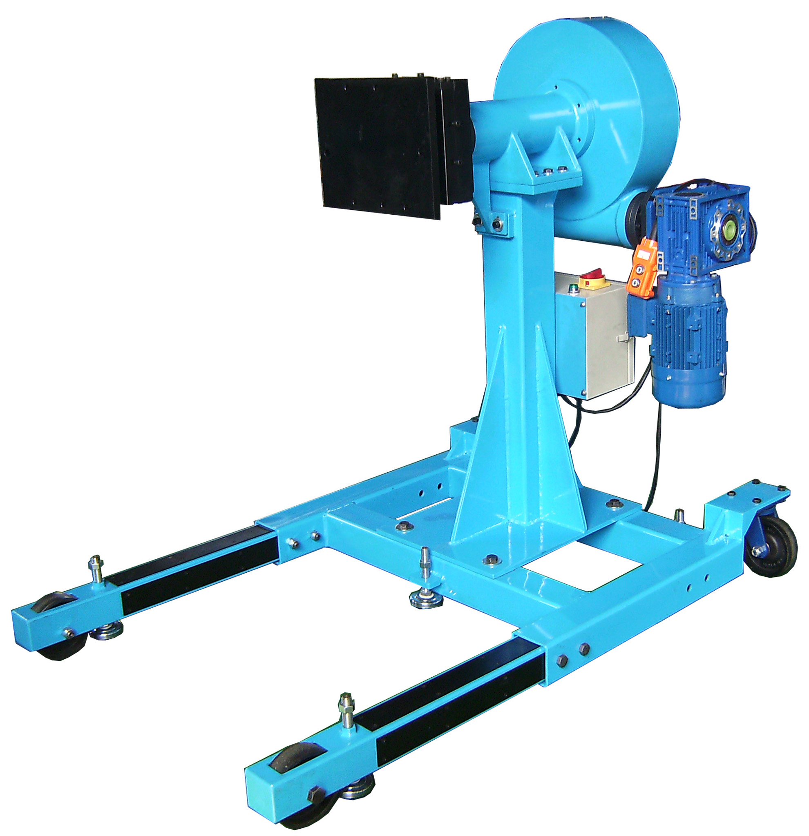

- The gear type universal K/D rack is designed for engine maintenance.

- The gear type universal K/D rack can be removed and be replaced with holder base for transmission maintenance if necessary.

- The gear and engine can be pivoted from 360 degrees during operation. Whenever the gear turning around, the engine will be rotated passively at the same time.

- Driven by 2HP motor. The patented design of H.C.B

- Specification of power:
Power 2HP motor

Resource Single-phase, 220V

Control Wire: 3 m

Power Cord: 5 m

Size: L: 1600 mm (extend)/ 1140 mm

W: 1000 mm

H: 1360 mm

- Capacity: 2000~3000 LB

- N.W.: 376Kgs

