
H.C.B-B1320-052
VOLVO TRUCK SOCKET
(Dr. 1", 6 POINTS, 52 mm)

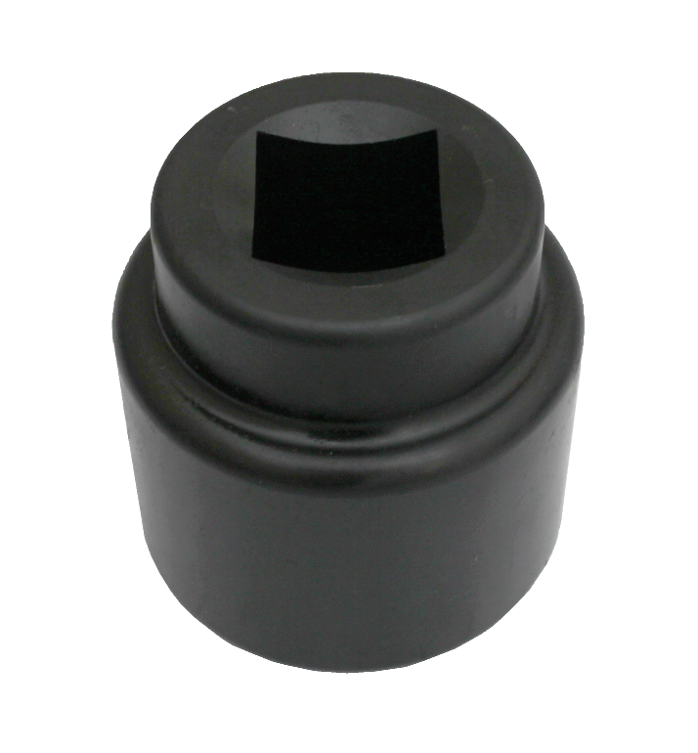
Dr. 1”

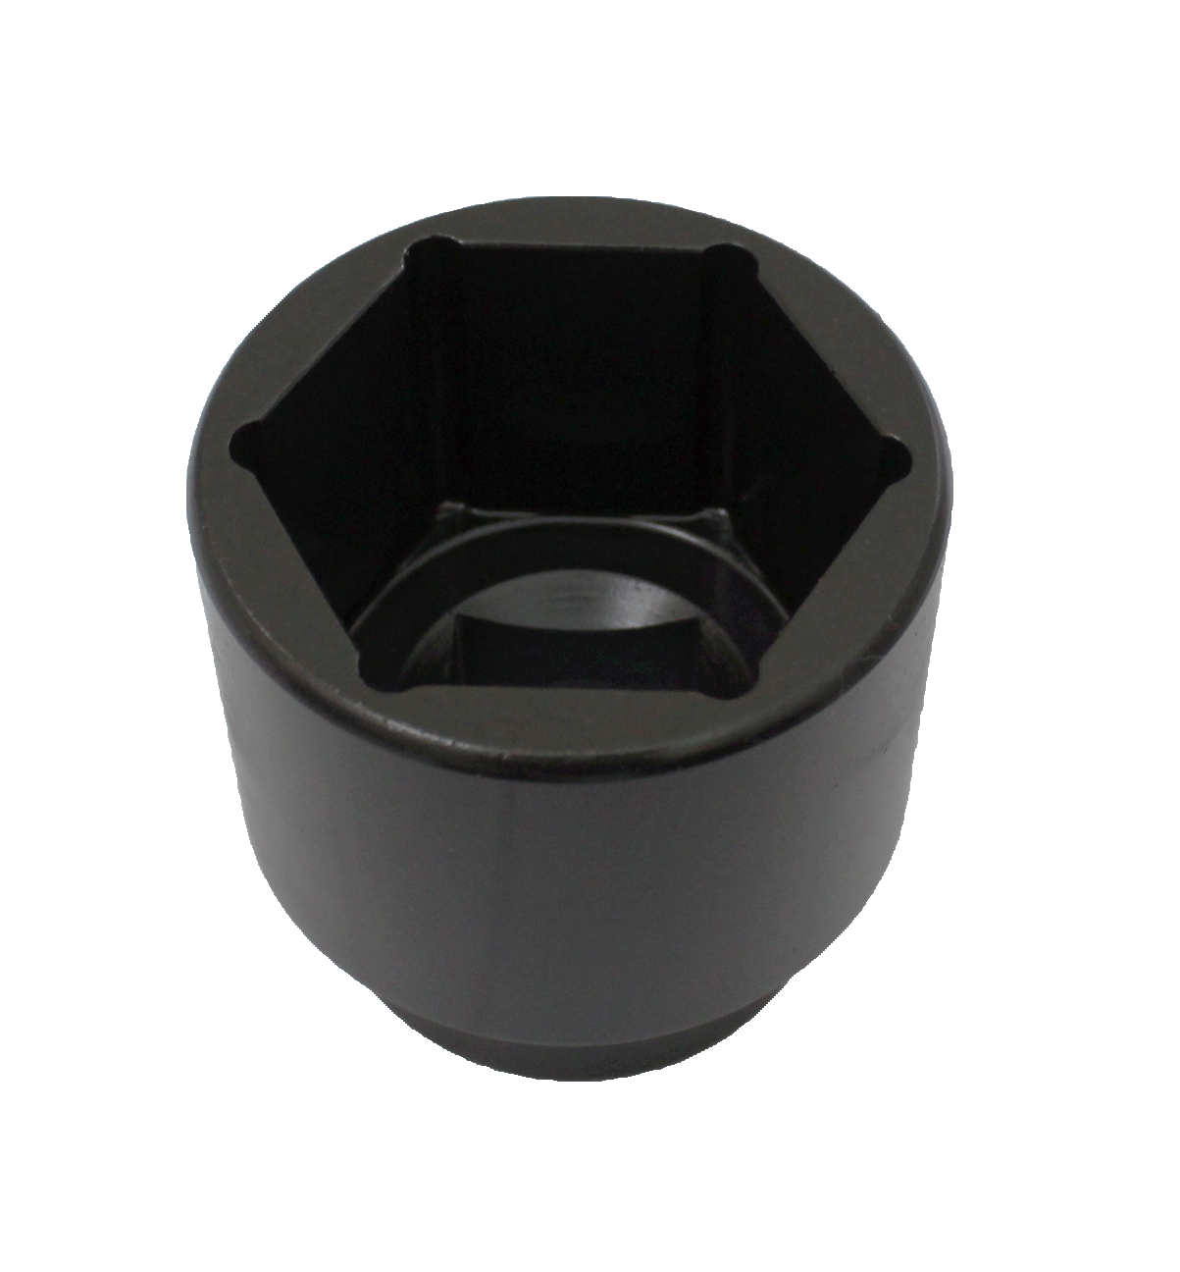
SW
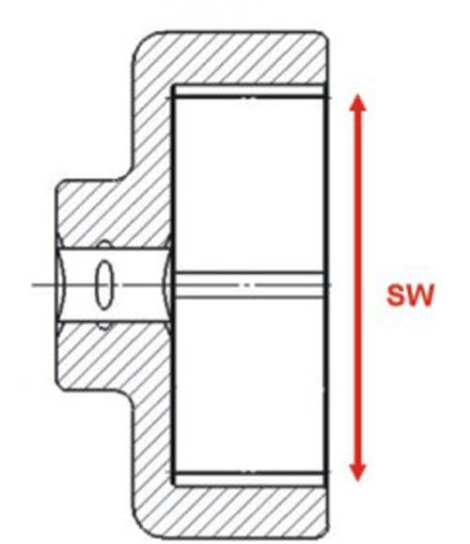

40mm

70mm

- Specification:
Item no. | Dr. | SW | Application
H.C.B-B1320-052 | 1” | 52mm | VOLVO
H.C.B-B1320-070 | 1” | 70mm | VOLVO，ECROU BPW，VOLVO，BPW NUT，HINO 17 TONS
H.C.B-B1320-075 | 1” | 75mm | VOLVO，SAE GIGANT ECROU，VOLVO FL7 back wheel，SAE，FUSO 17 TONS Korea DAEWOO(FX117)FRONT WHEEL
H.C.B-B1320-080 | 1” | 80mm | NUT BPW EH…6，5 to 12t，DAF，VOLVO(FM12)FRONT WHEEL, DAF(CF85)26 TONS lifting shaft, DAF(CF85) 35-43 TONS front wheel and lift shaft
H.C.B-B1320-085 | 1” | 85mm | NUT BPW EH… 13 to 16t，IVECO BPW NUT，SAF，SAE BPW NUT，SAE (NUT BPW EH… 13 to 16t，SAE GIGANT， IVECO
H.C.B-B1320-090 | 1” | 90mm | IVECO EUROCARGO，VOLVO，DAF (CF85) 26 TONSs front wheel nut
H.C.B-B1320-095 | 1” | 95mm | NUT BPW ECO，SAF，DISCOS，FONTENAX，RVI- IVECO Eurotraker，VOLVO FM12，IVECO/DAF
H.C.B-B1320-100 | 1” | 100mm | BPW，SAE GIGANT NUT
H.C.B-B1320-105 | 1” | 105mm | FIAT，DAF，VOLVO(FM12) REAR WHEEL，VOLVO FL7，DAF REAR WHEEL NUT, DAF(CF85)26 TONS drive shaft, DAF(CF85)35-43 TONS drive shaft
H.C.B-B1320-110 | 1” | 110mm | FRUEHAUF SMB
H.C.B-B1320-115 | 1” | 115mm | FORD，SETRA，DAF
H.C.B-B1320-120 | 1” | 120mm | DAF，SCANIA
H.C.B-B1320-125 | 1” | 125mm
H.C.B-B1320-130 | 1” | 130mm
H.C.B-B1320-135 | 1” | 135mm
H.C.B-B1320-140 | 1” | 140mm | SAF
H.C.B-B1320-145 | 1” | 145mm
H.C.B-B1320-150 | 1” | 150mm
H.C.B-B1320-155 | 1” | 155mm
H.C.B-B1320-160 | 1” | 160mm | Fontenac renault trailer axle nut disassembly
H.C.B-B1320-165 | 1” | 165mm
H.C.B-B1320-170 | 1” | 170mm
H.C.B-B1320-175 | 1” | 175mm
H.C.B-B1320-180 | 1” | 180mm
H.C.B-B1320-185 | 1” | 185mm
H.C.B-B1320-190 | 1” | 190mm
H.C.B-B1320-195 | 1” | 195mm
H.C.B-B1320-200 | 1” | 200mm

