
H.C.B-B1314
BENZ & MAN TRUCK FRONT AXLE NUT SOCKET (Dr. 3/4”, SW 56 mm, 71 mm)
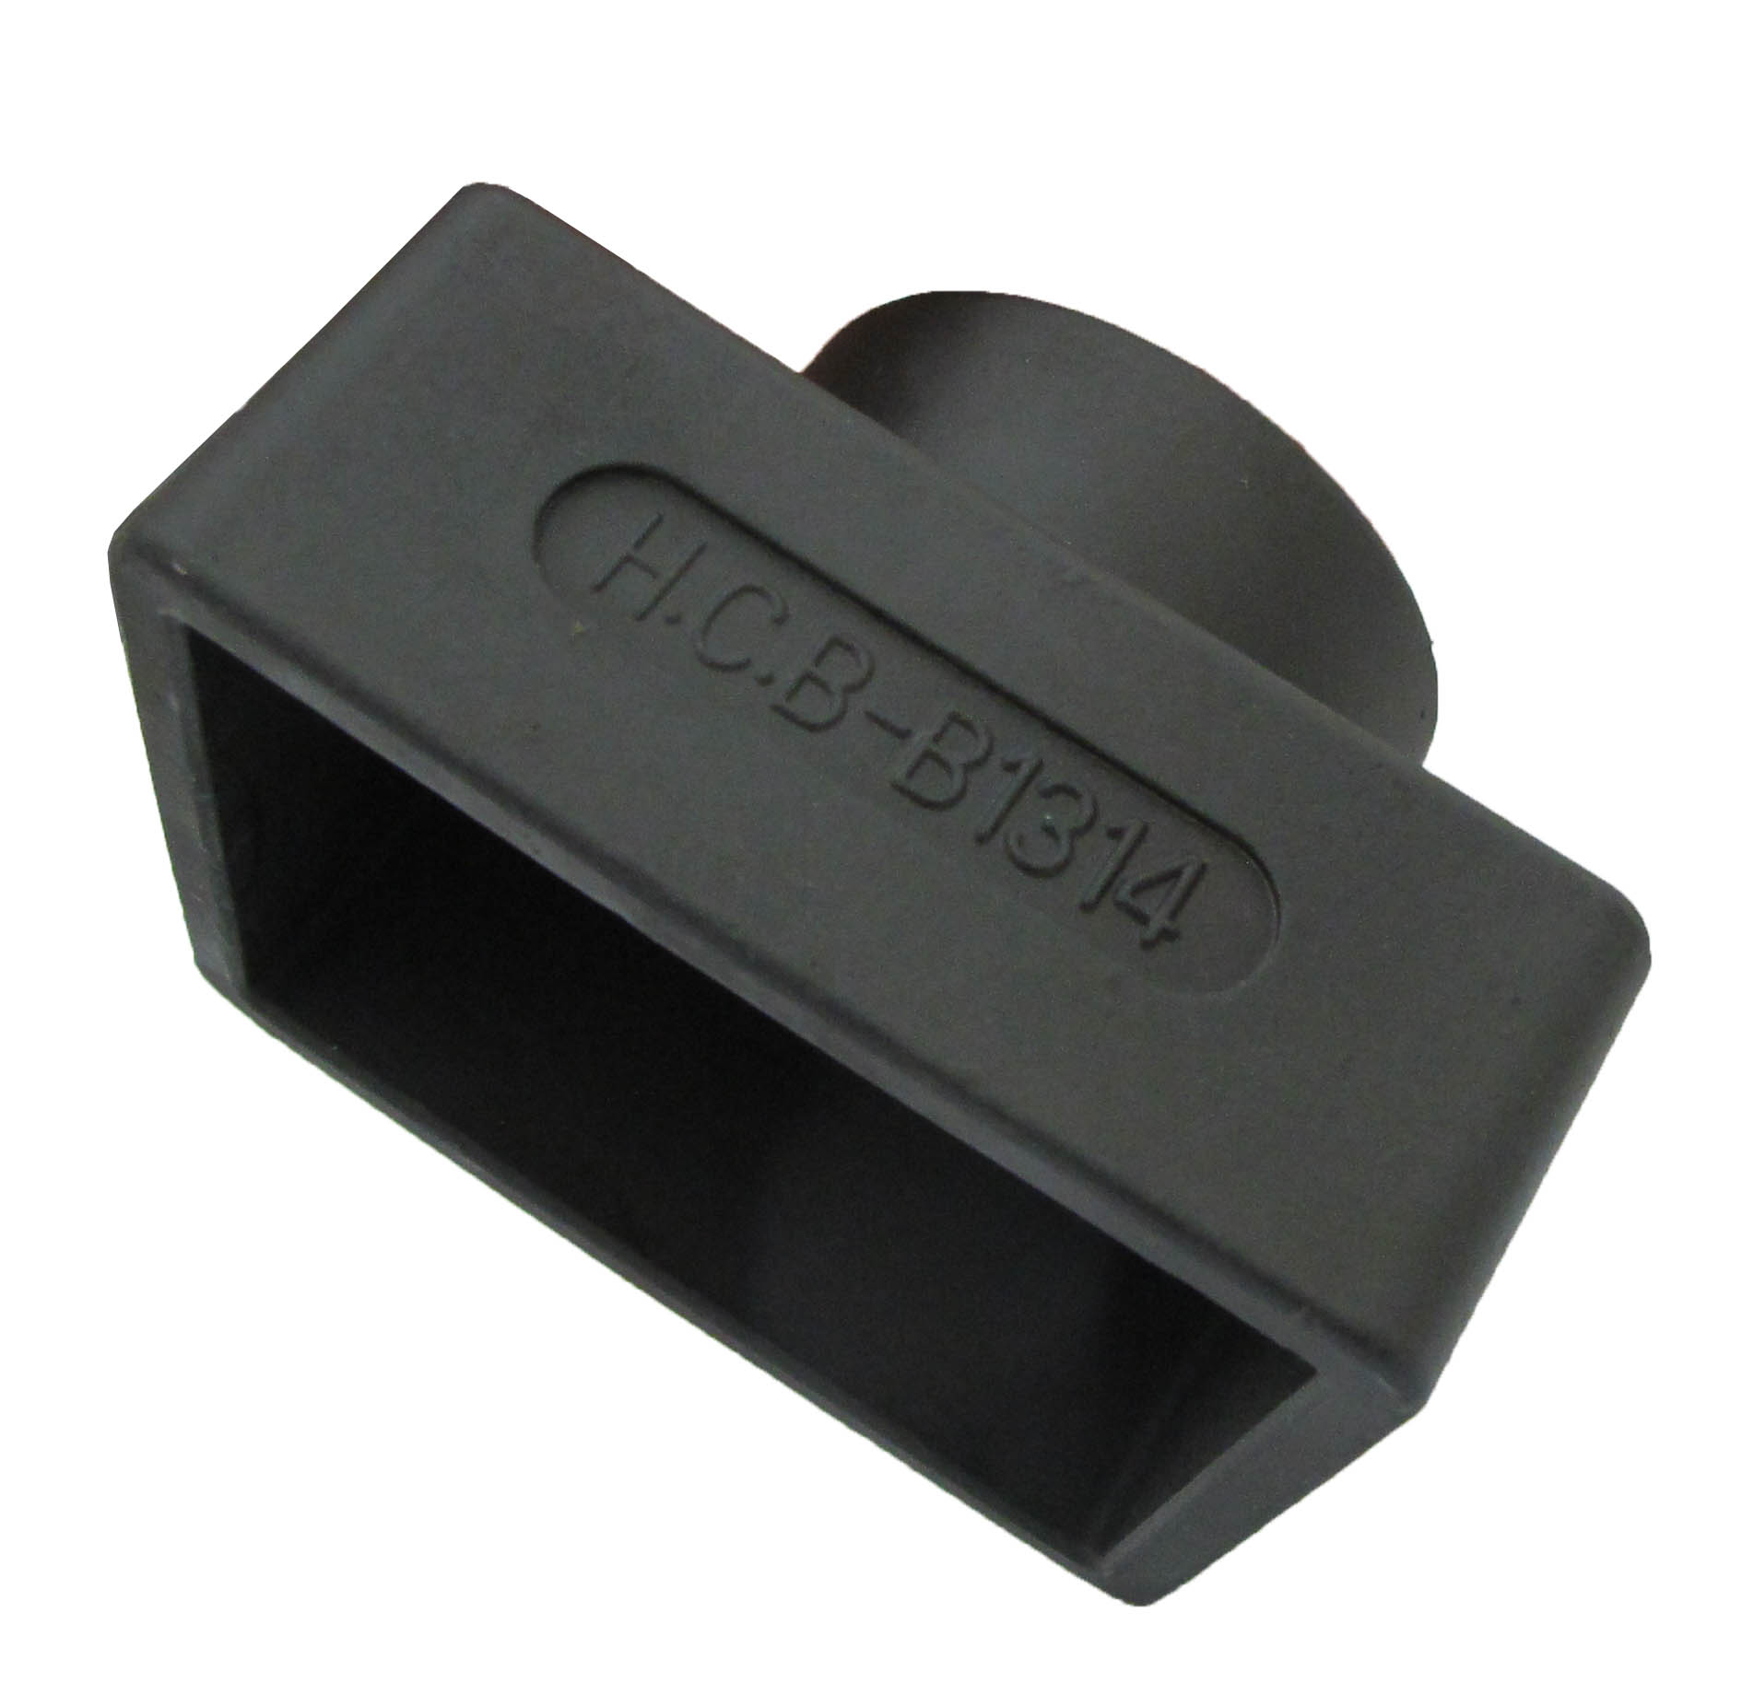
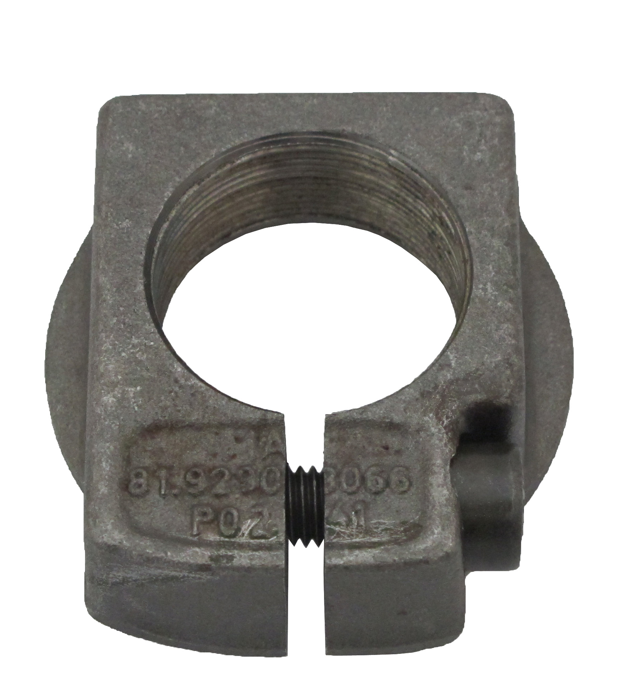
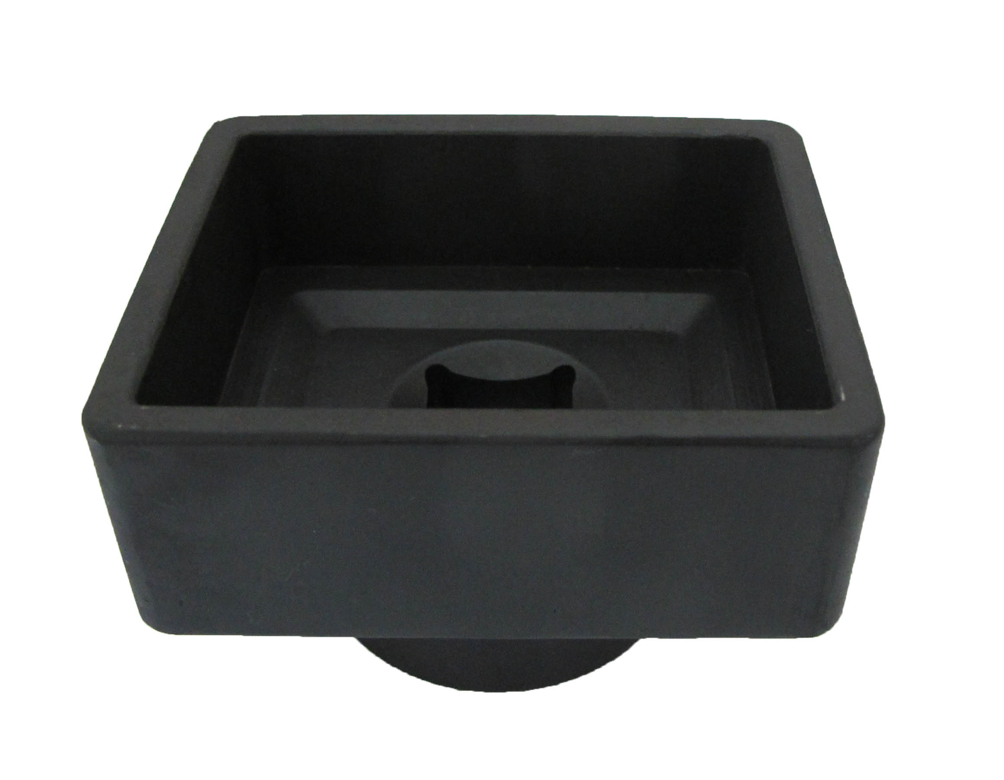

- Specification: Dr. 3/4” x SW 56mm × 71mm
- Applicable:
DAF, BENZ trucks (axles VL 3/8, 13, VO 3/10, VL 4/7, 9, 10, VD 4/14, VO 4/11, 13, 18, VL4/15, 16, 19 and VD 4/20 in type 363, 385, 387, 389, 391, 393, 395, 617, 620, 621, 622, 623, 625 and 649 (ex: BENZ ACTROS with drum brake tightening nut no. 652 330 00 88))
BENZ buses (axles VO 3/10, 4/11, 4/13 and 4/19 in type 0303, 0305-G and 0307)
MAN trucks (with clamping nut no. 81.92901-0066)
KASSBOHRER / SETRA (front axle 6,5 + 7,5 in types S 210 and 215, SG 219-221 and non-driven rear axle types S 216 HDS and S228 DT)

H.C.B-B1314
BENZ & MAN TRUCK FRONT AXLE NUT SOCKET (Dr. 3/4”, SW 56 mm, 71 mm)

- Specification: Dr. 3/4” x SW 56mm × 71mm
- Applicable:
DAF, BENZ trucks (axles VL 3/8, 13, VO 3/10, VL 4/7, 9, 10, VD 4/14, VO 4/11, 13, 18, VL4/15, 16, 19 and VD 4/20 in type 363, 385, 387, 389, 391, 393, 395, 617, 620, 621, 622, 623, 625 and 649 (ex: BENZ ACTROS with drum brake tightening nut no. 652 330 00 88))
BENZ buses (axles VO 3/10, 4/11, 4/13 and 4/19 in type 0303, 0305-G and 0307)
MAN trucks (with clamping nut no. 81.92901-0066)
KASSBOHRER / SETRA (front axle 6,5 + 7,5 in types S 210 and 215, SG 219-221 and non-driven rear axle types S 216 HDS and S228 DT)

