
H.C.B-B1265
SCANIA (320/340) / VOLVO (FM12) PITMAN ARM PULLER (58 mm) (W/HYDRAULIC)
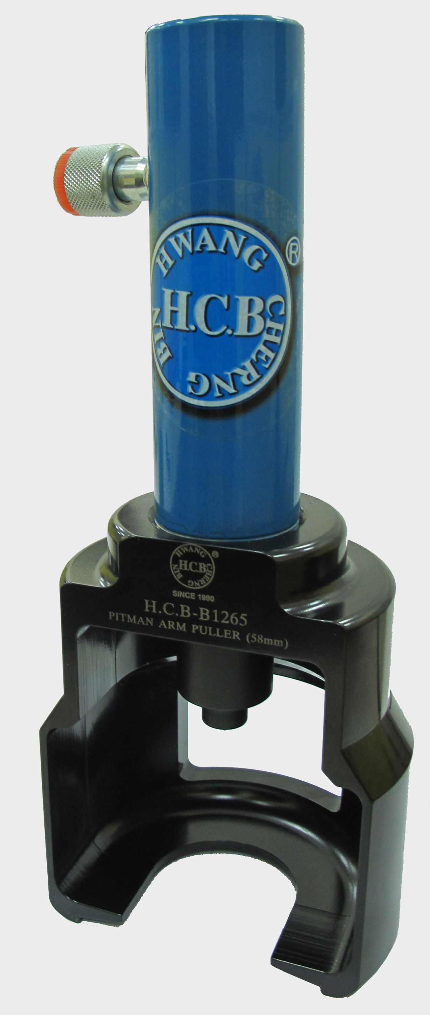
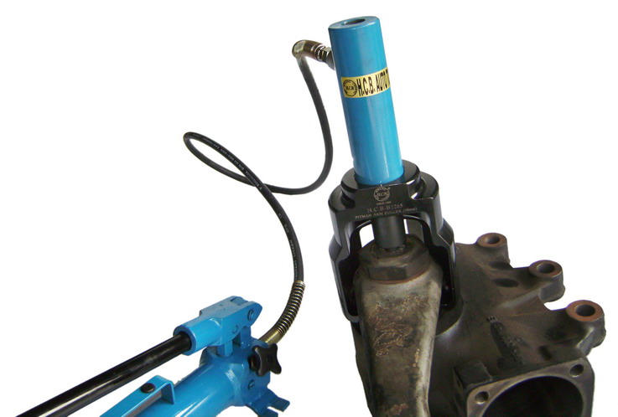

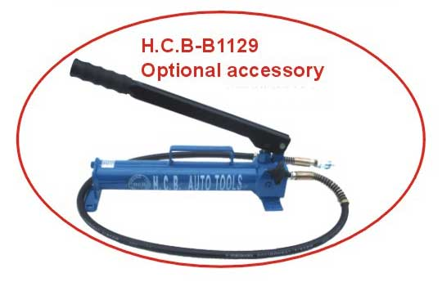

- To use on pitman arm of European trucks.
- No need to destroy the pitman arm.
- Applicable: SCANIA, European truck…
- To loosen the fixed nut on the arm before using H.C.B-A1265.

H.C.B-B1265
SCANIA (320/340) / VOLVO (FM12) PITMAN ARM PULLER (58 mm) (W/HYDRAULIC)

- To use on pitman arm of European trucks.
- No need to destroy the pitman arm.
- Applicable: SCANIA, European truck…
- To loosen the fixed nut on the arm before using H.C.B-A1265.

