
H.C.B-B1239
MAN FRONT WHEEL HUB REMOVER
(20 TONS HYDRAULIC)
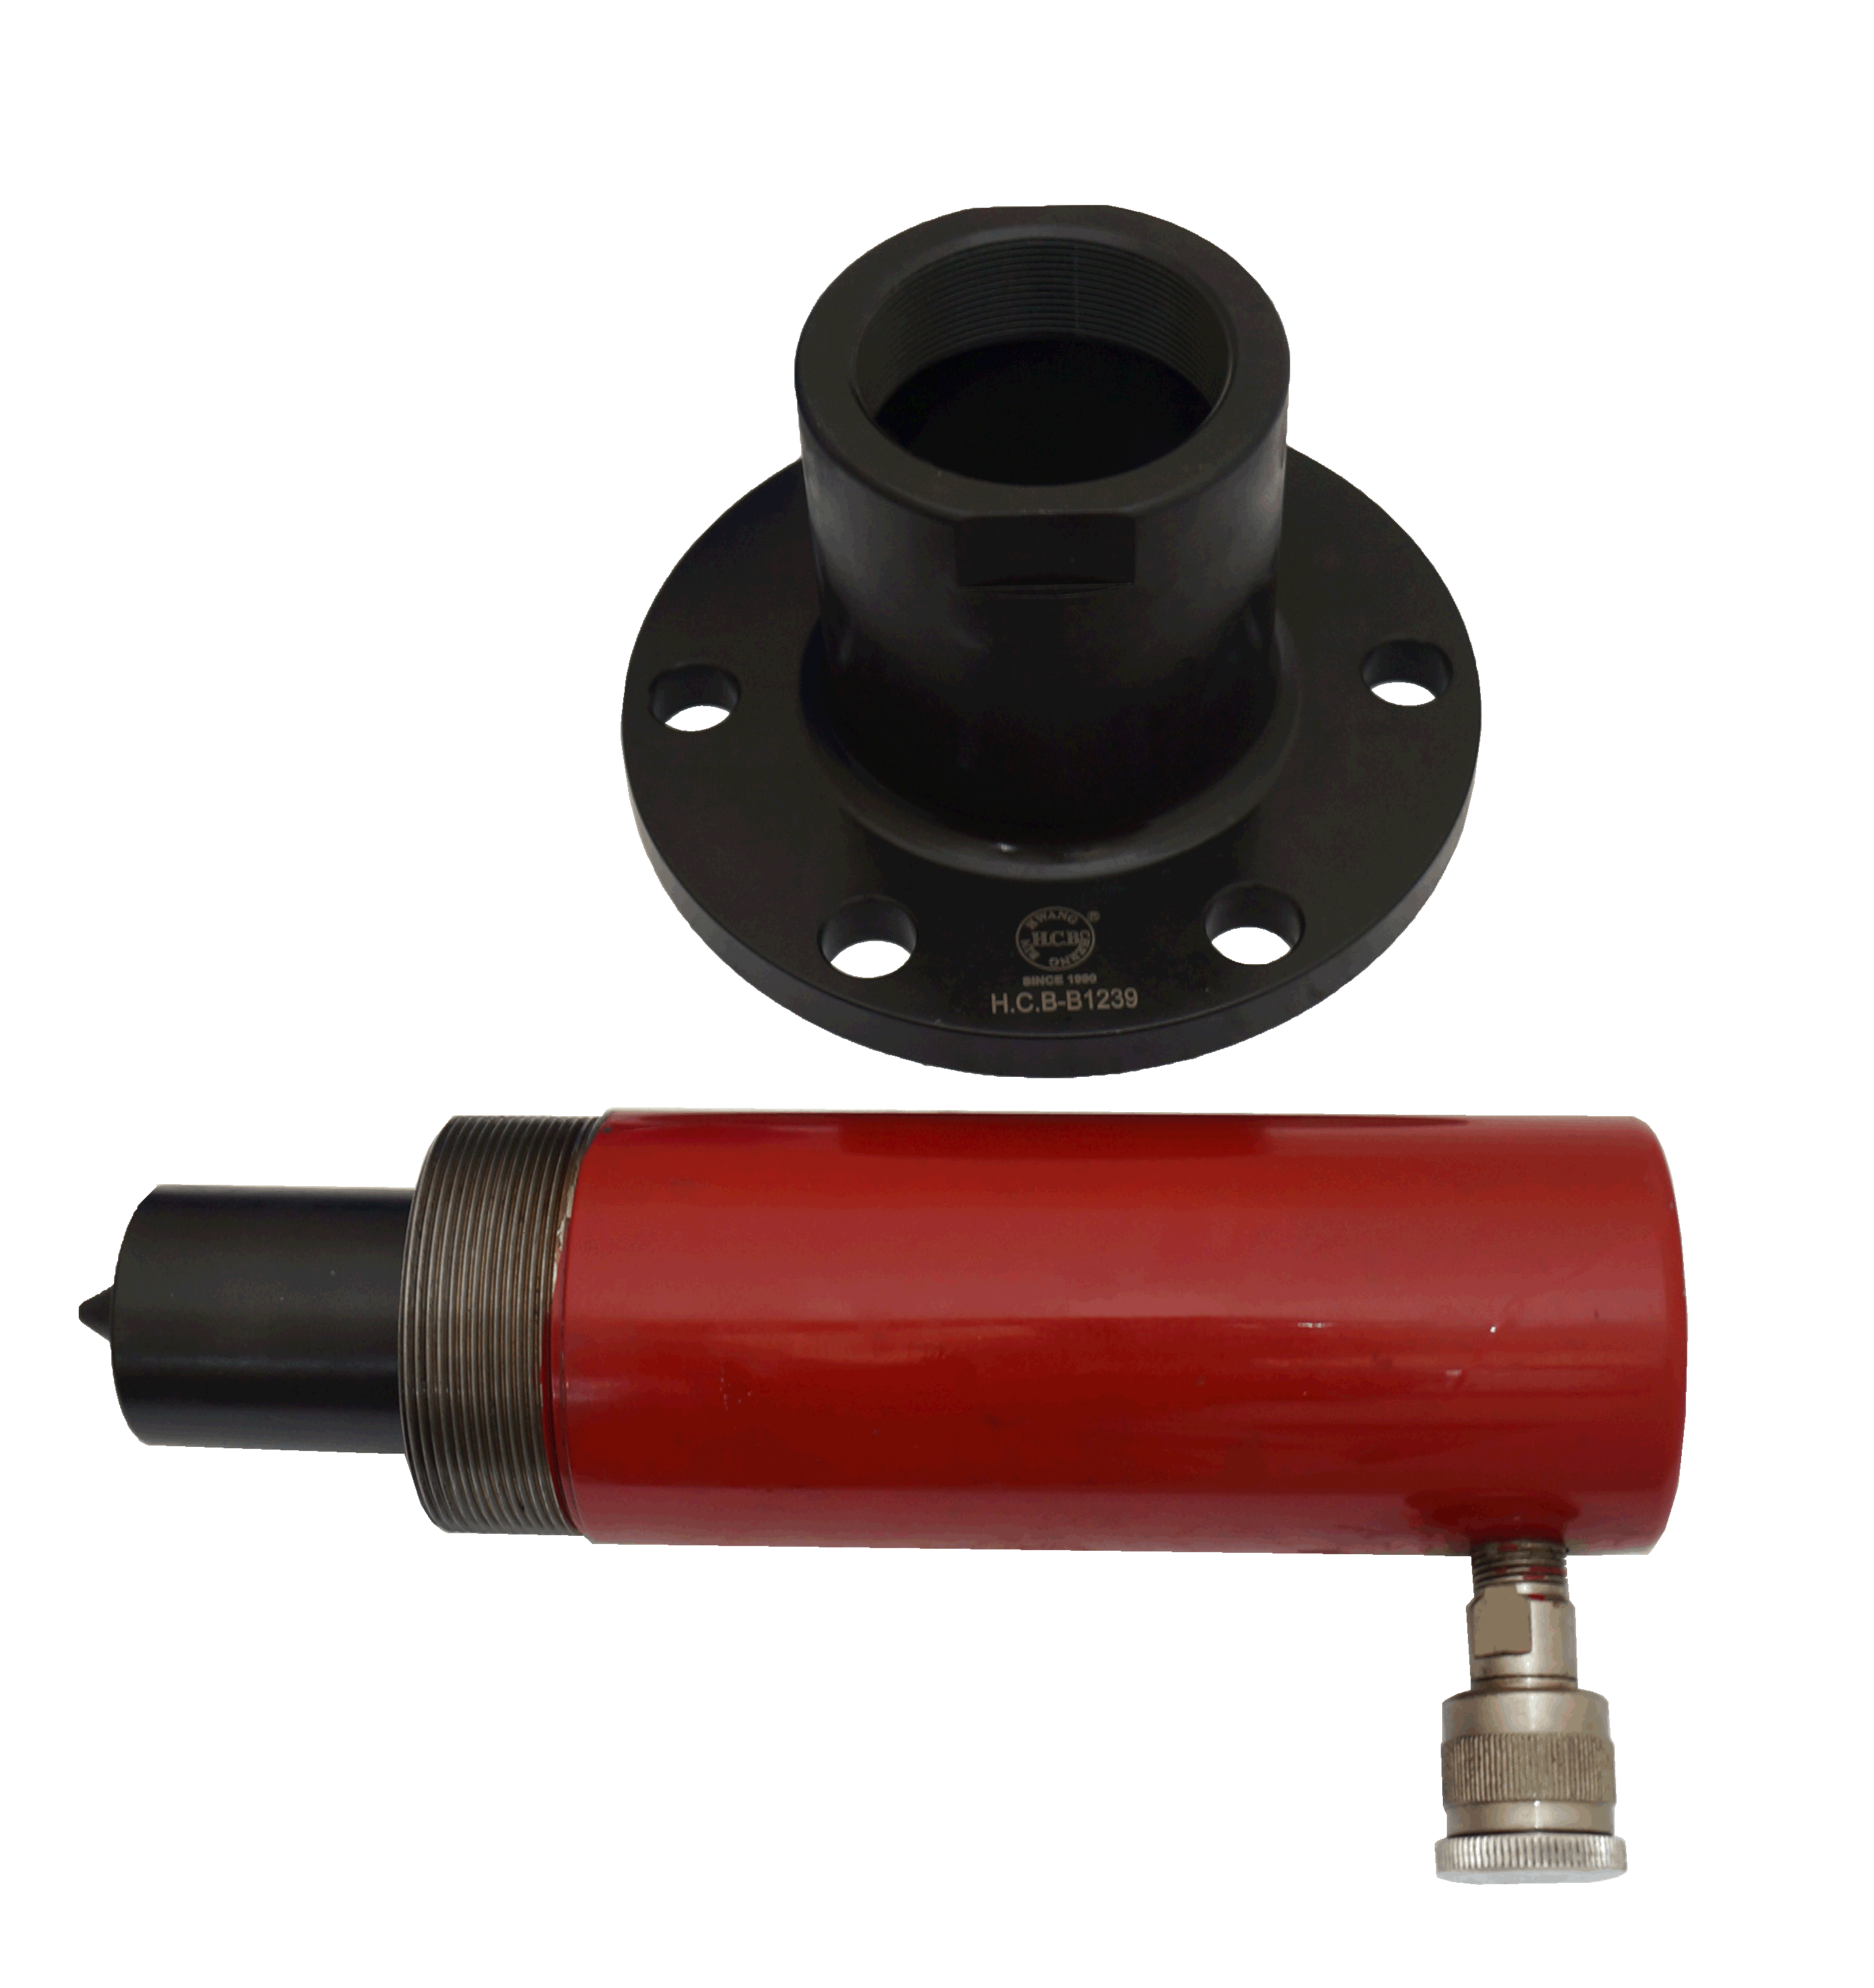

- If axle bearing of MAN is stuck due to over heat, use this tool with air wrench for labor saver and easier removal.
- With the 20 tons hydraulic, let maintance work easily and easily.
- P.C.D:ψ166mm
- Application: MAN truck

