
H.C.B-B1186
VOLVO SHOCK ABSORBER SPRING WASHER REMOVAL SOCKET (Dr. 3/4") (REAR)
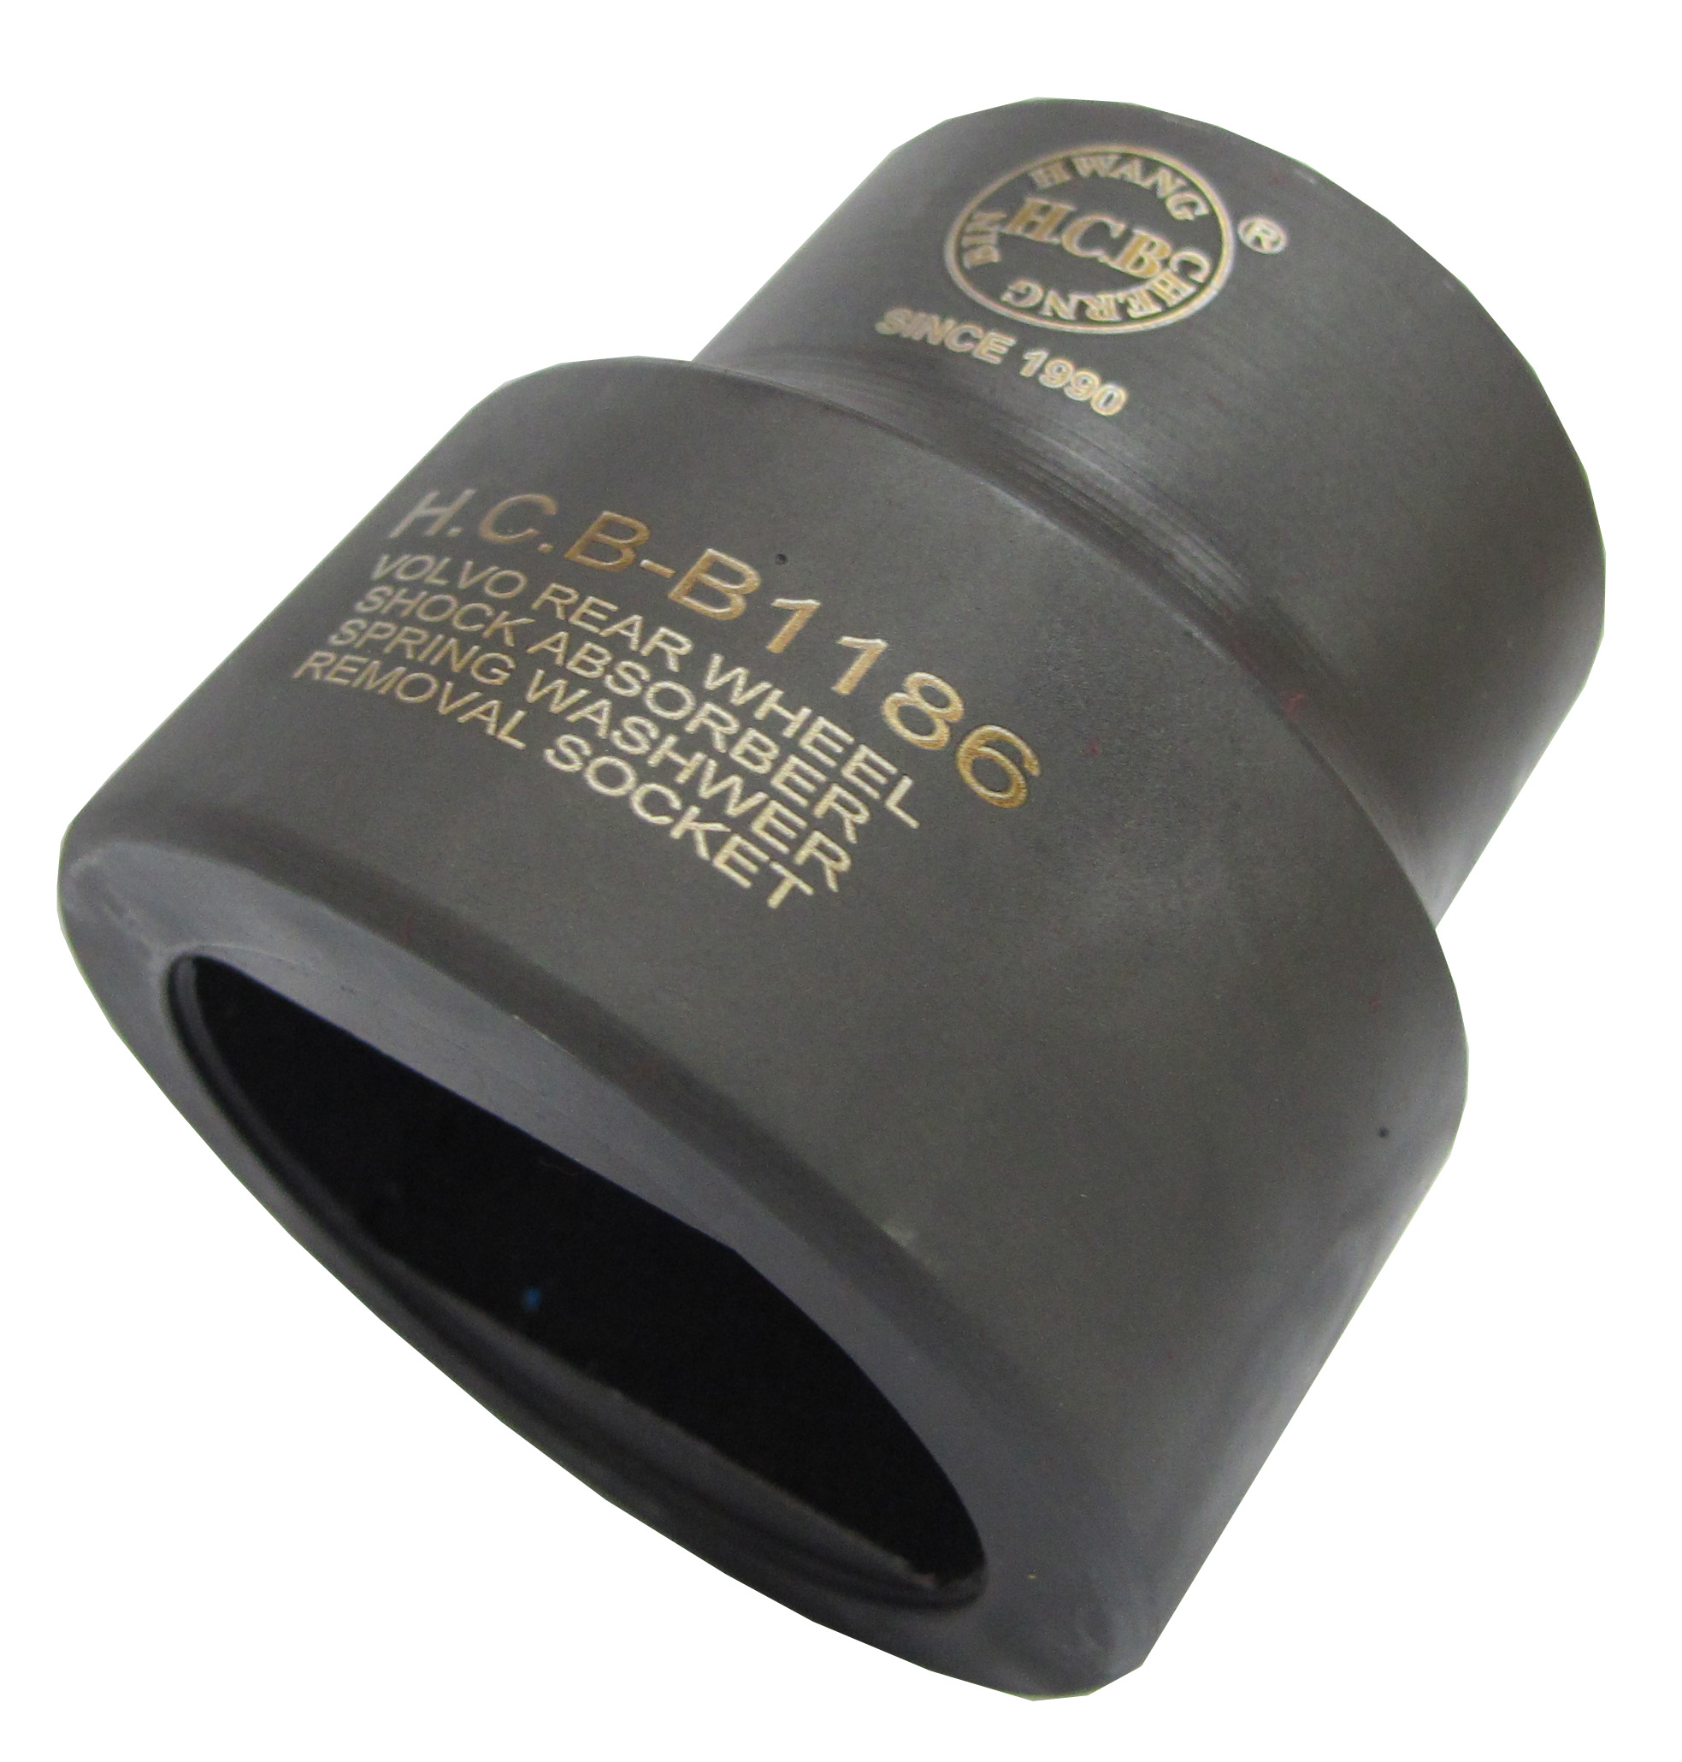
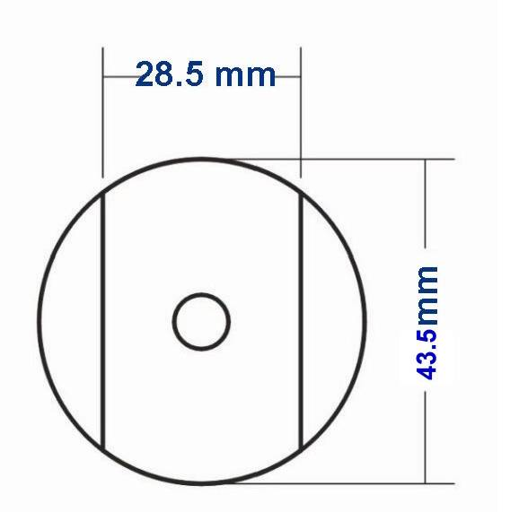
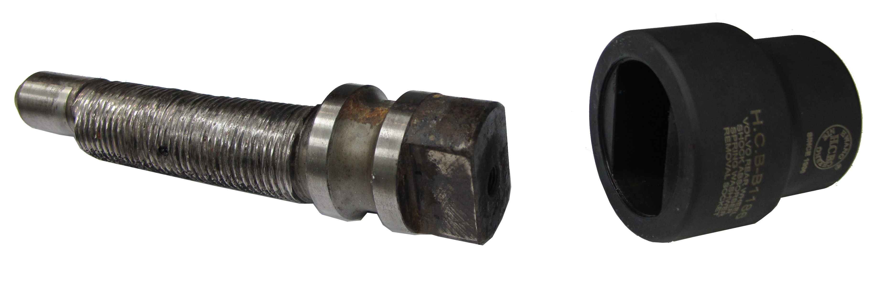
Dr. 3/4”

H.C.B-B1186
VOLVO SHOCK ABSORBER SPRING WASHER REMOVAL SOCKET (Dr. 3/4") (REAR)
Dr. 3/4”

