
H.C.B-B1091
SCANIA TRUCK FRONT
WHEEL AXLES HUB EXTRACTOR

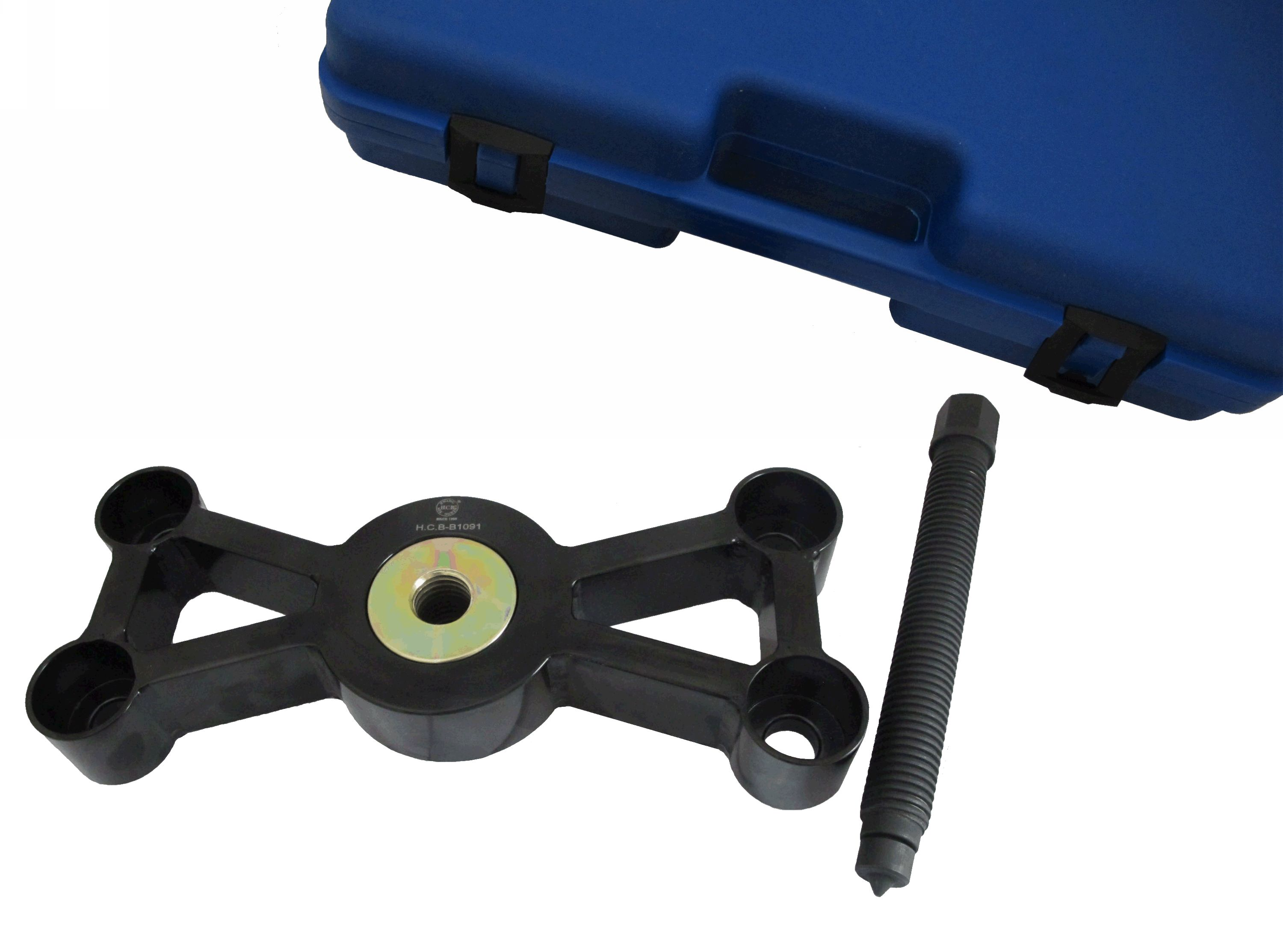

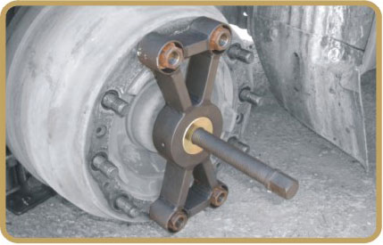

Caution: Before demolish the screws, you should loosen
the wheel brakes first to keep it idle.

▇ When SCANIA axle bearing is stuck due to it is over heat, use this kit with air wrench for labor savor and easier removal.

H.C.B-B1091
SCANIA TRUCK FRONT
WHEEL AXLES HUB EXTRACTOR

Caution: Before demolish the screws, you should loosen
the wheel brakes first to keep it idle.

▇ When SCANIA axle bearing is stuck due to it is over heat, use this kit with air wrench for labor savor and easier removal.

