
H.C.B-A9033
DETROIT DIESEL 60 SERIES JAKE BRAKE RETAINING RING INSTALLER TOOL
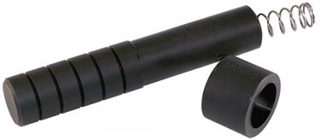

- This tool reassemble master piston, pushrod, spring, retainer, and spirolox ring in housing using master piston assembly tool A9033.
- Note: when placing retainer into bore- part number should be visible.
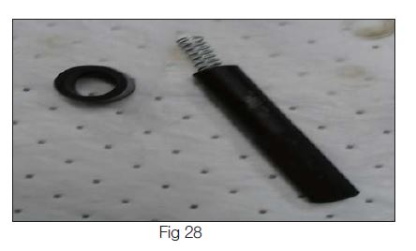

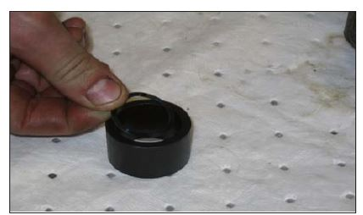
- Loading spirolox into tapered ring.

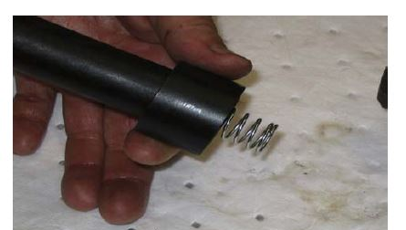

- Engage master piston assembly tool into bore. Ridge will engage with bore chamfer.
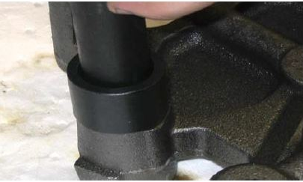
- Push down on spirolox until it snaps in to place

- Note: The spring should hold the master piston completely in the housing. If not, the spring has relaxed and must be replaced.
- The smaller diameter end of the spring engages to the master piston push rod ball end. Spring must not expand over ball end.
- The detroit diesel 60 series jake brake retaining ring installer tool use on A9033
- OEM no.ref.: J-45976

