
H.C.B-A6151
SCANIA 9L CRANKSHAFT FRONT SEAL INSTALLATION TOOL

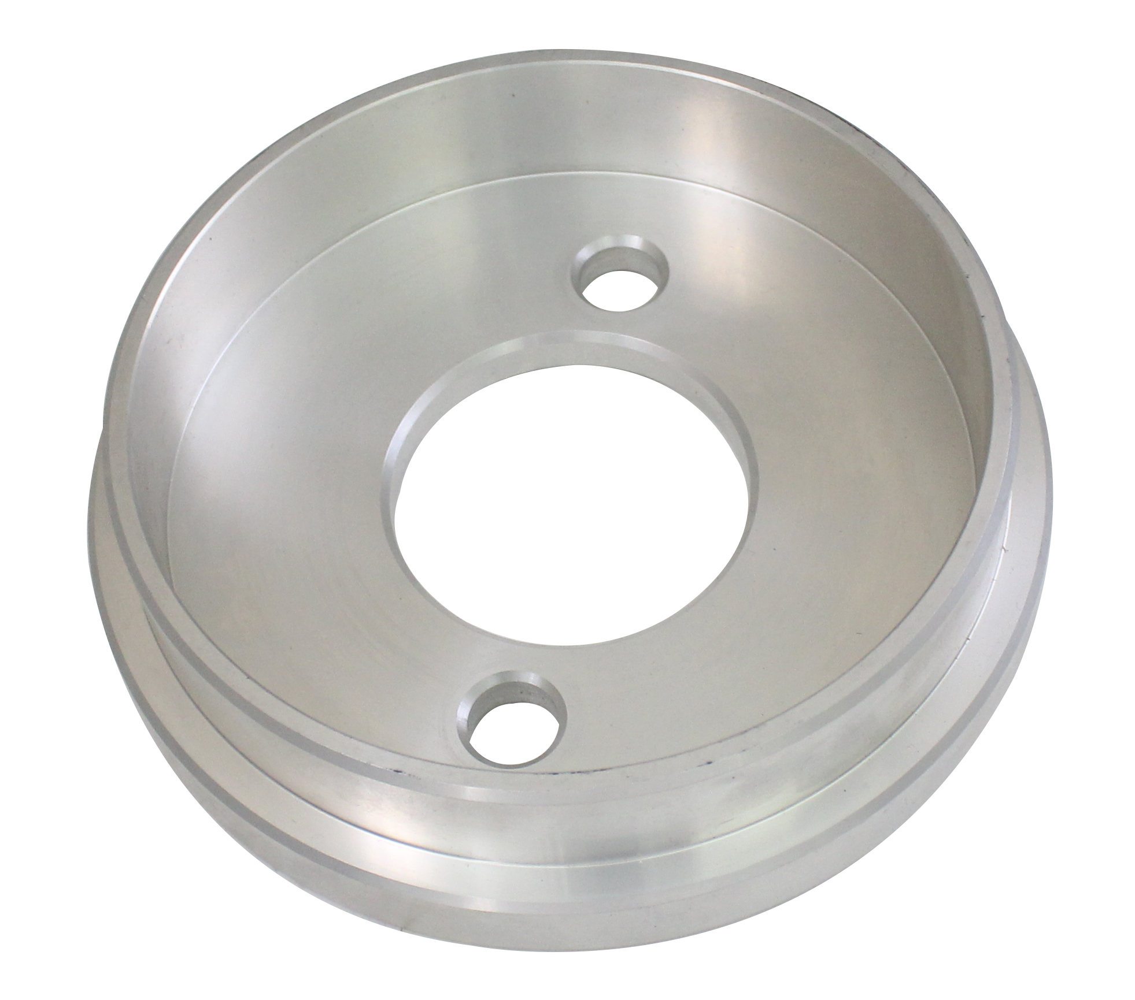

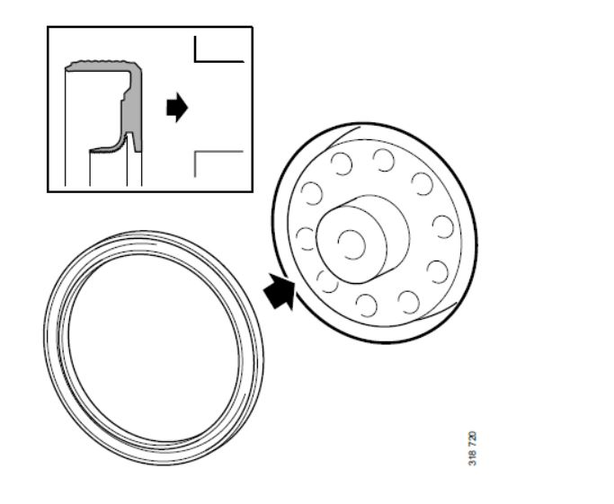
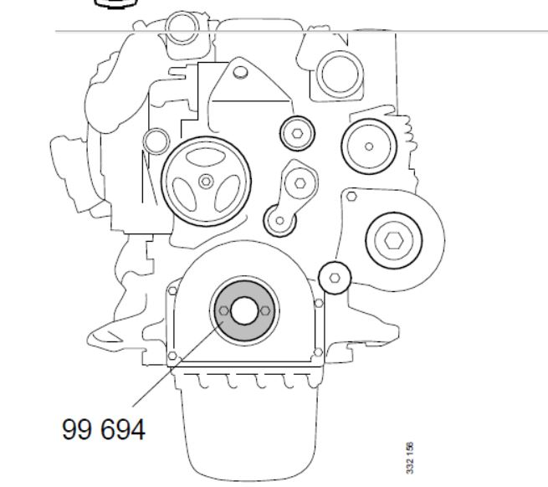

- Application • Commonly found on class 6-8 transportation trucks and equipment. (Kenworth, Peterbilt, Freightliner, Mack, Volvo, etc.)
- Easily remove even the most stubborn pitman arms on Sheppard M110 gear boxes.
- Eliminates dangerous hammering and cutting torch methods
- May be used with up to a 3/4″impact tool
- High strength steel casting designed for high capacity pulling.
- Simple to slip on for instant results
- OEM ref: TIGER 10389

