
H.C.B-A6150
SCANIA 16L CRANKSHAFT FRONT SEAL INSTALLATION TOOL
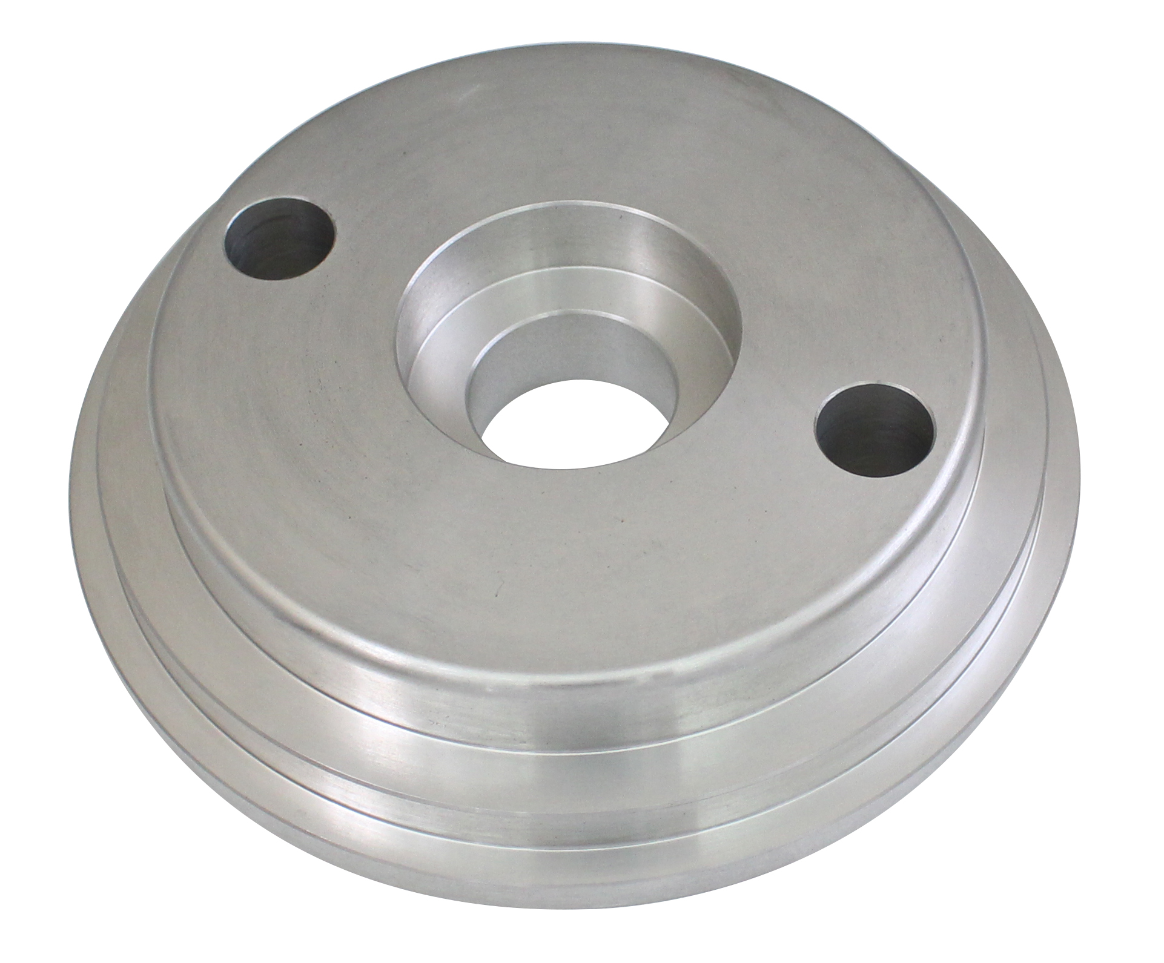

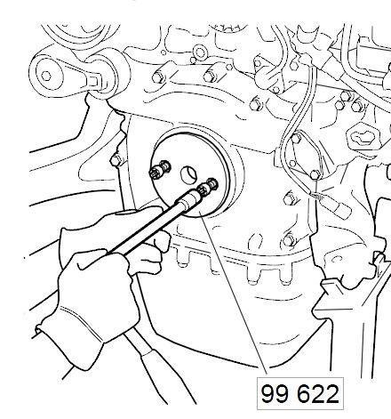

- Used when fitting the crankshaft seal on 16 litre engines with cylinder block generation 2.
- Note: The crankshaft seal must not be lubricated. The sleeve in which the seal is supplied should be left on until the crankshaft seal is fitted on the engine.
- Fit the new crankshaft seal to 99 622 Press drift. Fit the tool and press the seal into place by taking 2 screws from the inner pulley and tightening them in the tool and crankshaft. Press the seal at an even speed, approximately 100 mm/min.

Application:
4 series truck (1994-2008)
P, G, R, T series truck (2003- )
L, P, G, R, S series truck (2016- )
F, K, N series bus (2004- )
E2011 (2010- )

- OEM no.ref.: 99622

