
H.C.B-A6149
SCANIA 11/12L FRONT CRANKSHAFT SEAL INSTALLATION TOOL(WITH GEARED-UP FAN
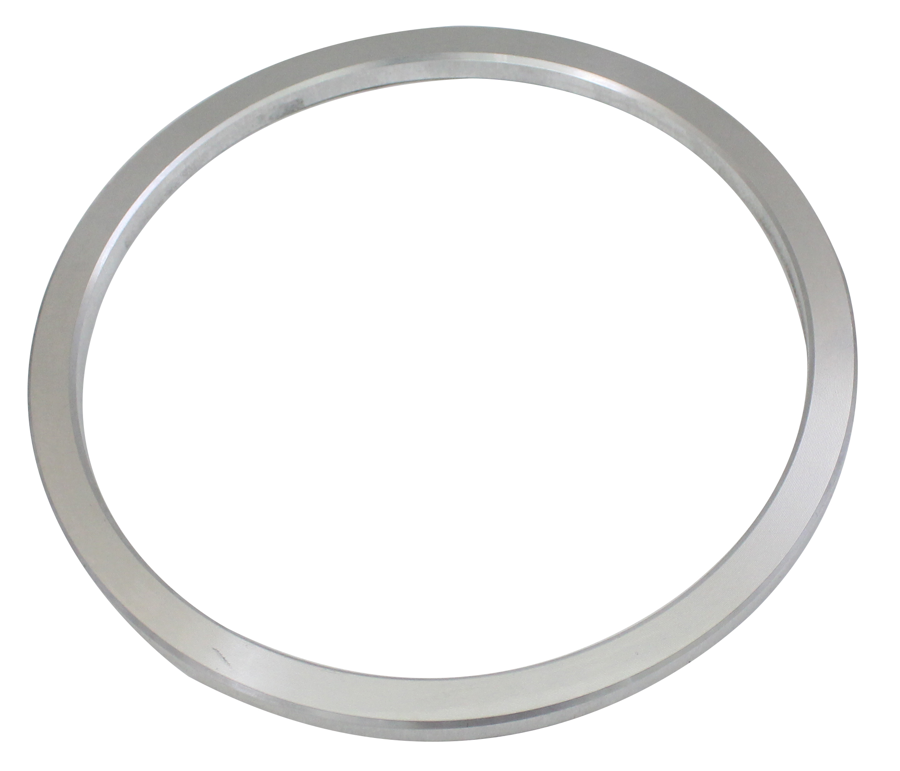

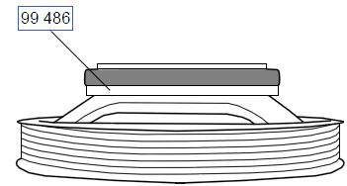

- Use to fit the front crankshaft seal on 11 and 12 litre engines with a geared-up fan.
- Note: The crankshaft seal must “not” be lubricated.

Application:
4 series truck (1994-2008)
P, G, R, T series truck (2003- )
4 series bus (1994-2010)
F, K, N series bus (2004- )
P96 (1996- )

- OEM no.ref.: 99486

