
H.C.B-A6148
SCANIA 9/11/12 CRANKSHAFT FRONT SEAL INSTALLATION TOOL
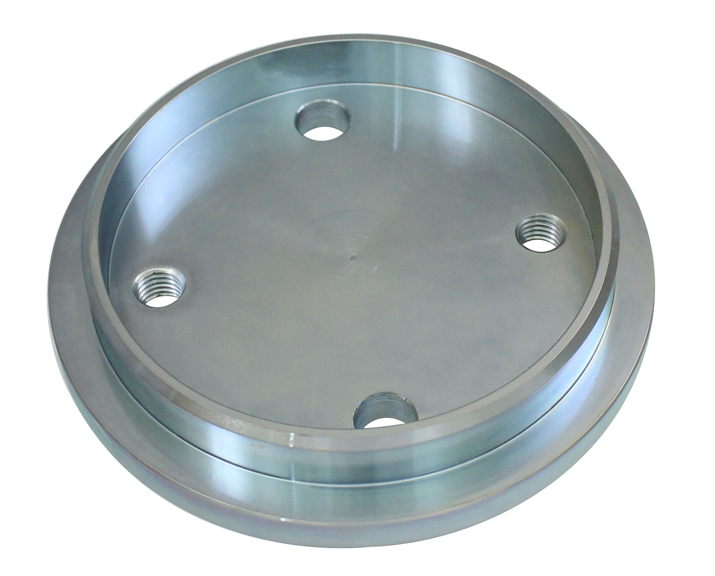

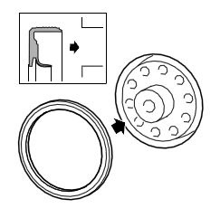

- Use for fitting the front crankshaft seal on 12 litre engines.
- Note: The crankshaft seal must not be lubricated. The sleeve in which the seal is supplied should be left on until the crankshaft seal is fitted on the engine.
- Application:
4 series truck (1994-2008)
P, G, R, T series truck (2003- )
4 series bus (1994-2010)
F, K, N series bus (2004- )
P96 (1996- )
E2011 (2010- )

- OEM no.ref.: 99374

