
H.C.B-A6147
SCANIA 11/12L FRONT CRANKSHAFT SEAL INSTALLATION TOOL(WITH GEARED-UP FAN
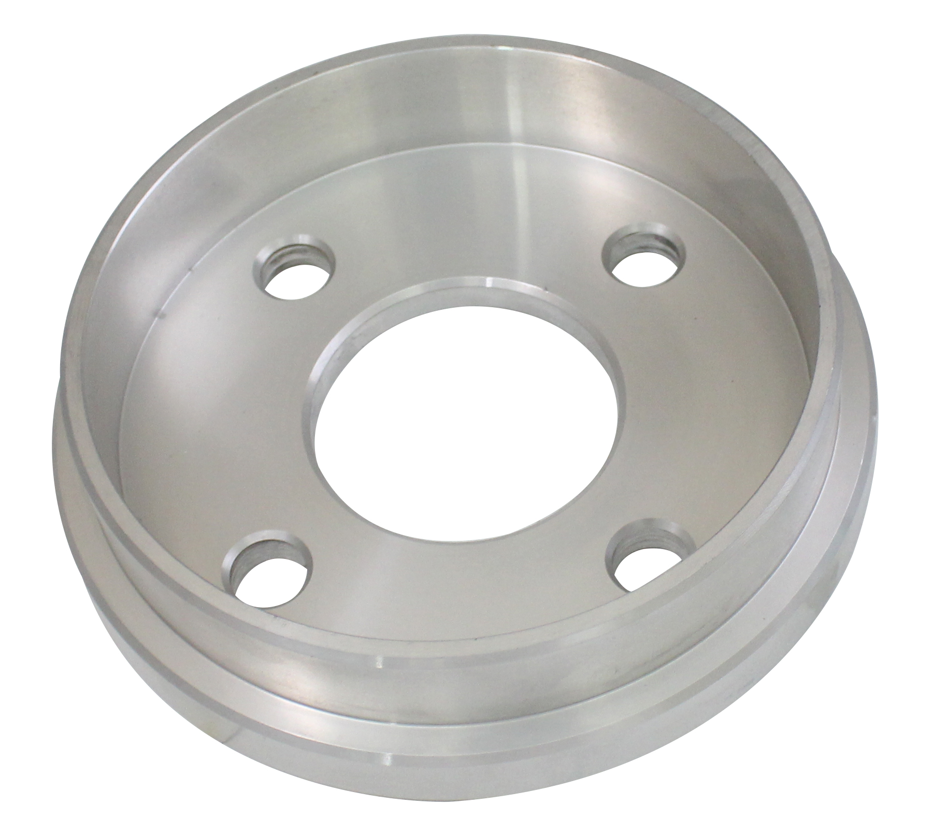

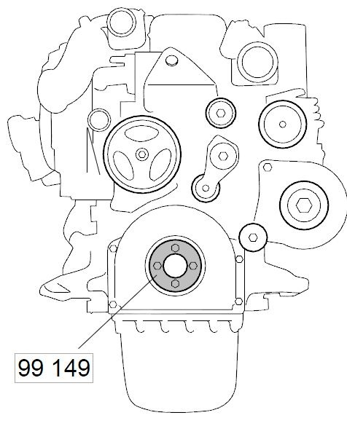

- Use for fitting the front crankshaft seal on 13 litre engines with cylinder block generation 2
- Note: The crankshaft seal must be fitted dry and on no account must it be lubricated. Do not touch the sealing lip with your fingers.

- Application:
4 series truck (1994-2008)
P, G, R, T series truck (2003- )
L, P, G, R, S series truck (2016- )
4 series bus (1994-2010)
F, K, N series bus (2004- )
E2011 (2010- )

- OEM no.ref.: 99149

