
H.C.B-A6146
SCANIA SEALING RING PROTECTION COVER

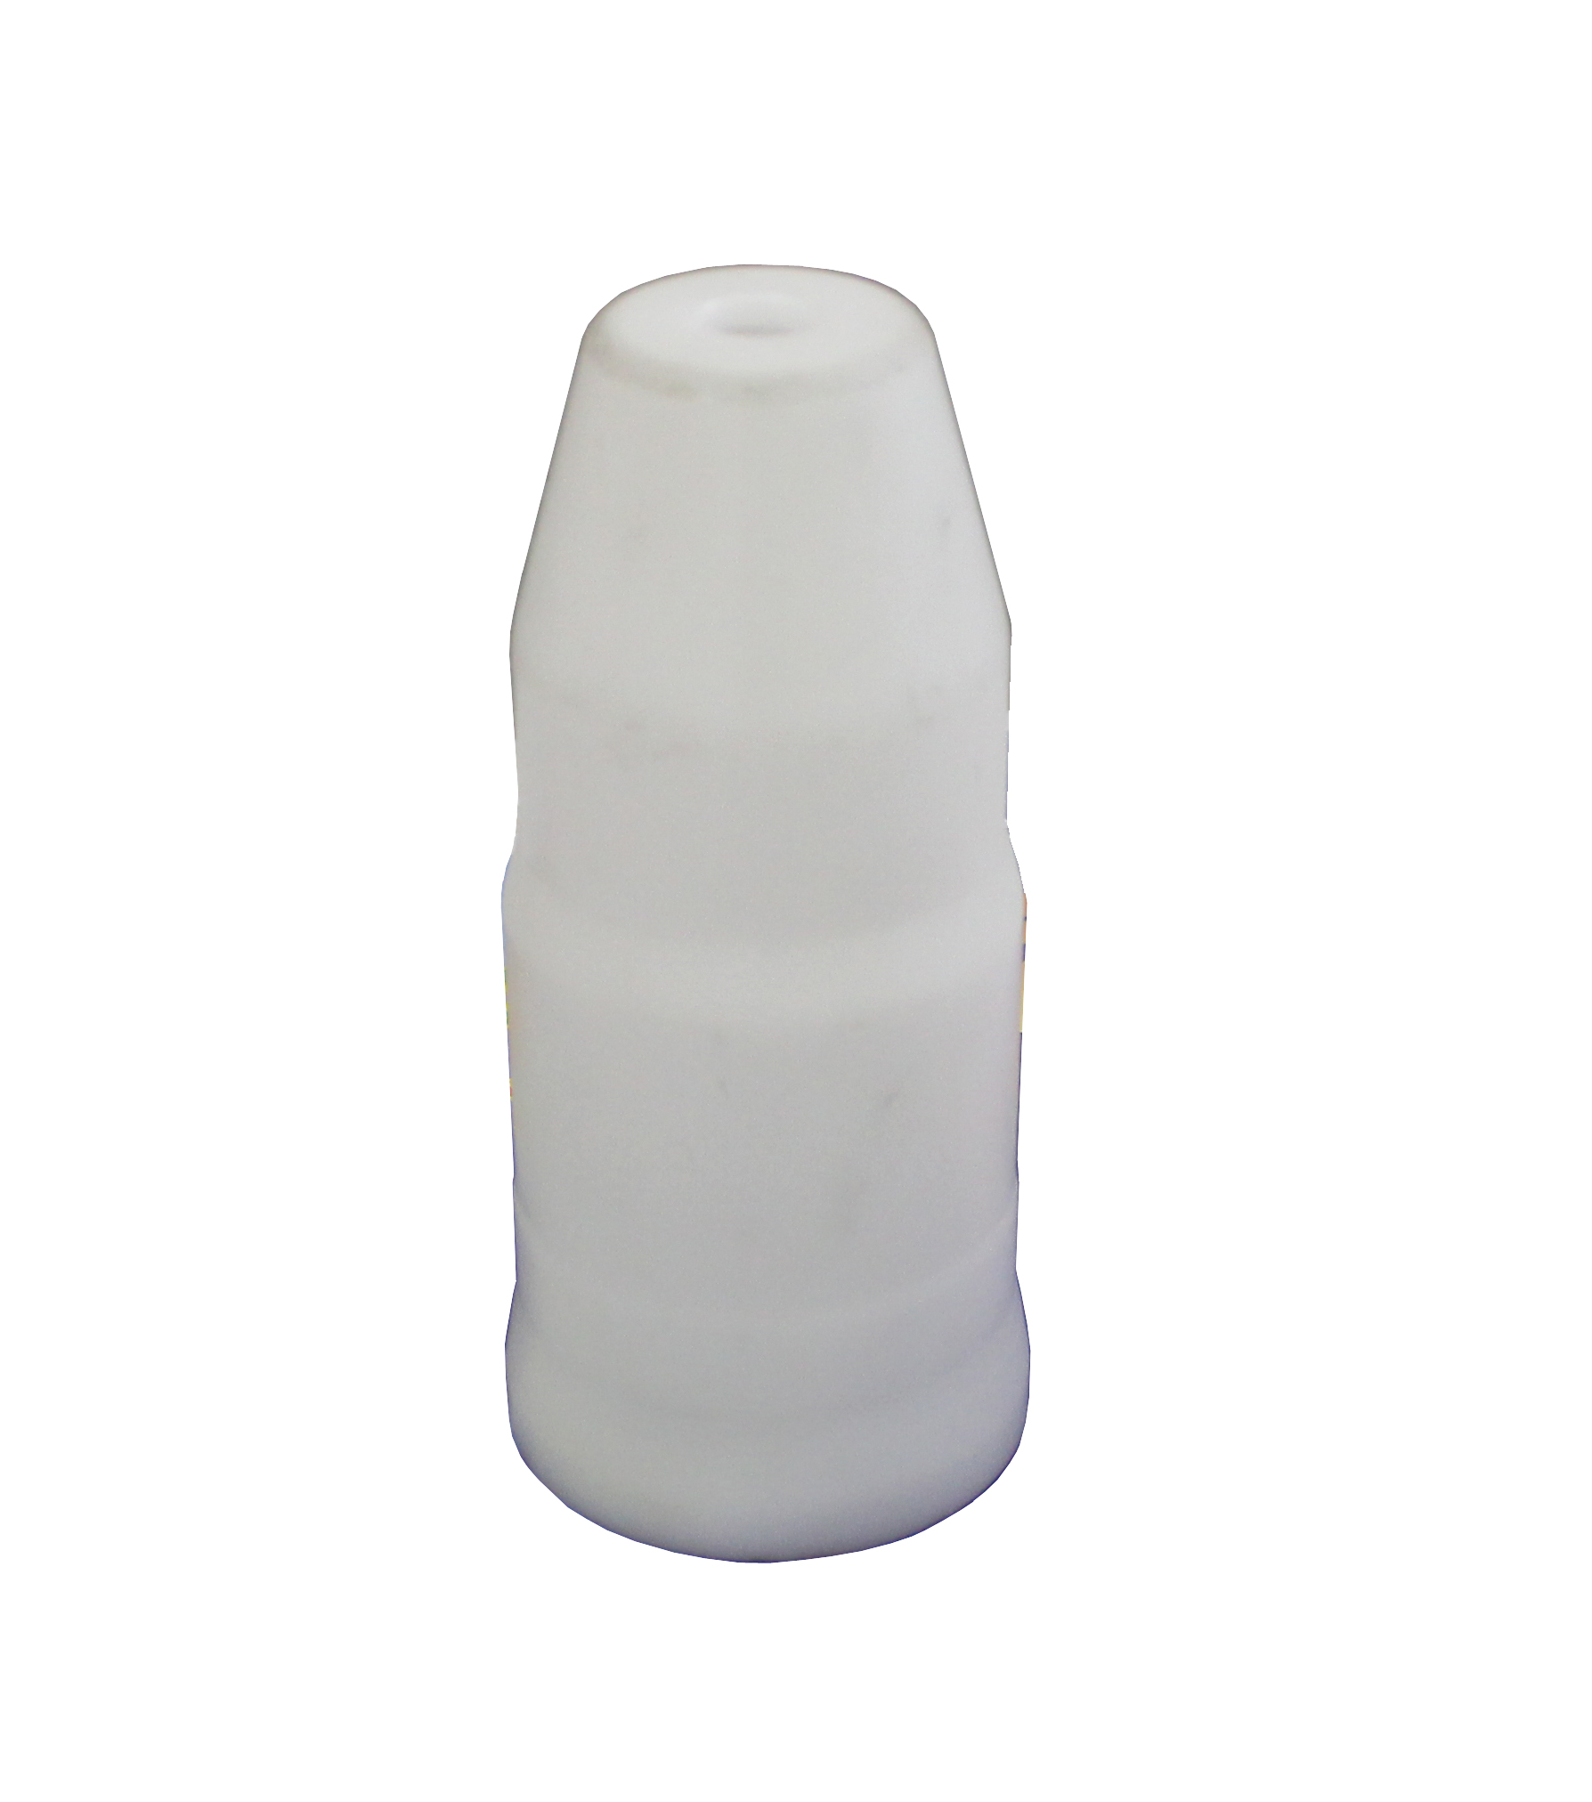

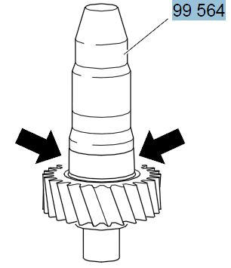
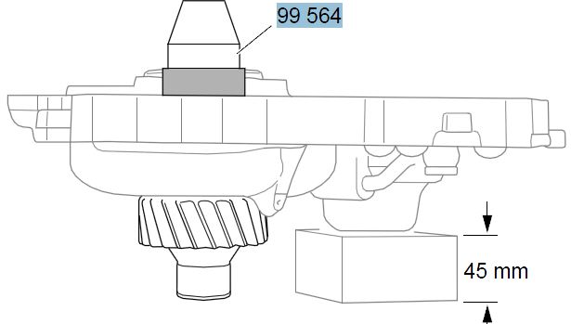

- Used as protection over rotor shaft to protect the sealing rings in the retarder housing for retarder 2..
- Applies to freewheeling retarder,this tool must be fitted tightly against the shaft, otherwise the seal may be damaged during installation.
- Application:
P, G, R, T series truck (2003- )
L, P, G, R, S series truck (2016- )
F, K, N series bus (2004- )

- OEM no.ref.: 99564

