
H.C.B-A6144
SCANIA HUB NUT SOCKET 119mm 6point , 1"
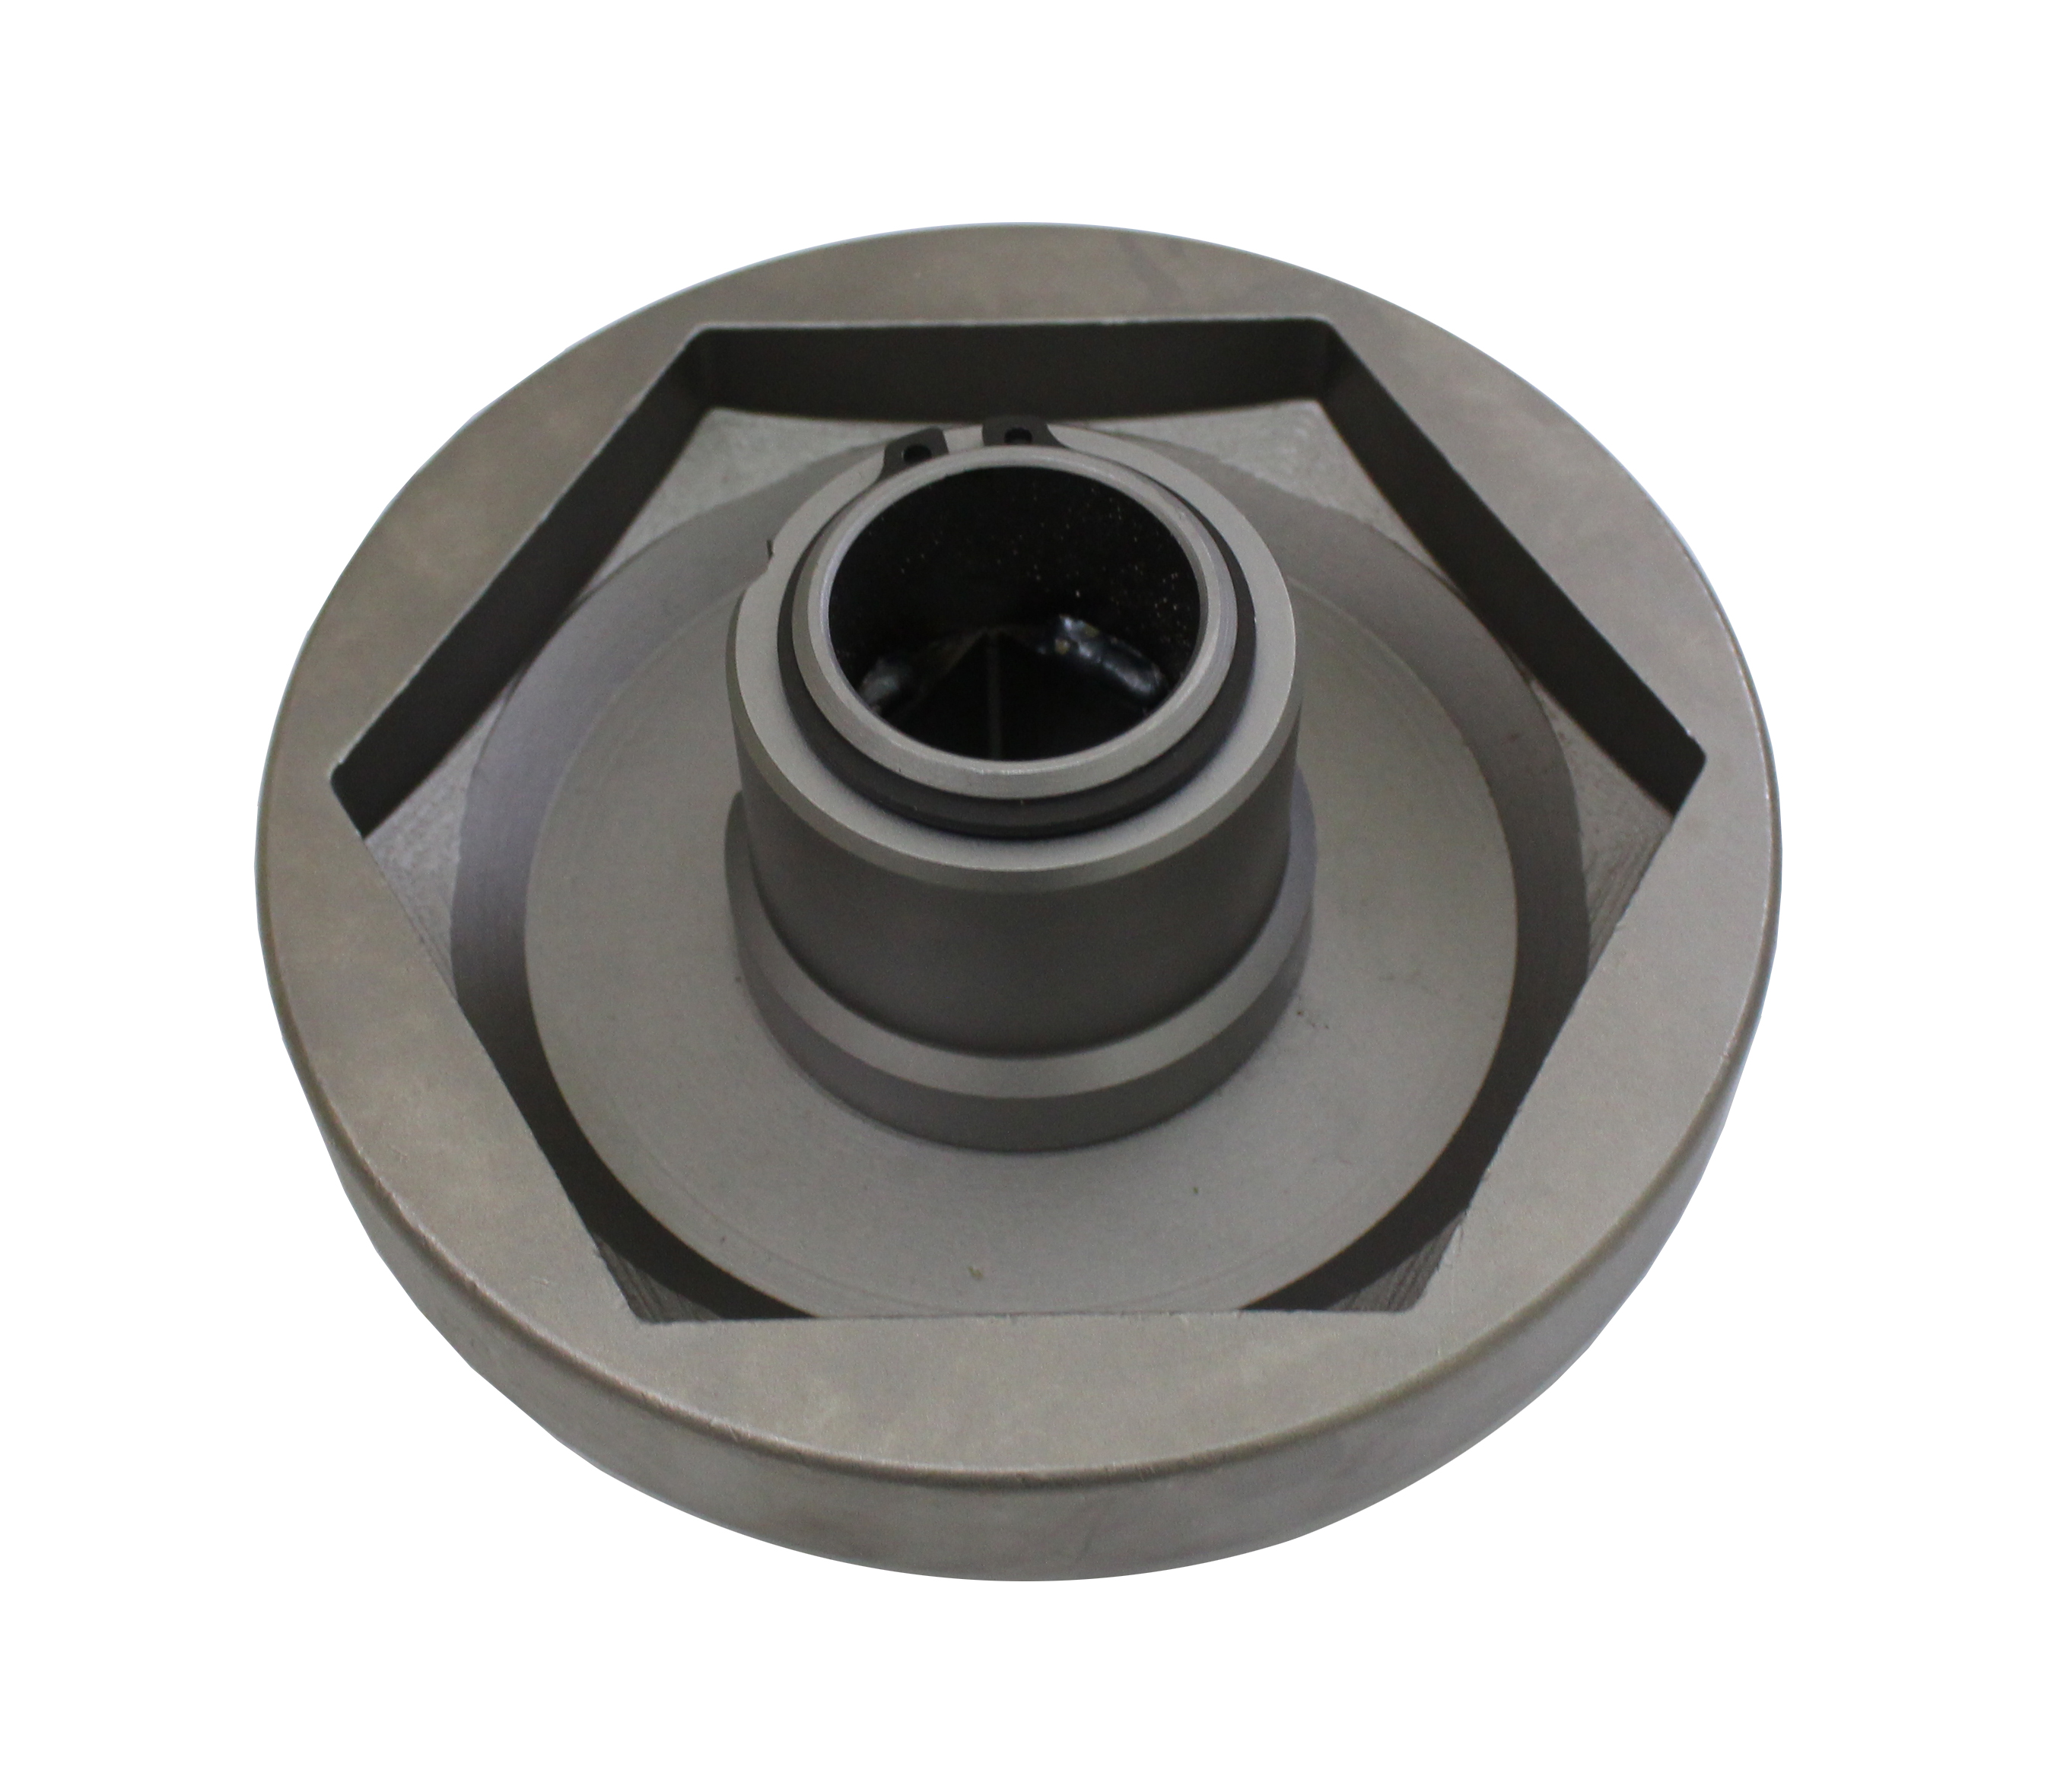

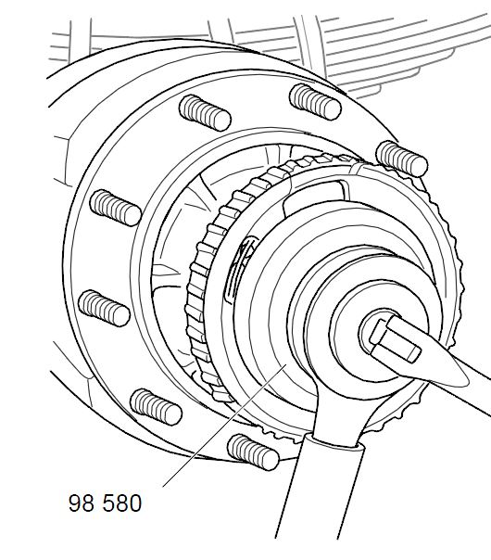

- Use for hub nut 119 mm, hexagon, rear wheel hub.

- Application:
4 series truck (1994-2008)
P, G, R, T series truck (2003- )
4 series bus (1994-2010)
F, K, N series bus (2004- )

- OEM no.ref.: 98580

