
H.C.B-A6142
SCANIA BEARING & SEALING RING
PRESS TOOL
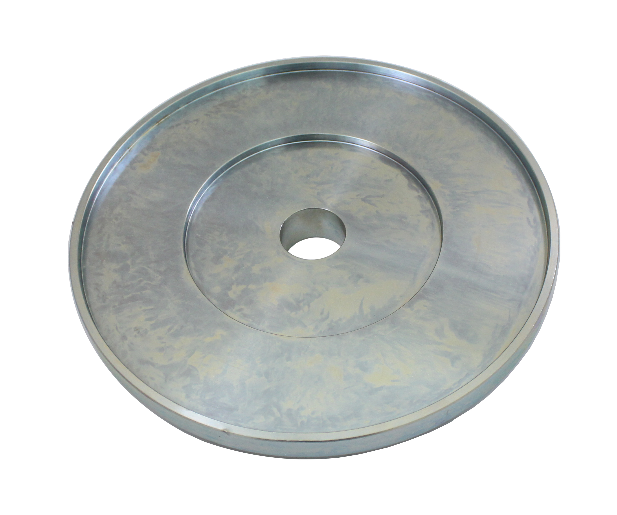

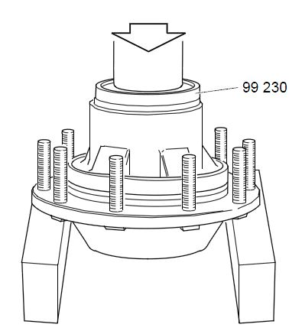

- Use for bearing and sealing ring in AD100 and AD1500 hubs. .
For pulse wheel in planetary gear for GR, GRS900R gearboxes, from chassis serial number:
Scania Södertälje 1 180 030.
Scania Netherlands 4 312 951.
- Application:

4 series truck (1994-2008)
P, G, R, T series truck (2003- )
L, P, G, R, S series truck (2016- )
4 series bus (1994-2010)
F, K, N series bus (2004- )

- OEM no.ref.: 99230

