
H.C.B-A6139

SCANIA SEALING ASSEMBLY TOOL
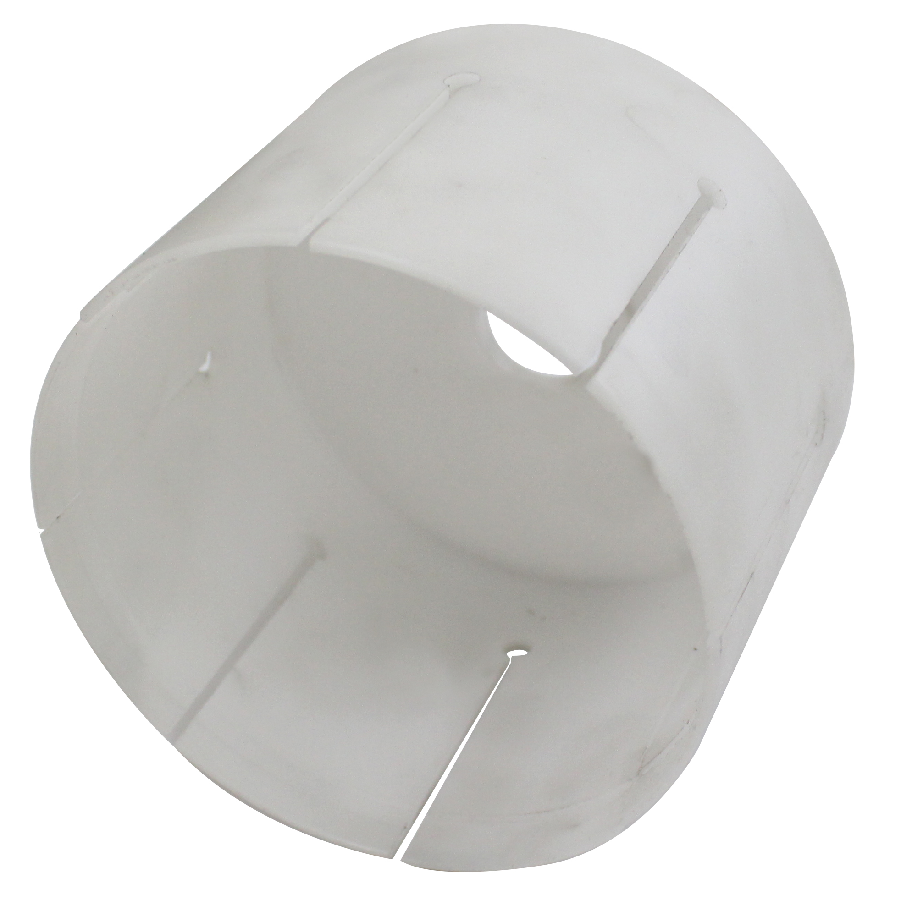

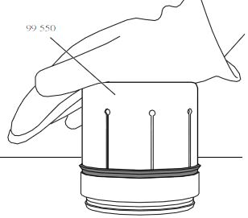

- Used for sealing ring for accumulator piston in retarder 2
- Application:

P, G, R, T series truck (2003- )
L, P, G, R, S series truck (2016- )
F, K, N series bus (2004- )

- OEM no.ref.: 99550

