
H.C.B-A6134
SCANIA PRESS TOOL

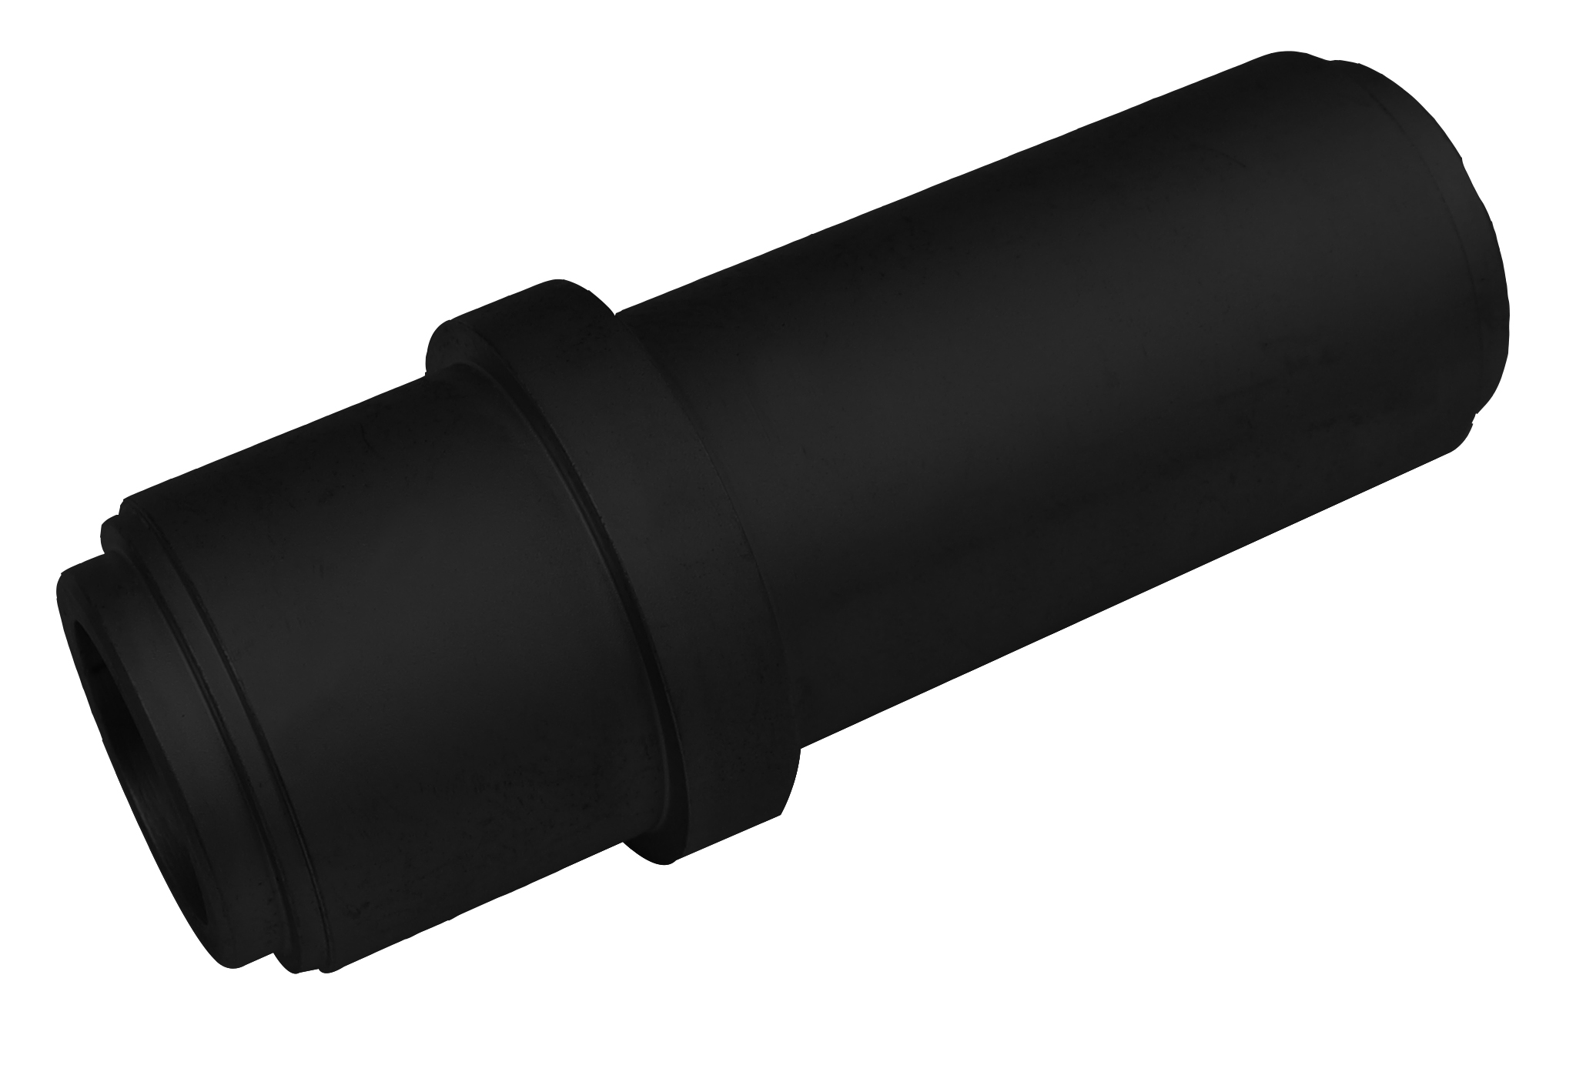

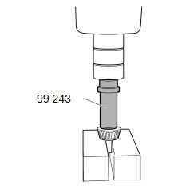

- Use for needle roller bearing in drive sleeve and power take-off shaft EK300/310, EK330/340.
- Application:
4 series truck (1994-2008)
P, G, R, T series truck (2003- )
L, P, G, R, S series truck (2016- )
F, K, N series bus (2004- )

- OEM no.ref.: 99243

