
H.C.B-A6126
DAF CF85 DPF (DIESEL PARTICULATE FILTER) PULLER

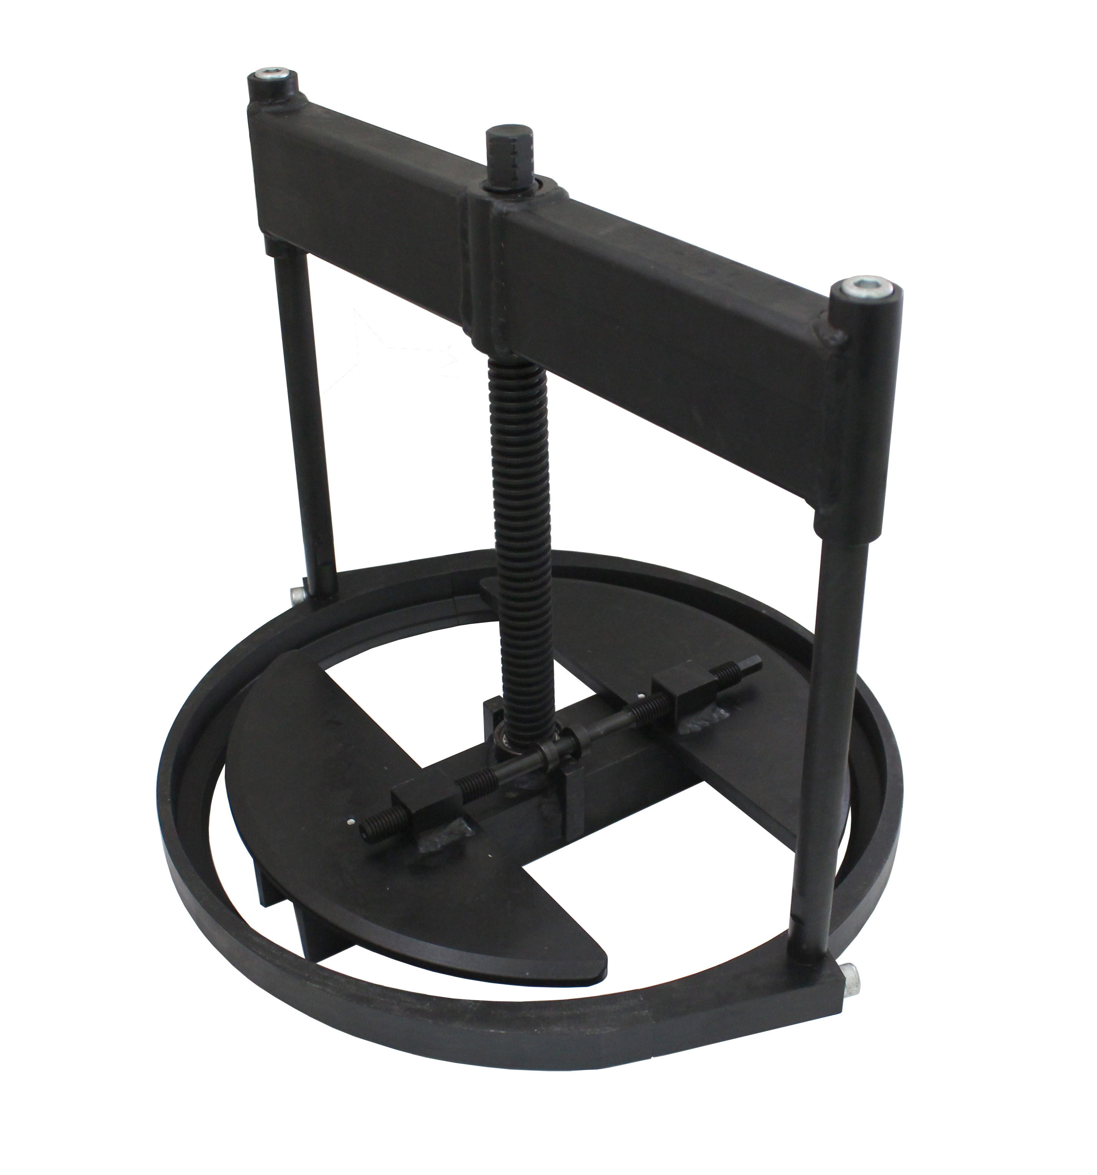

- Use for remove the diesel particulate filter

- Application: CF85/XF105

- Engine: MX13

- Save time & Labor

- OEM no.ref.: 2124327

