
H.C.B-A6124

SPL BEARTING CAP INSTALLER

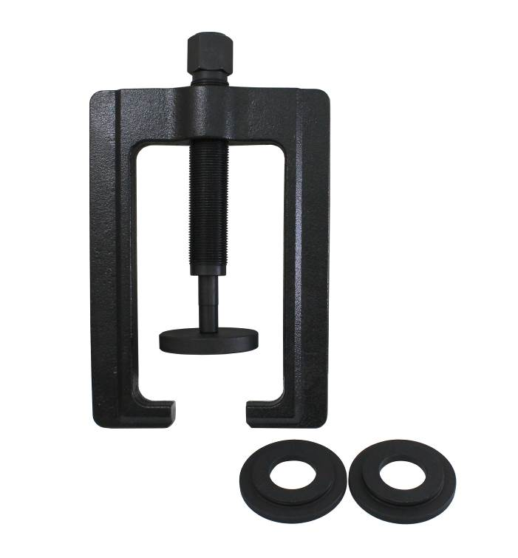

- Application :Commonly found on class 6-8 transportation trucks and equipment. (Kenworth, Peterbilt, Freightliner, Mack, Volvo etc.) • SPL 140, 170, 250 Series drivelines

- The SPL Bearing Cap Installer was designed to be as simple as possible. Pre-determined “installed heights” specified by the manufacturer have been engineered into the tool ensuring correct installation of bearing caps – every time.
- Manufactured from high-grade steel for strength and durability
- Color-coded adapters are included for servicing different driveline series
- Reduces the risk of damage to the driveshaft, yokes, and joints
- OEM ref: TIGER 10217

H.C.B-A6124

SPL BEARTING CAP INSTALLER

- Application :Commonly found on class 6-8 transportation trucks and equipment. (Kenworth, Peterbilt, Freightliner, Mack, Volvo etc.) • SPL 140, 170, 250 Series drivelines

- The SPL Bearing Cap Installer was designed to be as simple as possible. Pre-determined “installed heights” specified by the manufacturer have been engineered into the tool ensuring correct installation of bearing caps – every time.
- Manufactured from high-grade steel for strength and durability
- Color-coded adapters are included for servicing different driveline series
- Reduces the risk of damage to the driveshaft, yokes, and joints
- OEM ref: TIGER 10217

