
H.C.B-A6113
HEAVY DUTY YOKE PULLER

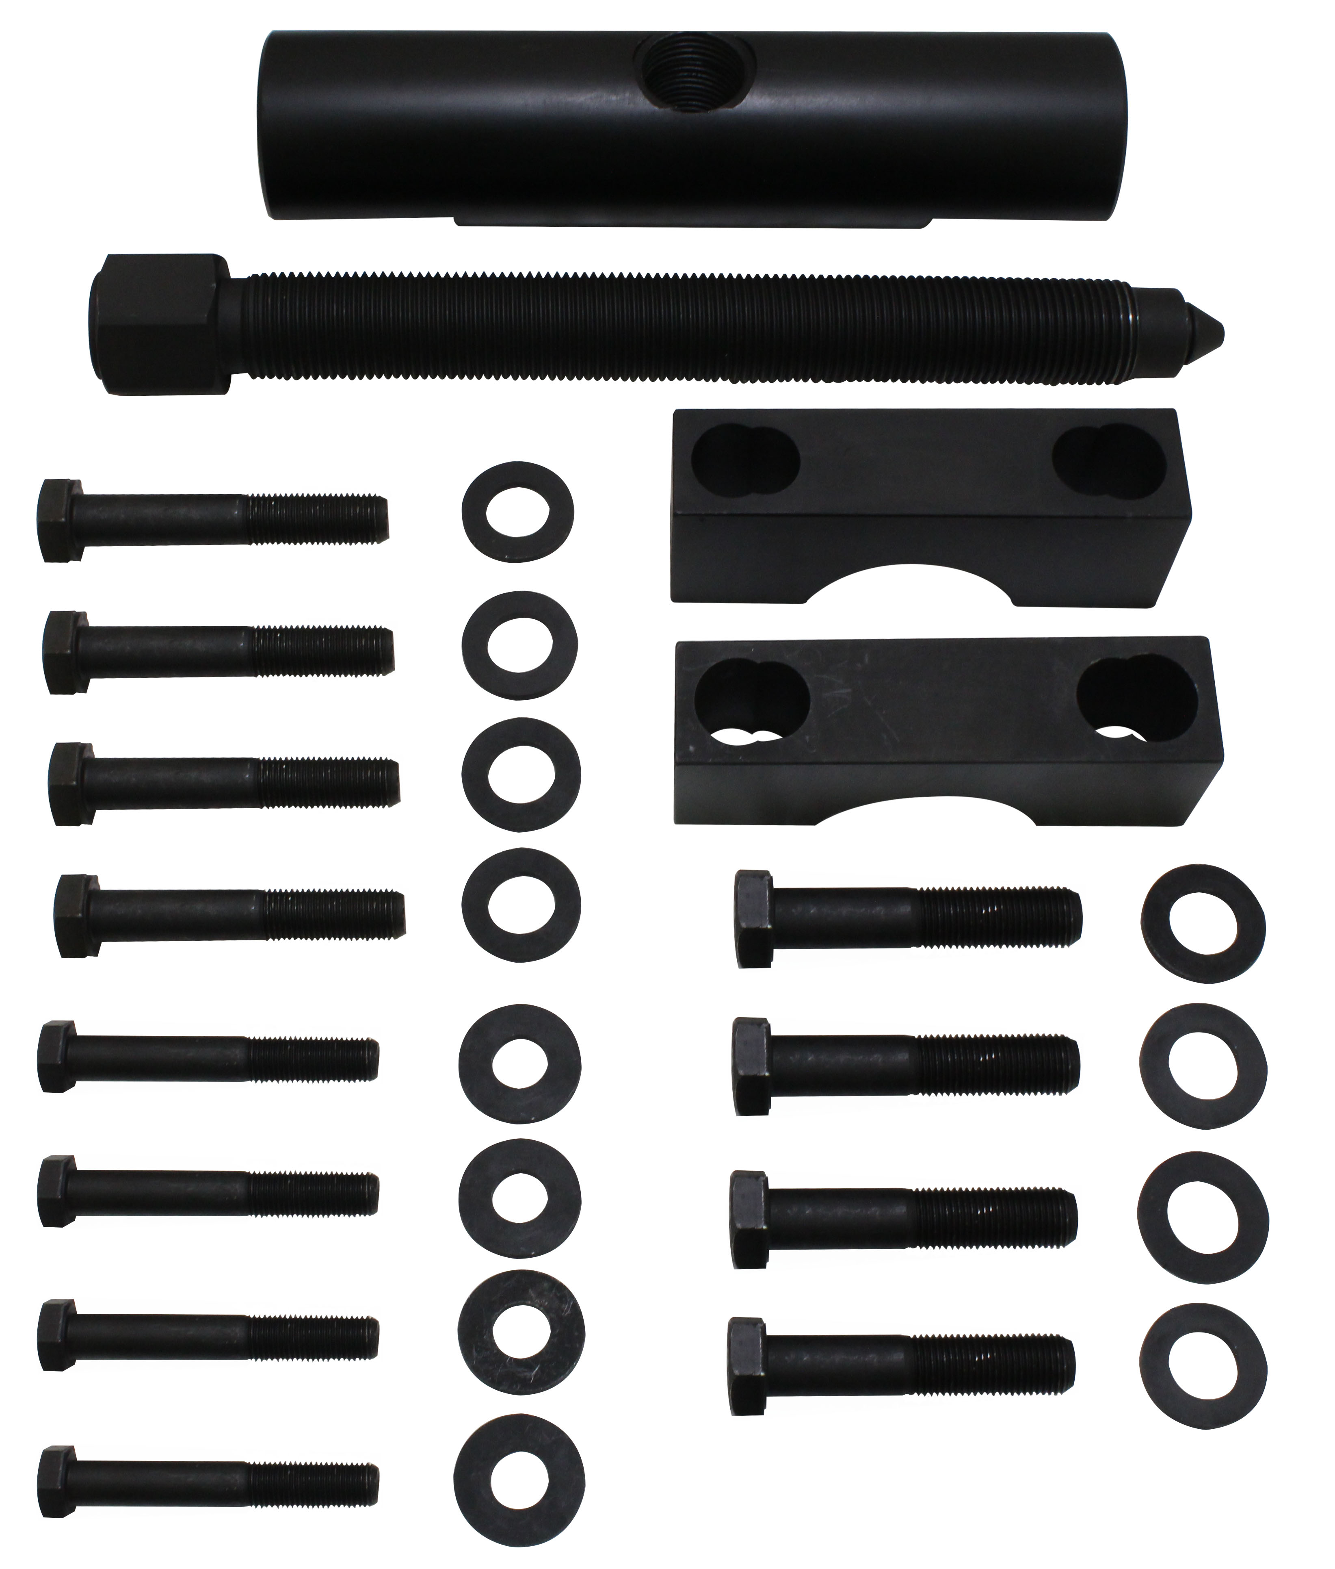

- DESCRIPTION
Simplifies and expedites the removal of heavy-duty yokes on drive shafts, transmissions and rear-end differentials without damage to yokes or other components.
- Manufactured from high-grade steel for strength and durability.
- Engineered for use with a 1″ impact tool.
- Generates over 25,000 lbs of pulling power.

- Application
- Yokes with a bearing diameter between 1 7/8″ and 2 3/16″.
- Spicer and Meritor 1610, 1710, 1760, 1810 series
- Spicer SPL 140, 170, 250 series
- Meritor (Rockwell) RPL 20 and 25 series.

