
H.C.B-A6112
BOLT-RETAINED BEARING
CUP INSTALLER
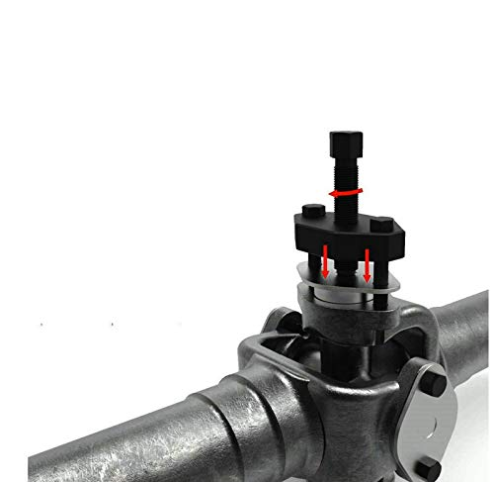

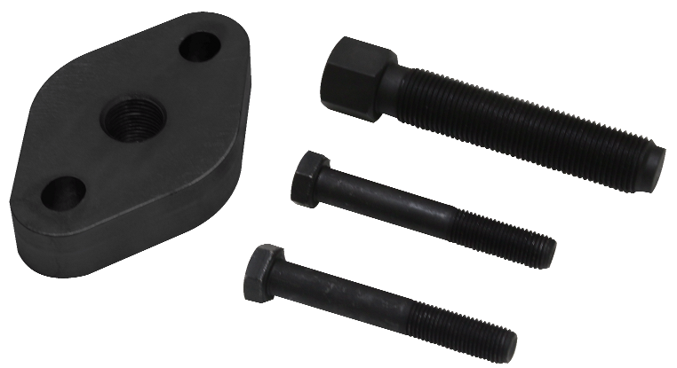

- Accurately install bolt-retained bearing caps in minutes.
- Accurately aligns bolt-retained bearing caps for easy installation
- Reduces the risk of damage to needle bearings
The outside guide bolts are designed to ensure the bolt-retained bearing cap is accurately aligned for installation. An impact or hand wrench is then applied to the forcing screw, installing the new bearing cap with ease and efficiency.
Installing the bearing cap without the use of a hammer eliminates frustrating dislocation of needle bearings, while also protecting surrounding vehicle components.
Application
• Commonly found on class 6-8 transportation trucks and equipment. (Kenworth, Peterbilt, Freightliner, Mack, Volvo etc.)
• Spicer 1610-1880 Series
- Features
Accurately aligns bolt retained bearing cups
Reduces the risk of damage to needle bearings during the installation process

H.C.B-A6112
BOLT-RETAINED BEARING
CUP INSTALLER

- Accurately install bolt-retained bearing caps in minutes.
- Accurately aligns bolt-retained bearing caps for easy installation
- Reduces the risk of damage to needle bearings
The outside guide bolts are designed to ensure the bolt-retained bearing cap is accurately aligned for installation. An impact or hand wrench is then applied to the forcing screw, installing the new bearing cap with ease and efficiency.
Installing the bearing cap without the use of a hammer eliminates frustrating dislocation of needle bearings, while also protecting surrounding vehicle components.
Application
• Commonly found on class 6-8 transportation trucks and equipment. (Kenworth, Peterbilt, Freightliner, Mack, Volvo etc.)
• Spicer 1610-1880 Series
- Features
Accurately aligns bolt retained bearing cups
Reduces the risk of damage to needle bearings during the installation process

