
H.C.B-A6074
MERCEDES BENZ ACTORS SEAL INSTALLATION TOOL SET
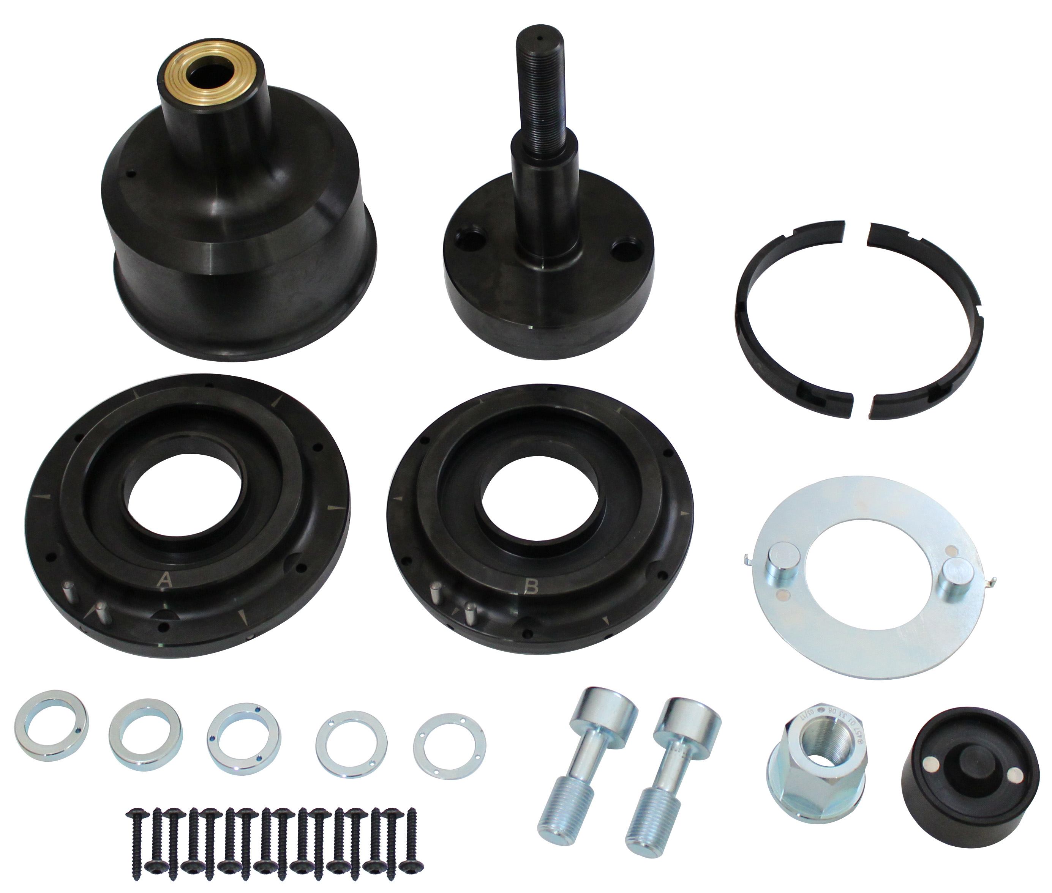

- Pull-out tool for removing radial shaft sealing ring or removing/installing the shaft sealing ring on the front crankshaft..
- Application: 457, 458, 460, 470, 471, 472, 473, 541, 542,930,932,934 941, 942 engine.

- OEM no. ref.: 457 589 01 33 00

- Only in combination with H.C.B-A6073(W 700 589 08 43 00) device

