
H.C.B-A6073
MERCEDEZ-BENZ ACTORS SEAL REMOVAL TOOL SET

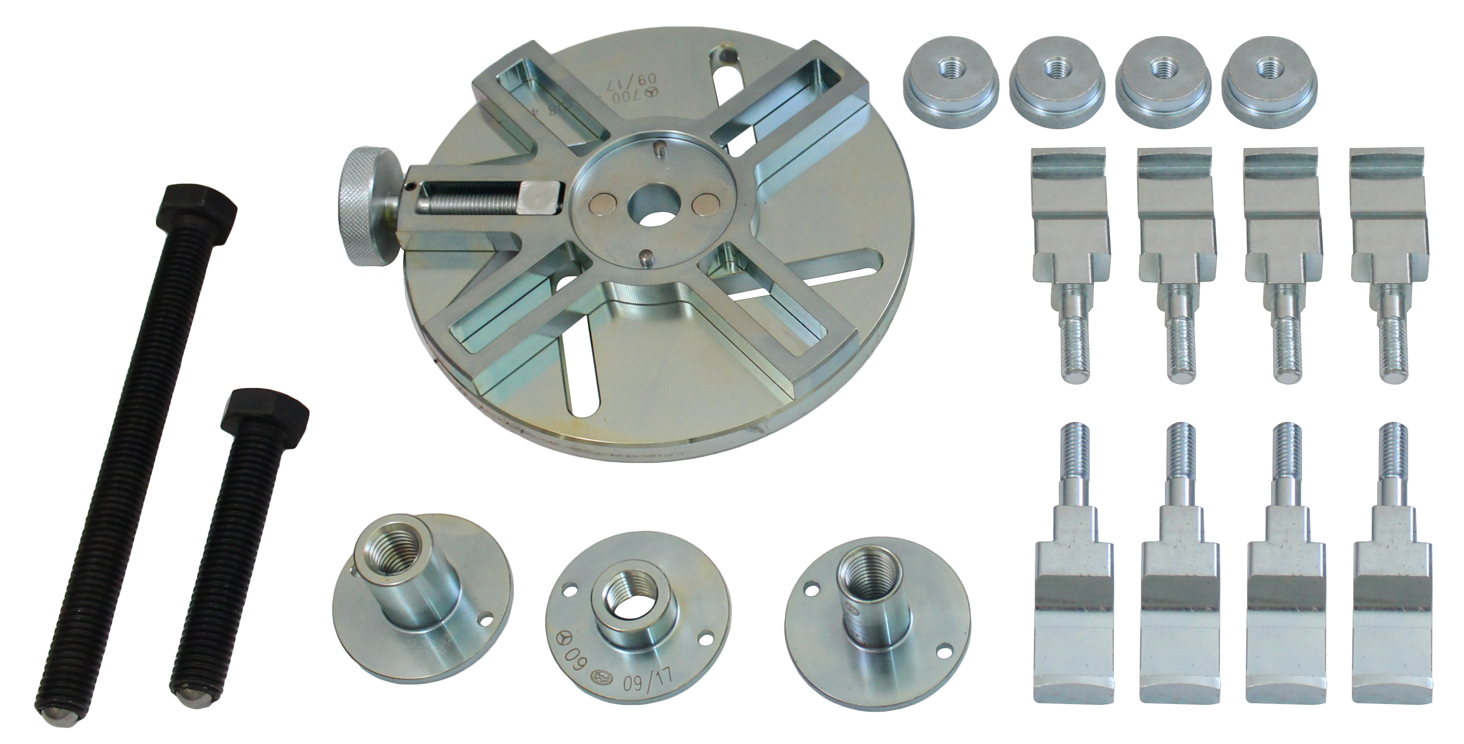

- Extraction and insertion tool to remove the radial shaft sealing ring or cassette-type sealing ring on the crankshaft at the front..

- Application: 457, 458, 460, 470, 471, 472, 473, 541, 542,930,932,934 941, 942 engine.

- OEM no. ref.: 700 589 08 43 00

- Only in combination with H.C.B-A6074(W 457 589 01 33 00) pulling out device .

