
H.C.B-A6071

SCANIA GEARBOX CUNTERHOLD

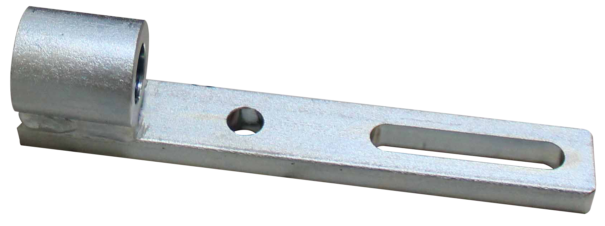

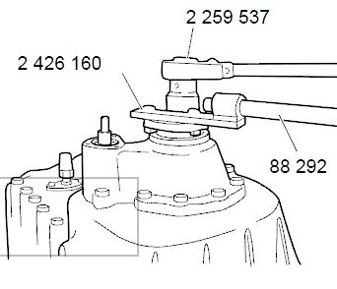

- For propeller shaft flanges and end yokes, all manual gearboxes, GA762 and all R/RB/RBP.
- Application:

P, G, R, T series truck (2003- ) L,
P, G, R, S series truck (2016- )
F, K, N series bus (2004- )

- OEM no.ref.: 2426160

