
H.C.B-A6070

SCANIA GEARBOX PULL ROD
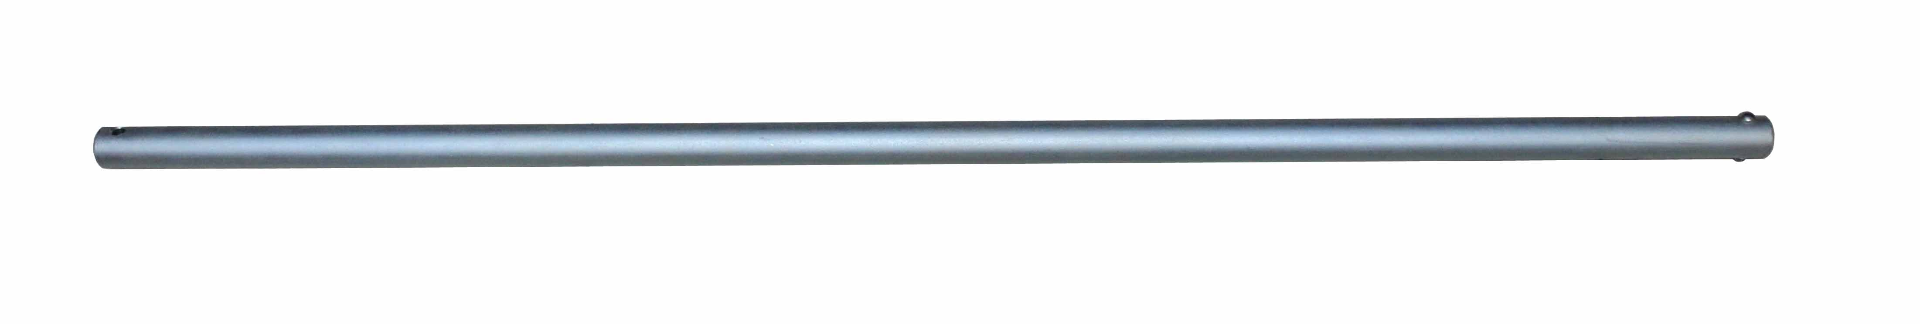
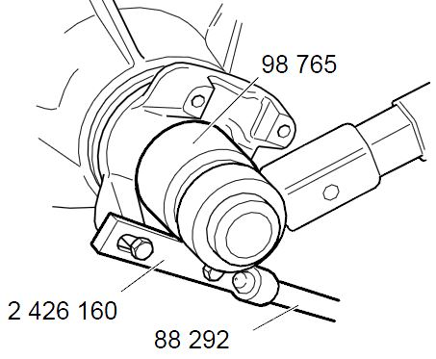

- The tools was developed for e.g.87 253 Counterhold or 2 426 160 Counterhold, all GPRT manual gearboxes and all R/RB/RBP.
- Application:
3 series truck (1987-1996)
4 series truck (1994-2008)
P, G, R, T series truck (2003- ) L, P, G, R, S series truck (2016- ) 3 series bus (1987-1999)
4 series bus (1994-2010)
F, K, N series bus (2004- )

- OEM no.ref.: 88292

