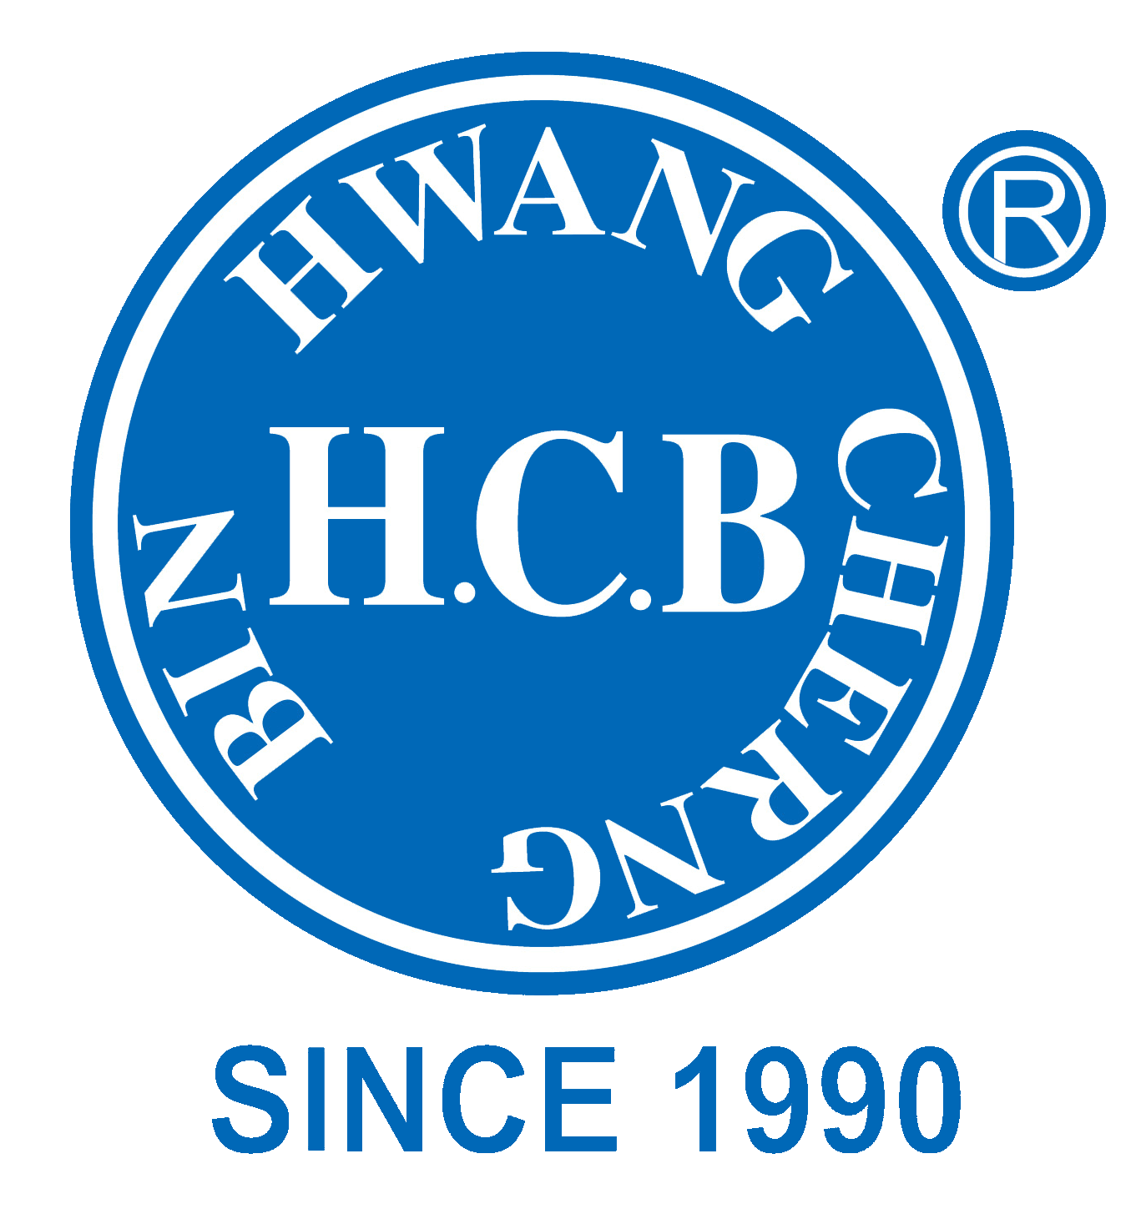
H.C.B-A6069

SCANIA TRANSMISSION SUPPORT DRIFT

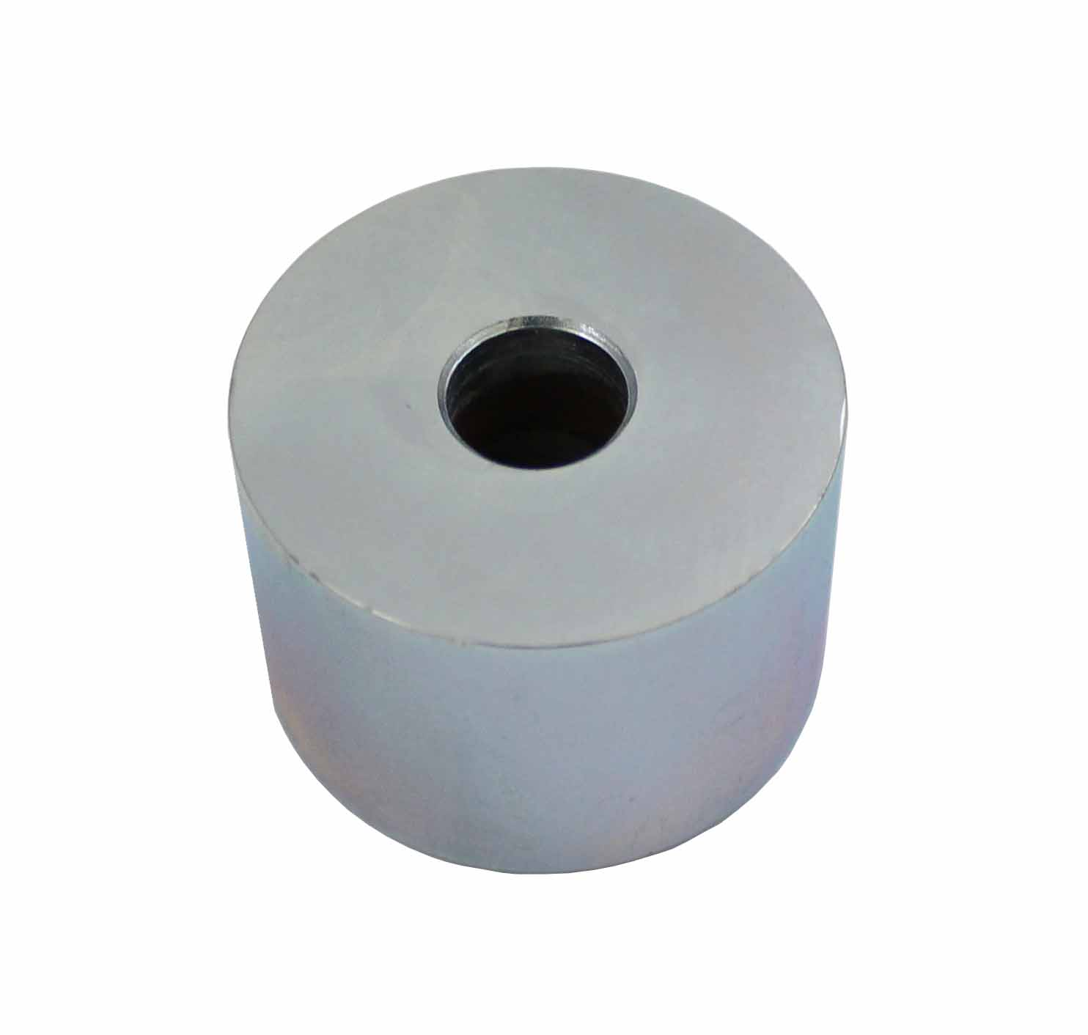

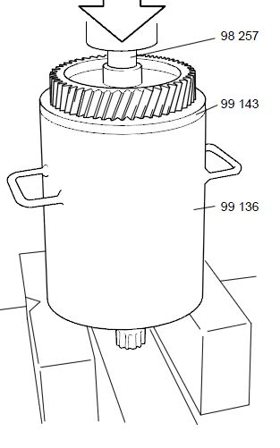

- The tools was developed for removal of the sun wheel and ball bearing in G/GS770, 771 and GR871 and pressing off the roller bearing, AM56, AM61. For use together with 2 588 006 Puller, 3 arm, 20- 150 mm.

- Application:
3 series truck (1987-1996)
4 series truck (1994-2008)
P, G, R, T series truck (2003- ) L, P, G, R, S series truck (2016- ) 4 series bus (1994-2010)
P96 (1996- )

- OEM no.ref.: 98257

