
H.C.B-A6068

SCANIA TRANSMISSION SUPPORT DRIFT
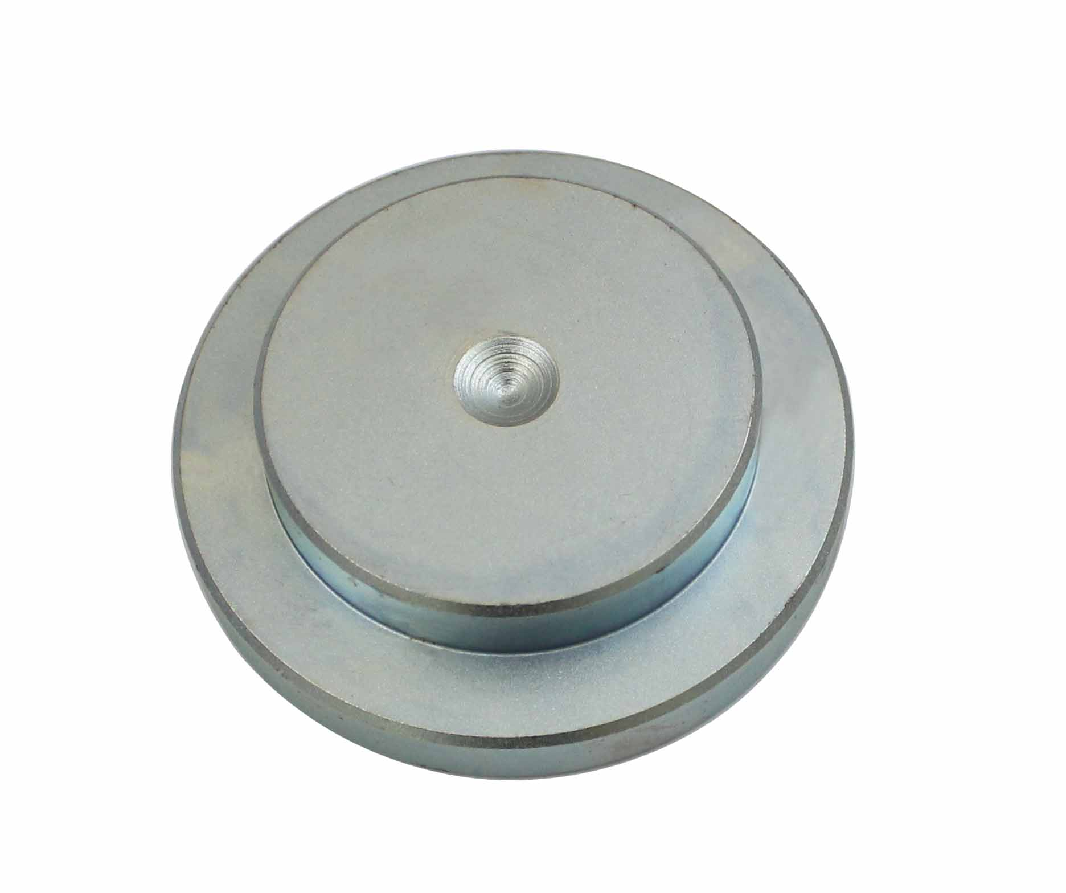

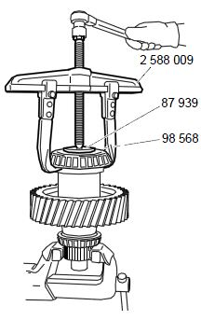

- The tools was developed for 98 567 Puller for differential housing bearing in RP/RBP830. Also for the pressing in of sealing ring, AM56, AM61 and AMD105.

- Application:
3 series truck (1987-1996)
4 series truck (1994-2008)
P, G, R, T series truck (2003- ) L, P, G, R, S series truck (2016- ) 3 series bus (1987-1999)
4 series bus (1994-2010)
F, K, N series bus (2004- )

- OEM no.ref.: 98568

