
H.C.B-A6067

SCANIA GUIDE PIN FOR CLUTCH ASSEMBLY

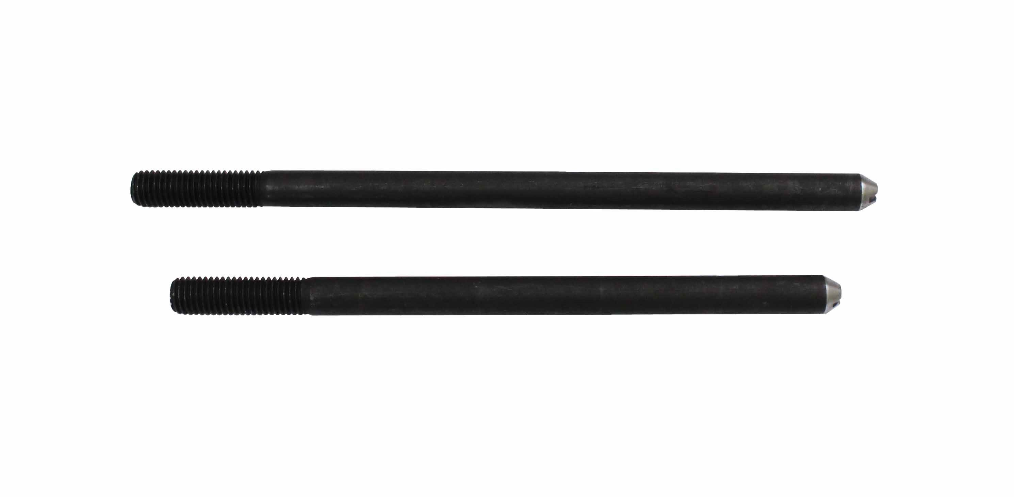

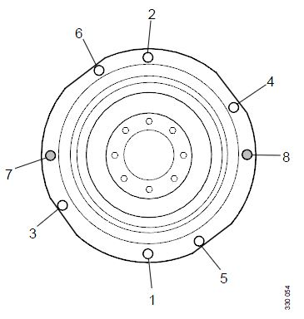

- The tools was developed for clutch assembly
- Fit 98 747 Guide pins for clutch assembly, M10 in holes 7 and 8.
- Application:
3 series truck (1987-1996)
4 series truck (1994-2008)
P, G, R, T series truck (2003- ) L, P, G, R, S series truck (2016- ) 4 series bus (1994-2010)
F, K, N series bus (2004- ) E2011 (2010- )

- OEM no.ref.: 98747

