
H.C.B-A6064

SCANIA TRANSMISSION LIFTING TOOL
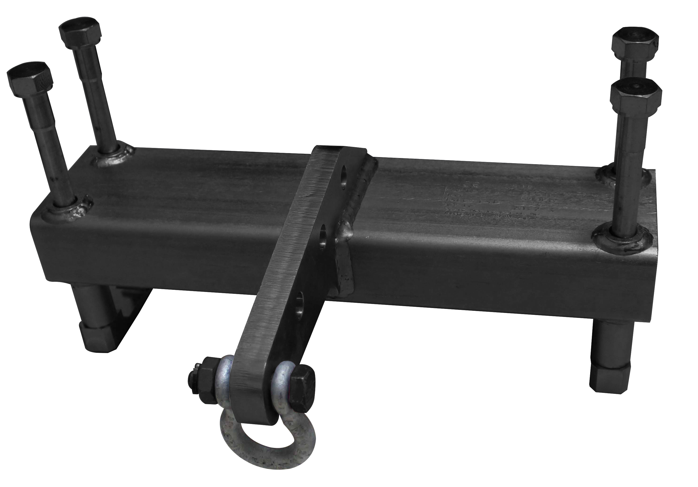

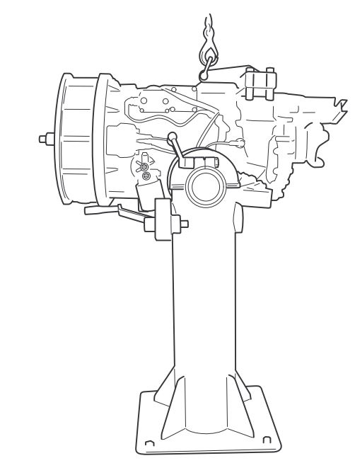
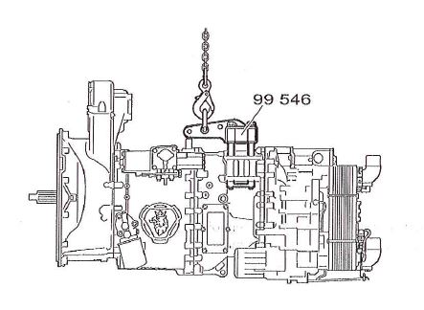

- The tools was developed exclusively for use hen lifting SCANIA transmissions.
- The tool is designed in such a way that it can be lifted safely and in accordance with regulations.
- For the safe and correct use of the tool, see the job description in the SCANIA service manual before starting work
Use restrictions:
Before use, the tool must be checked for damage. Review cracks
The tool should be used only by persons with good lifting knowledge.
  - The tool may only be used with the original parts supplied.
  - The 99546 is to be mounted on the gear unit with 4 screws and throws in accordance with the assembly and disassembly description below. tighten with the required torque
  - Mount the 99546 by tightening the screws in the couplings so that the gear is clamped between the risers and the underside of the rectangular tube of the hoist, see figure below. Before lifting, make sure that the screws are properly attached; dismantling is done in the reverse order
- OEM no.ref.: 99546
- Maximum load capacity 600kg

