
H.C.B-A6038
DURAMAX DIESEL 6.6L FRONT CRANKSHAFT SEAL INSTALLER TOOL

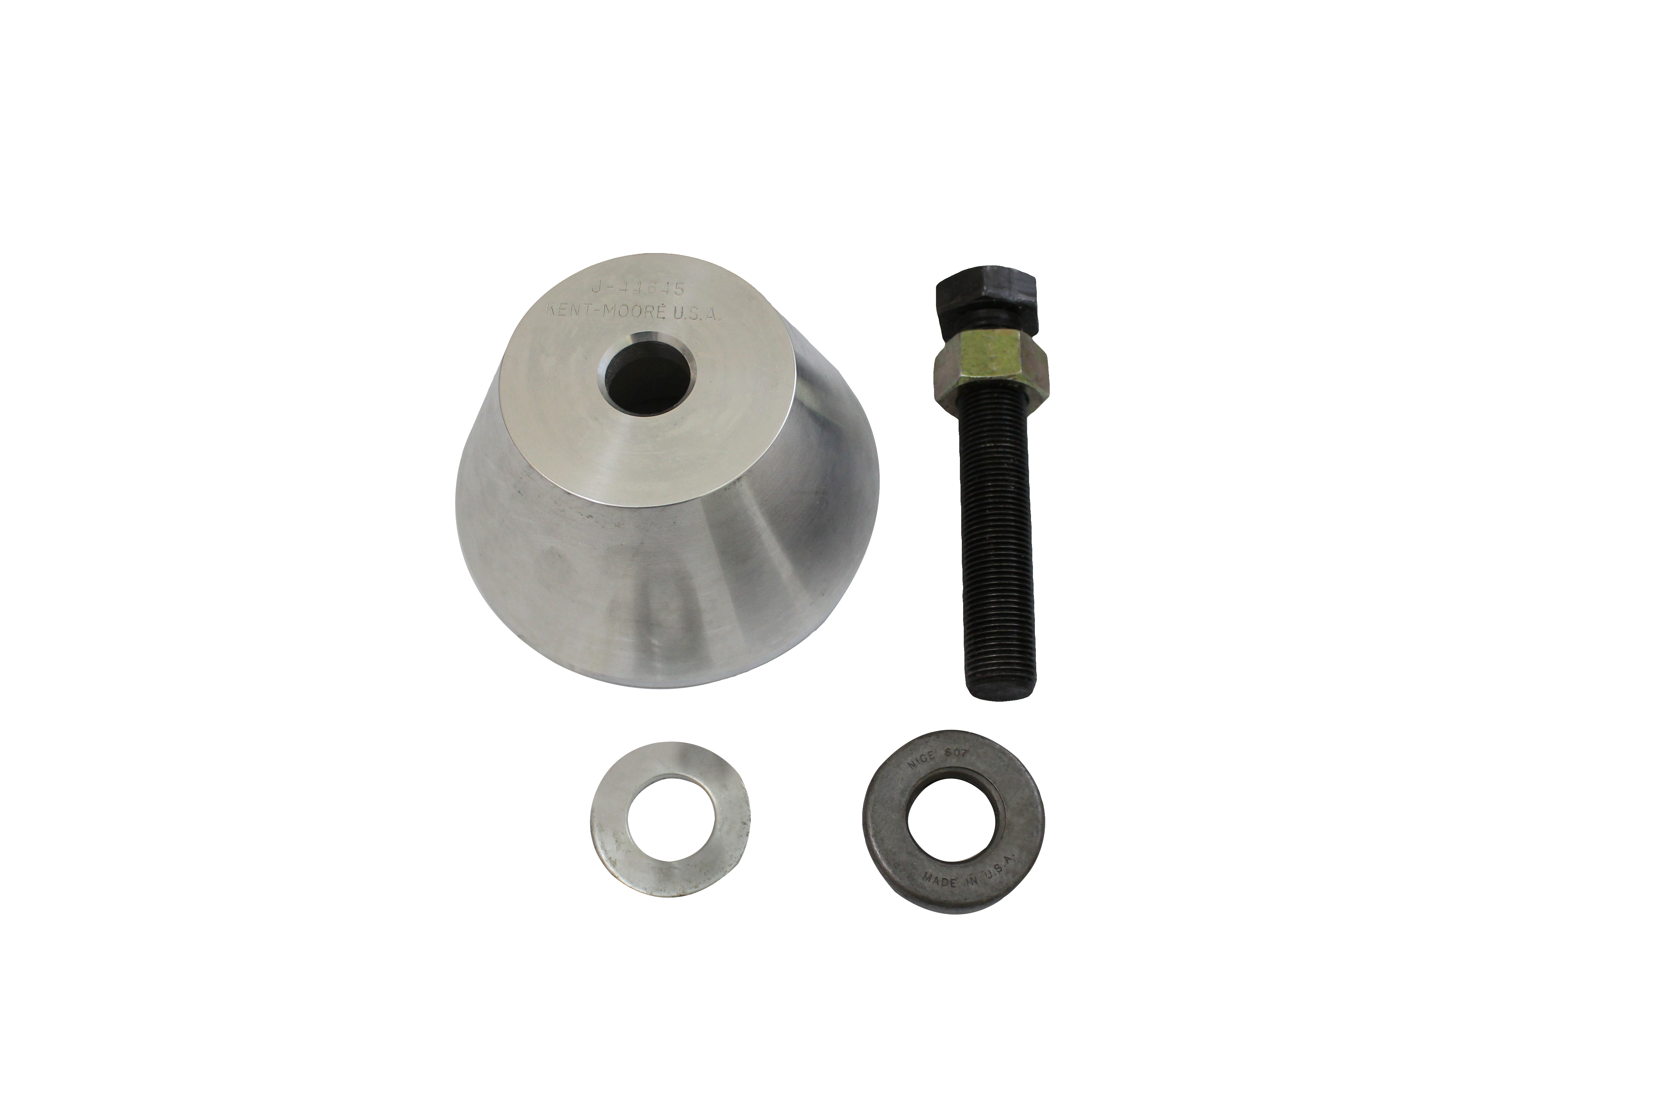

- Application: ISUZU 6.6L Duramax
2001-Later GMT800, 2500HD, 3500 with 6.6 liter Duramax diesel engine The crankshaft front seal is fitted to both the engine block and crankshaft. Fit of the inner and outer seal bodies is critical and any misalignment can result in leakage. H.C.B-A6038 is designed to install the seal to correct depth and alignment. Place the seal onto the end of the crankshaft. Screw H.C.B-A6038 into the end of the crankshaft. Turn the forcing screw so the body of the tool can push on seal until it bottoms in the block.

- OEM no.ref.:J-44645

