
H.C.B-A6033
VOLVO/DAF TRANSMISSION COMPANION FLANGE REMOVAL / INSTALLATION TOOL KIT
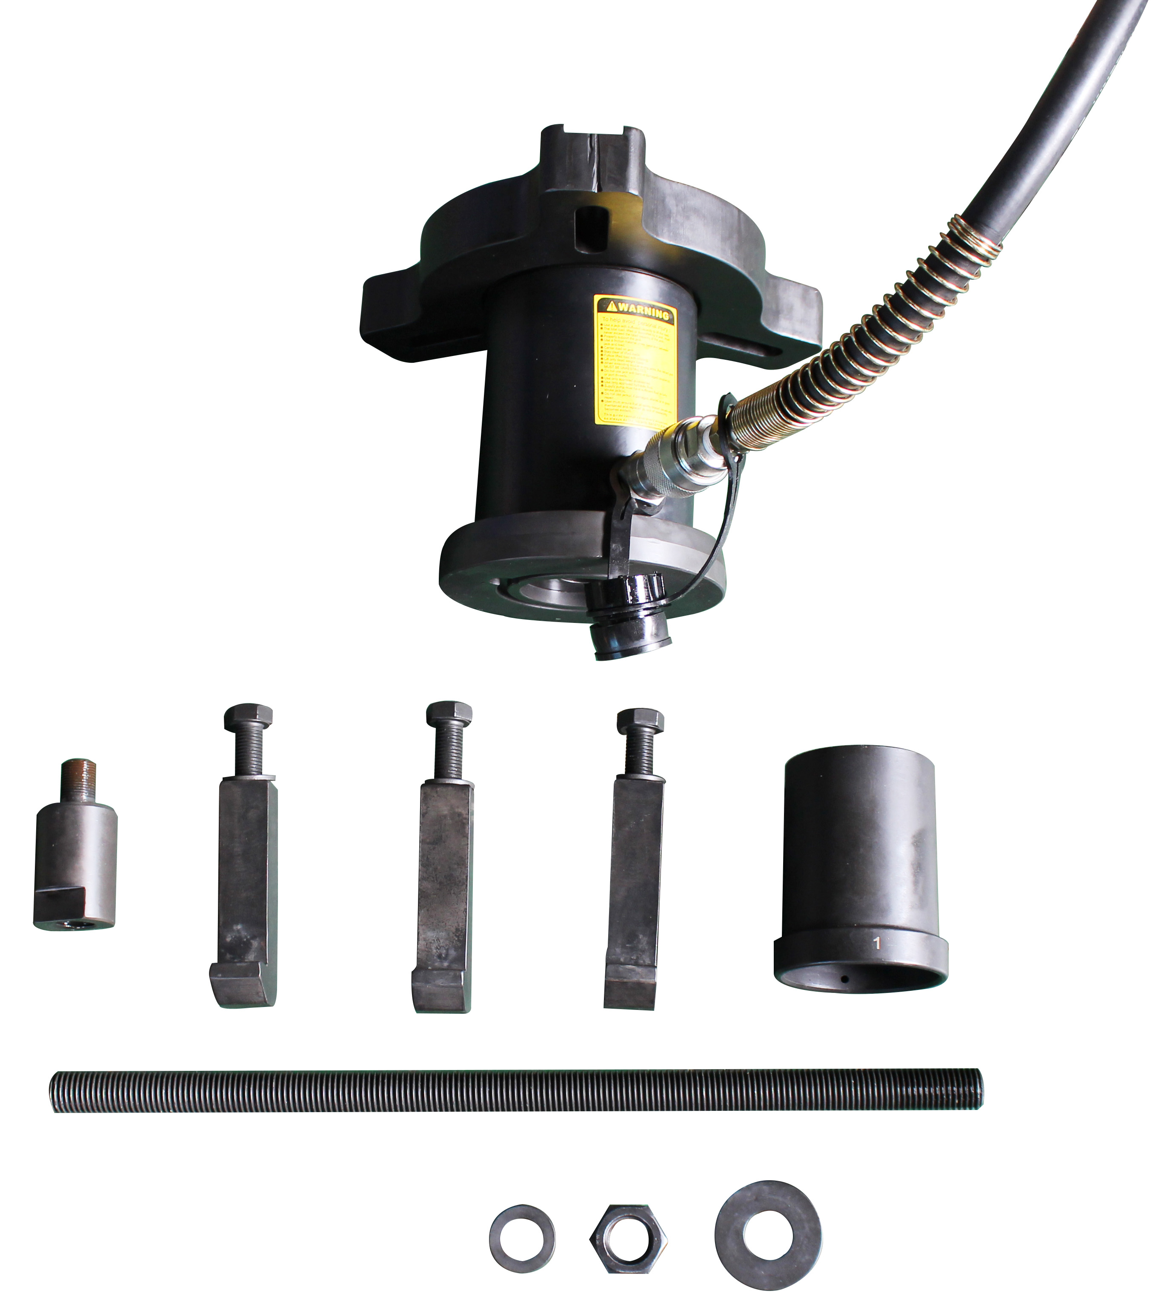

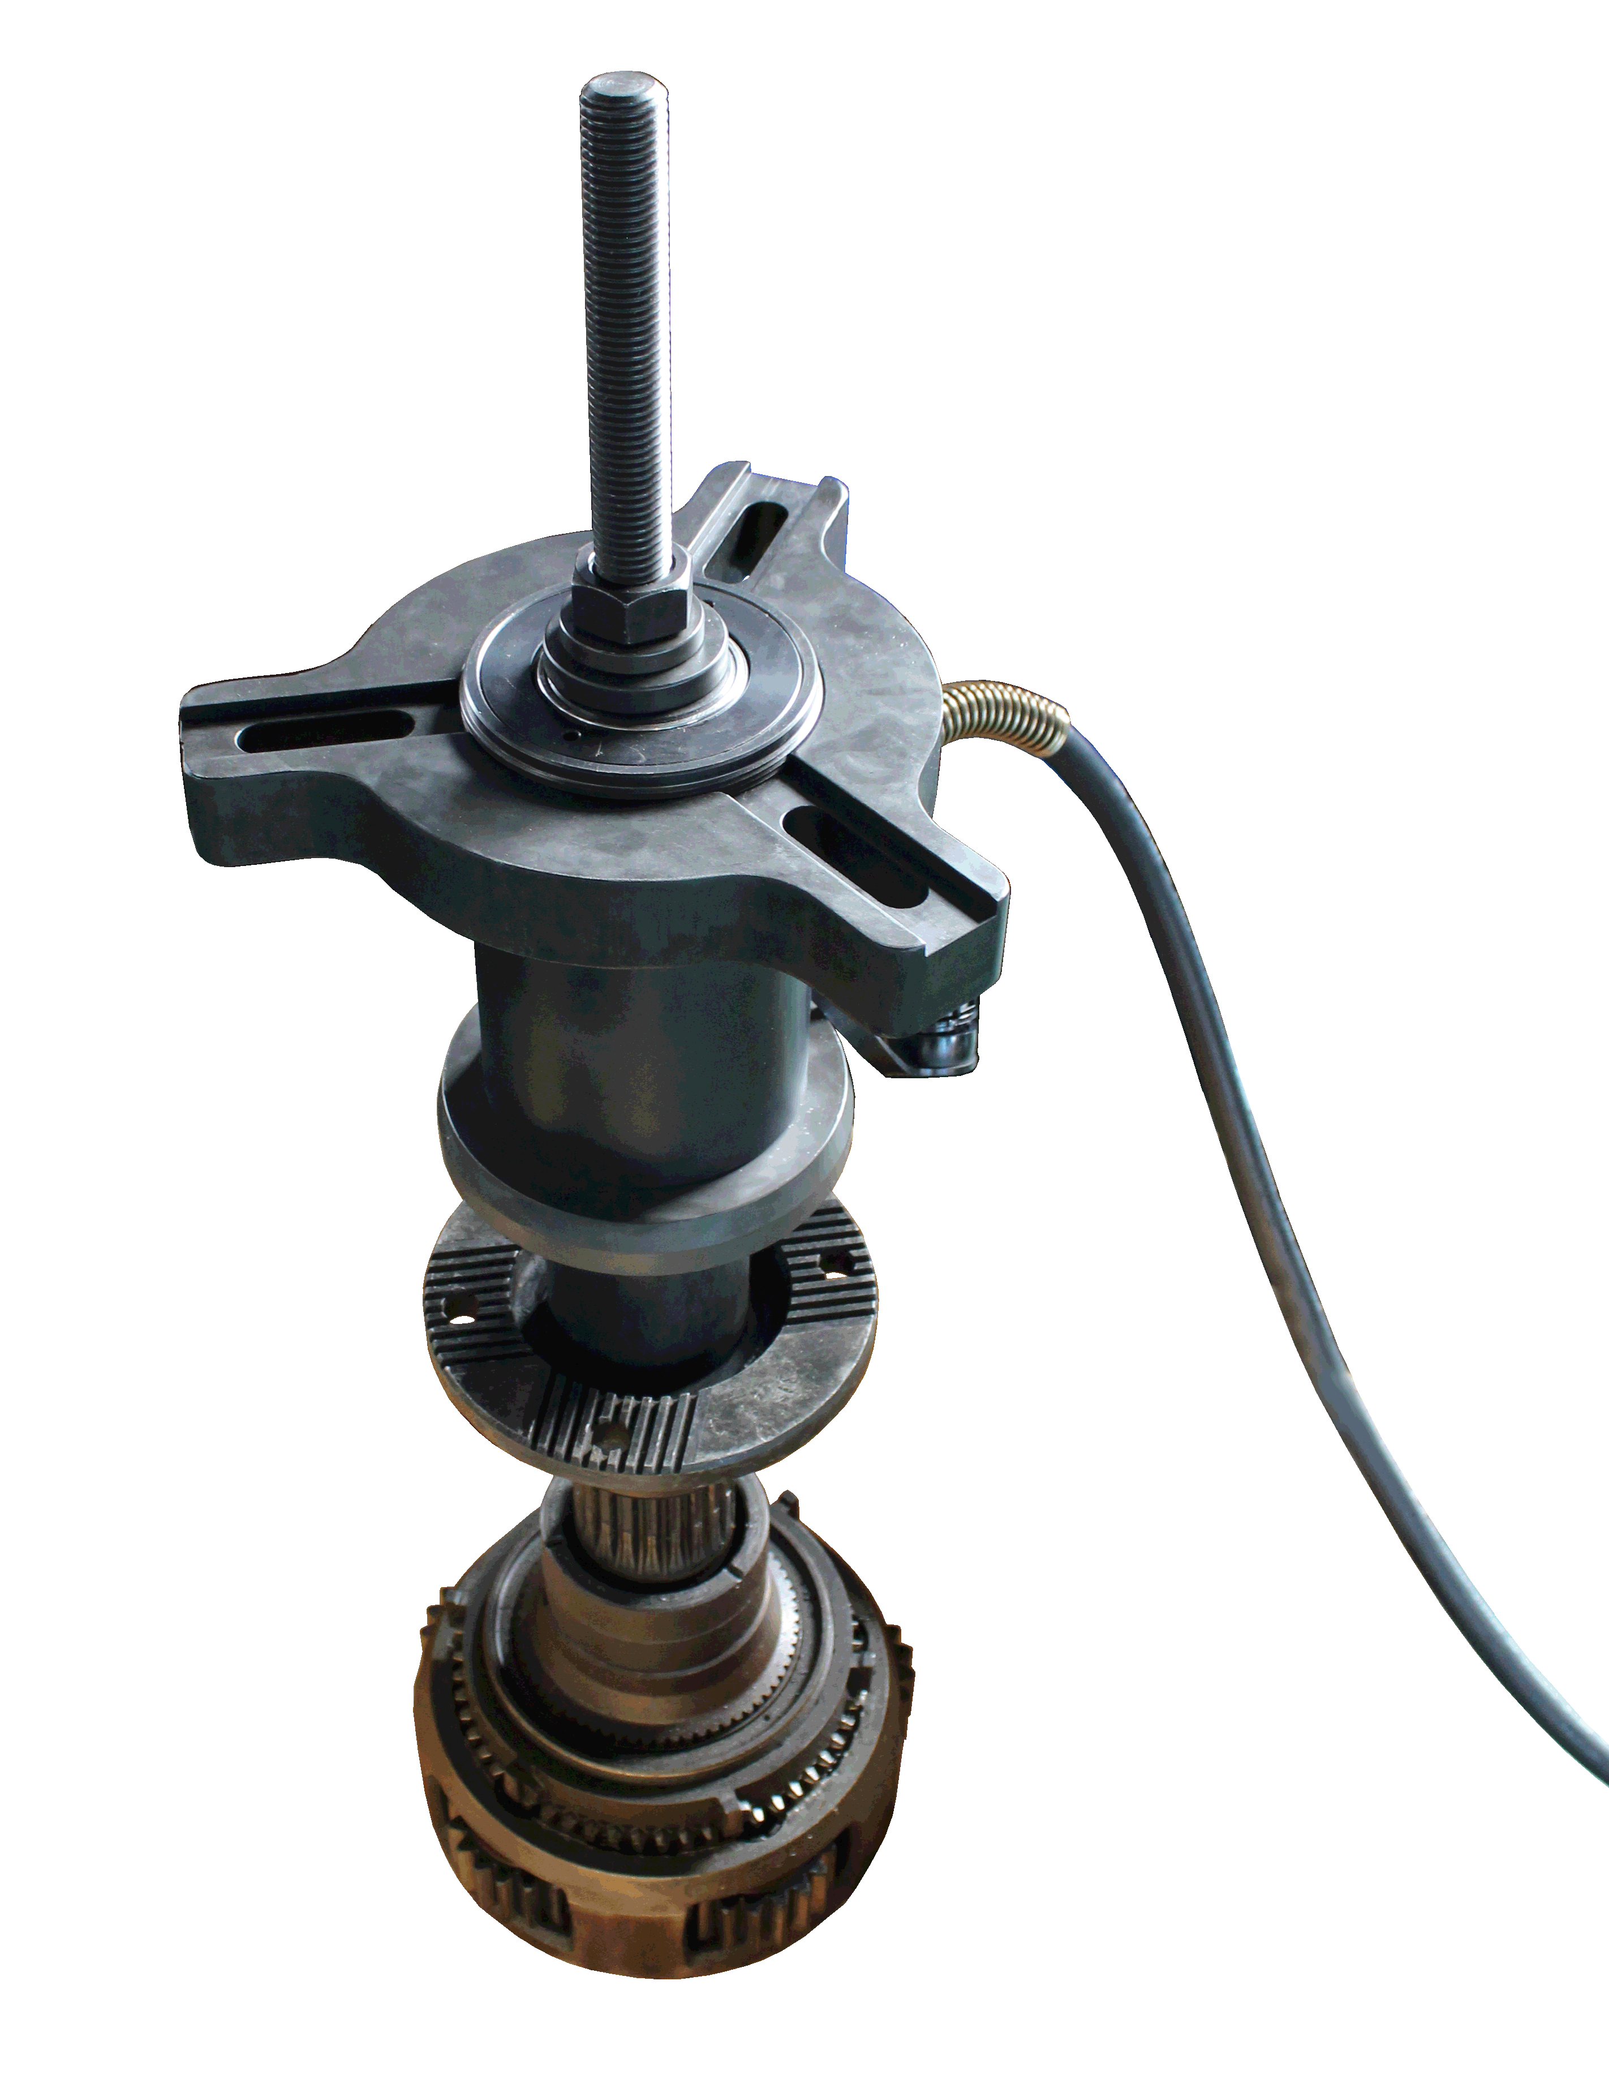
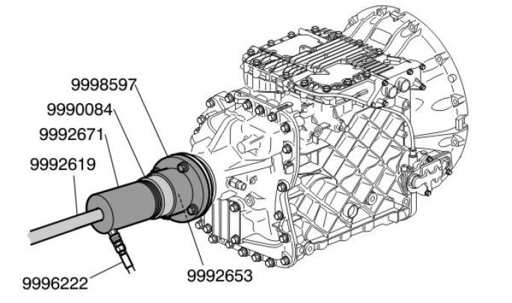

- Designed for remove/install the tranmission comppanion flange
- Application: VOLVO FM12 / DAF
- TRANMISSION codes: EV90/91
- OEM no.ref. :9996901/9996925/9992671/9996315/9996222

