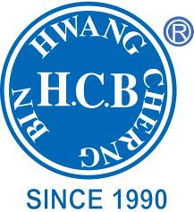
H.C.B-A6025
DODGE CUMMINS 5.9L/6.7L COMMON RAIL INJECTOR TUBE REMOVAL TOOL
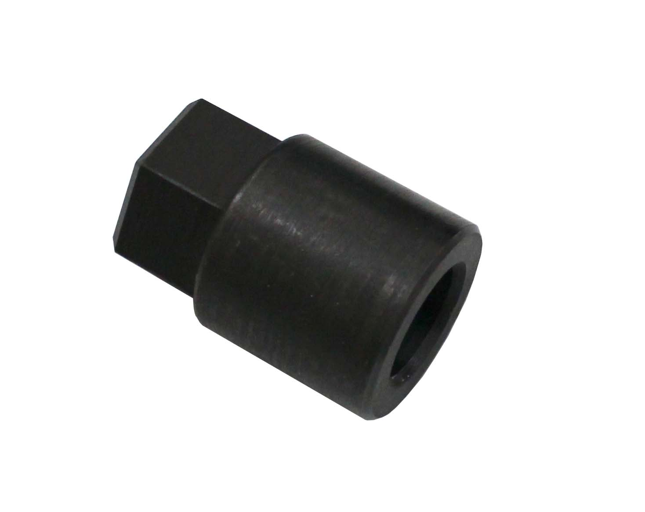

- Easy To Use Tool For Removal of Injector Tubes
- Application: 2003 – 2018 5.9L and 6.7L Dodge Cummins

