
H.C.B-A6024
CAT INJECTOR SLEEVE REMOVER & INSTALLER
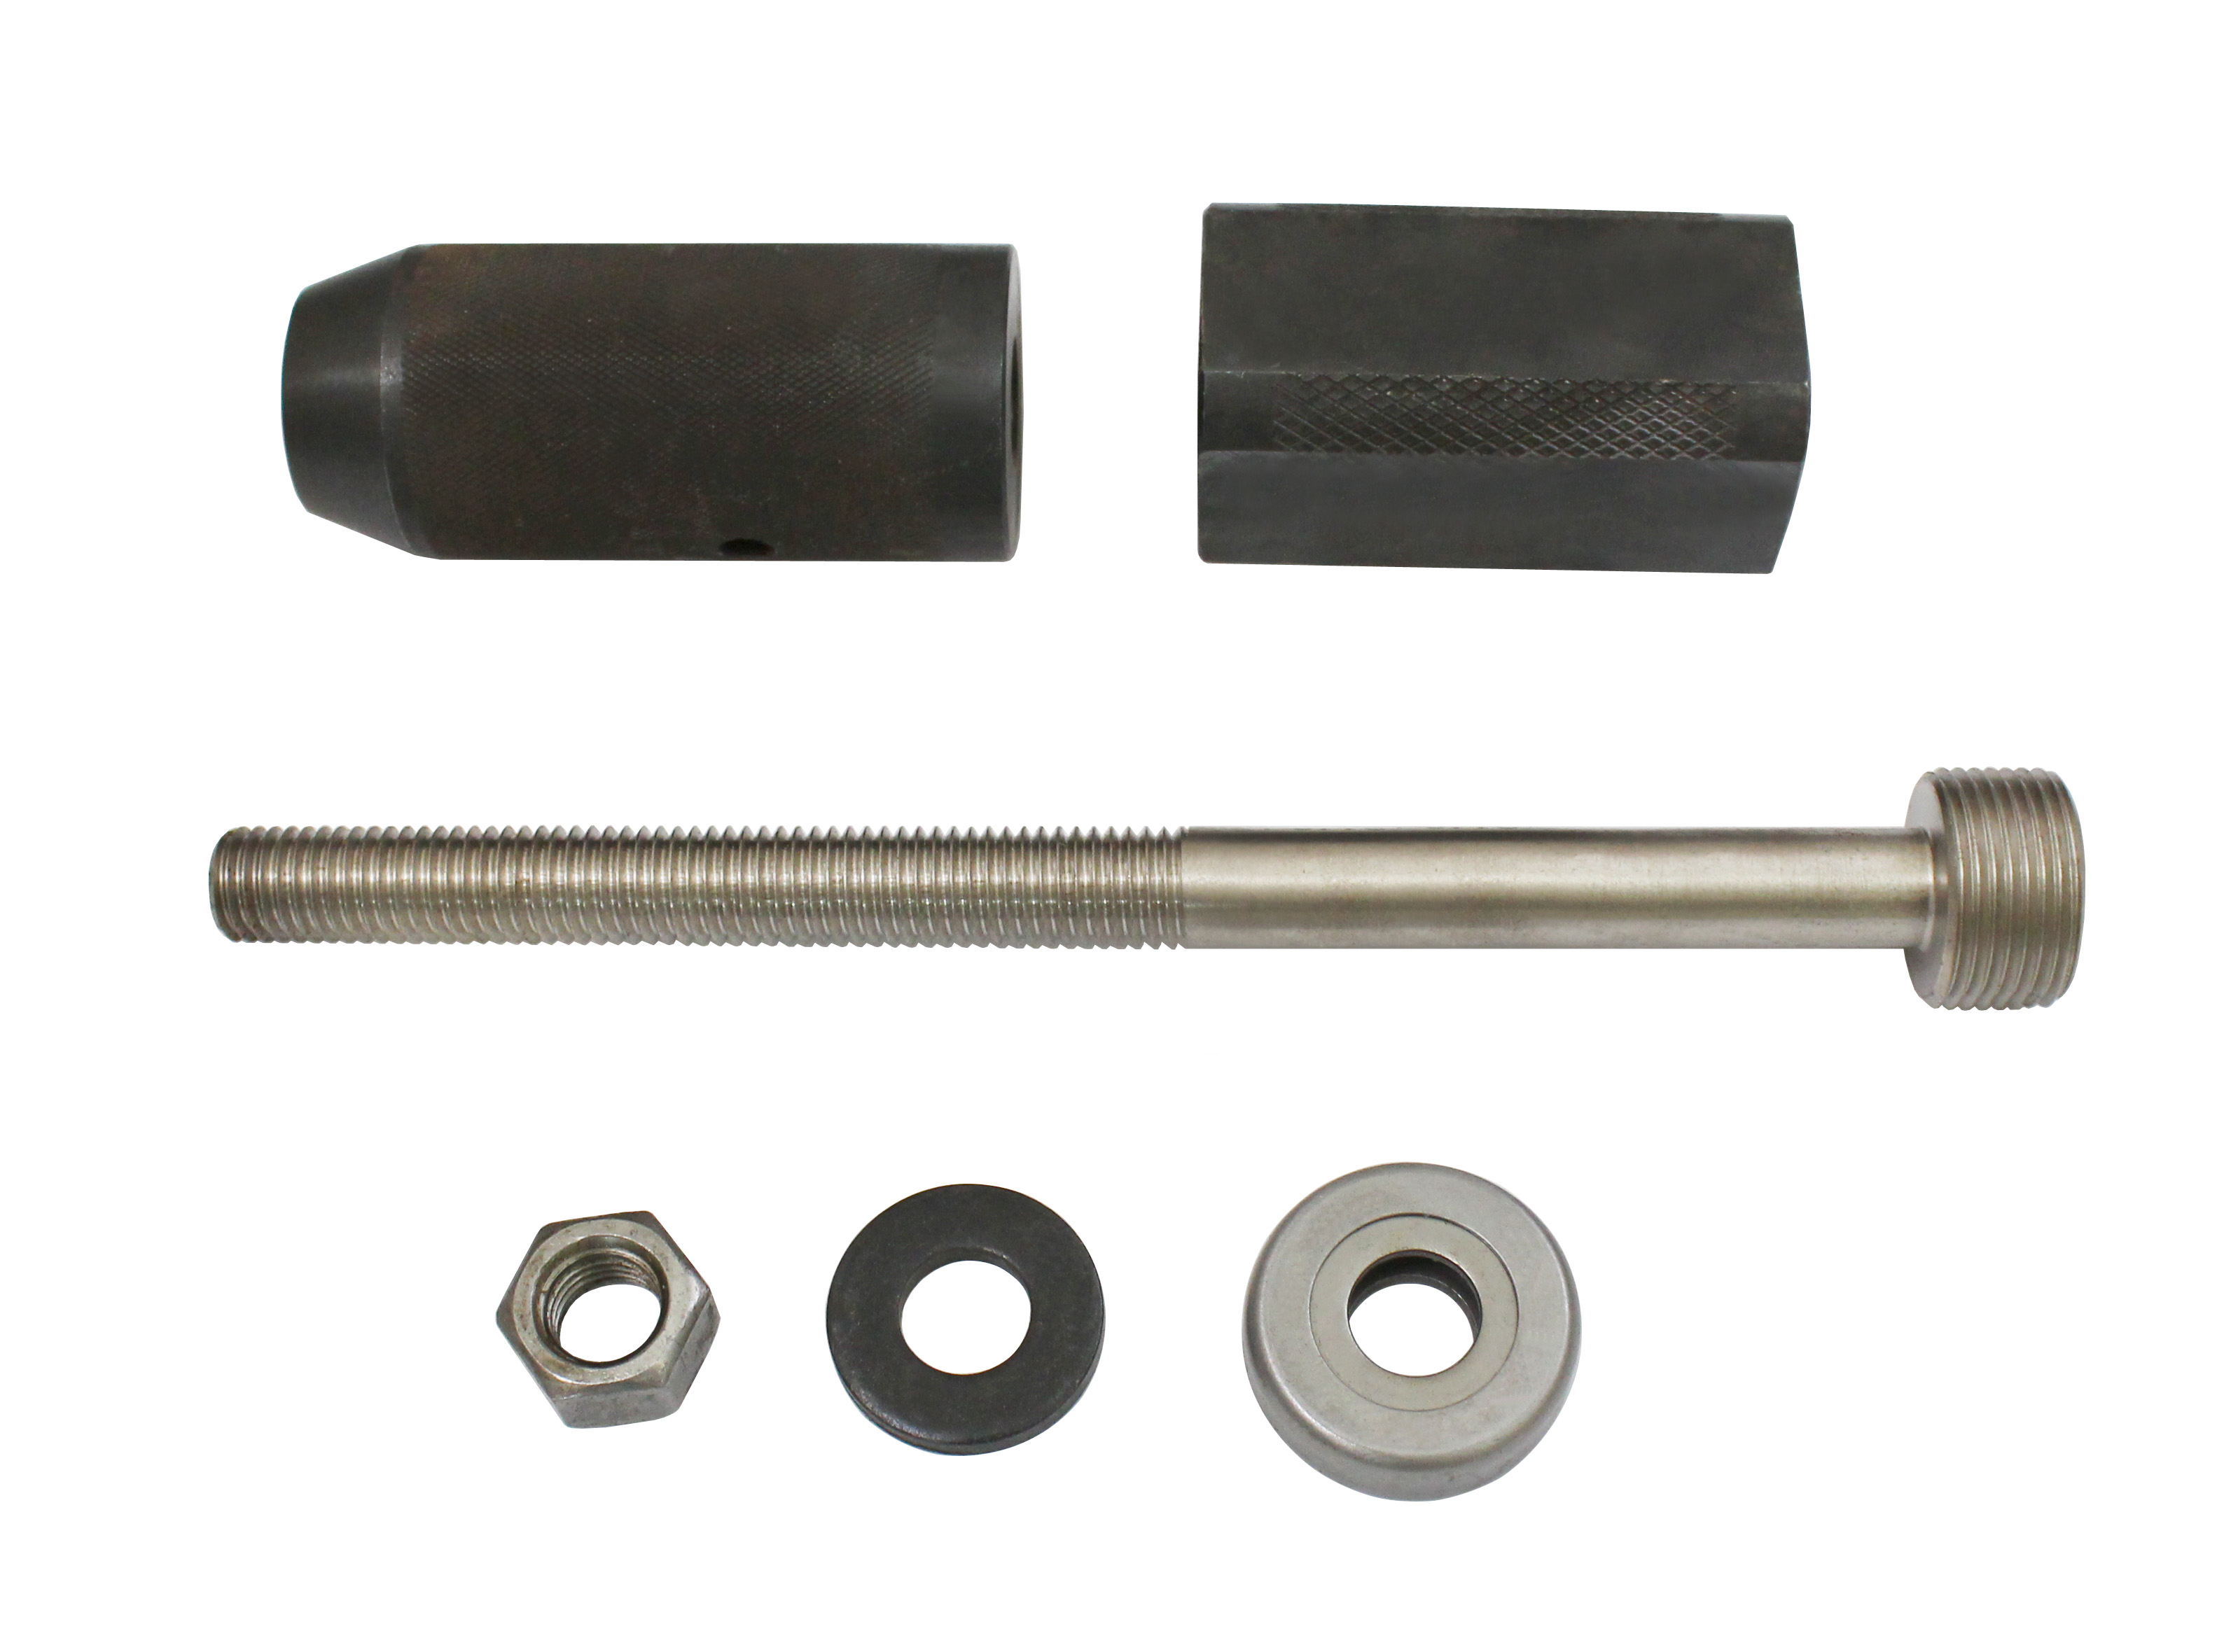

- Applications: Caterpillar C-10, C-12, C-15, and 3406 E engines
- For removal & install the Injector Sleeve
- OEM No. 9U-6891

