
H.C.B-A6006
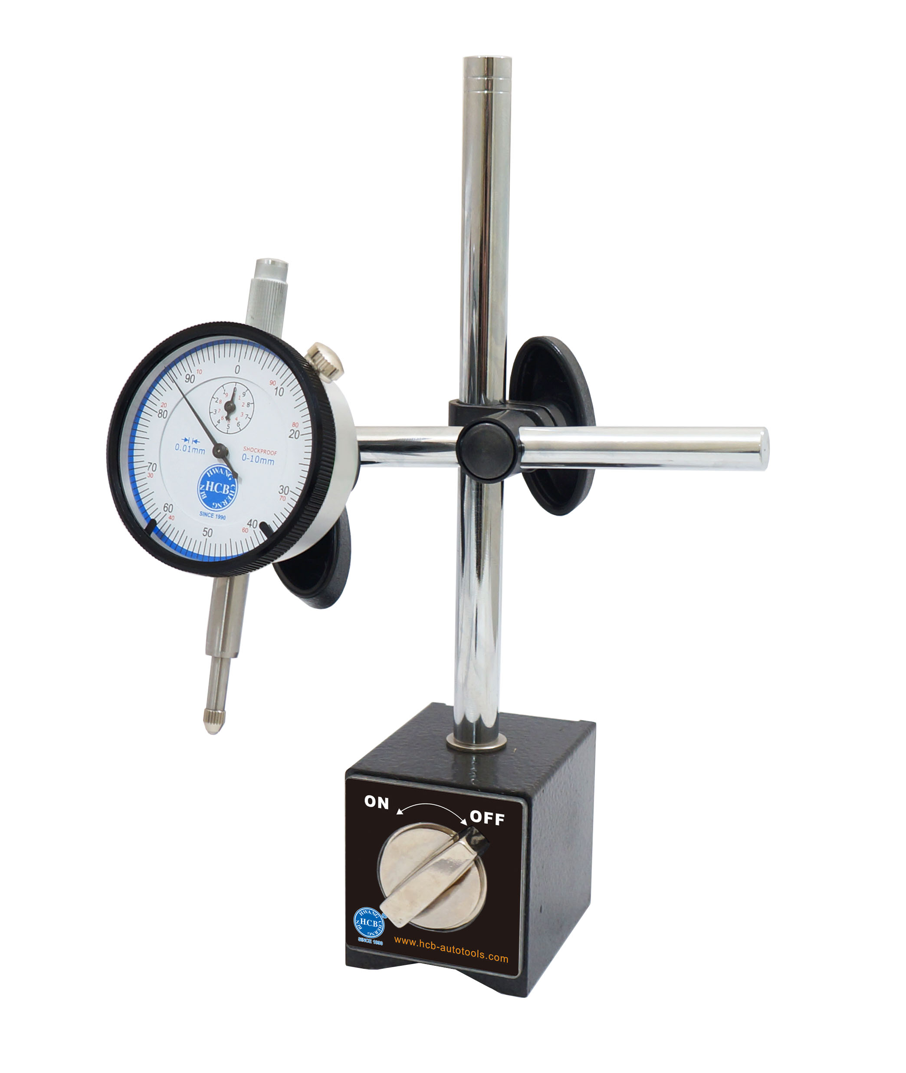
MAGNETIC STAND W/GAUGE

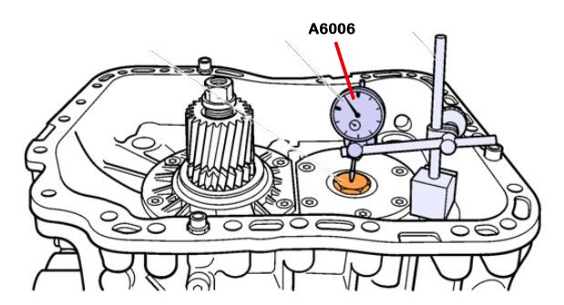

- This high quality base has a very strong magnet (50-lb force) which can mount to flat or round surfaces at any angle firmly and is easily activated with a convenient on-and-off switch.
- There is polished chrome, infinitely adjustable arm which can be adjusted to any desired angle.
- Product dimensions: 10.8" x 4.1" x 2.8"
- Content: Dial gauge, magnetic base, and adjustable arm.
- VOLVO OEM no. ref.: 9989876/999696

H.C.B-A6006
MAGNETIC STAND W/GAUGE

- This high quality base has a very strong magnet (50-lb force) which can mount to flat or round surfaces at any angle firmly and is easily activated with a convenient on-and-off switch.
- There is polished chrome, infinitely adjustable arm which can be adjusted to any desired angle.
- Product dimensions: 10.8" x 4.1" x 2.8"
- Content: Dial gauge, magnetic base, and adjustable arm.
- VOLVO OEM no. ref.: 9989876/999696

