
H.C.B-A5012
UNIVERSAL VALVE CORE REMOVER /INSTALLER TOOL KIT
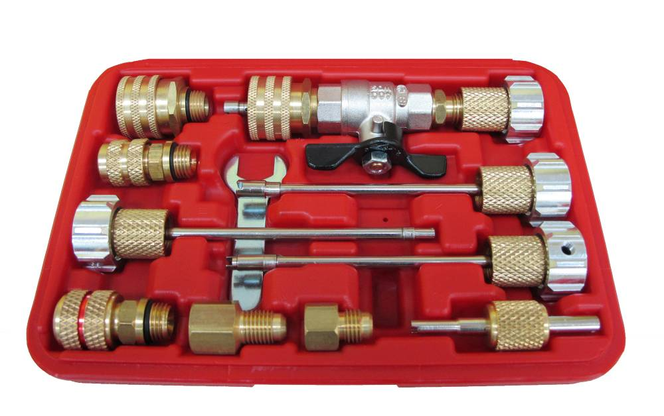

- This master tool kit allows you to service valve cores without losing the systems charge.
- The new unique design offers a locking device that holds the shaft in place while removing or installing the valve core. The remover/installer kit makes removal or insertion much easier especially on the larger R134a valve cores.
- Saves time and money.
- The new Valve Core Remover / Installer kit which is new and innovative tool saves time and money.
- This kit allows the user to change the service port valve core while the system is charged. The unique design cuts the usual 1/2-hour procedure time down to about 3 minutes.
- Kit covers all R12 & R134a system valve cores. Kit Includes:
- Valve Assembly
- R134a high side 16mm connector
- R134a low side 13mm connector
- 1/4" FL swivel connector
- Standard valve core remover/installer assembly
- GM large bore valve core remover/installer assembly
- JRA R134a valve core remover/installer assembly
- Eaton R134a low side valve core remover/installer assembly
- Eaton R134a high side valve core remover/installer assembly
- Adapter 1/4" -M x 3/16" -F high side GM/Ford
- Adapter 1/4" -M x 1/8" -F high side Ford

H.C.B-A5012
UNIVERSAL VALVE CORE REMOVER /INSTALLER TOOL KIT

- This master tool kit allows you to service valve cores without losing the systems charge.
- The new unique design offers a locking device that holds the shaft in place while removing or installing the valve core. The remover/installer kit makes removal or insertion much easier especially on the larger R134a valve cores.
- Saves time and money.
- The new Valve Core Remover / Installer kit which is new and innovative tool saves time and money.
- This kit allows the user to change the service port valve core while the system is charged. The unique design cuts the usual 1/2-hour procedure time down to about 3 minutes.
- Kit covers all R12 & R134a system valve cores. Kit Includes:
- Valve Assembly
- R134a high side 16mm connector
- R134a low side 13mm connector
- 1/4" FL swivel connector
- Standard valve core remover/installer assembly
- GM large bore valve core remover/installer assembly
- JRA R134a valve core remover/installer assembly
- Eaton R134a low side valve core remover/installer assembly
- Eaton R134a high side valve core remover/installer assembly
- Adapter 1/4" -M x 3/16" -F high side GM/Ford
- Adapter 1/4" -M x 1/8" -F high side Ford

