
H.C.B-A4010
RENAULT/VOLVO 2.0 16V ENGINE TIMING TOOLS
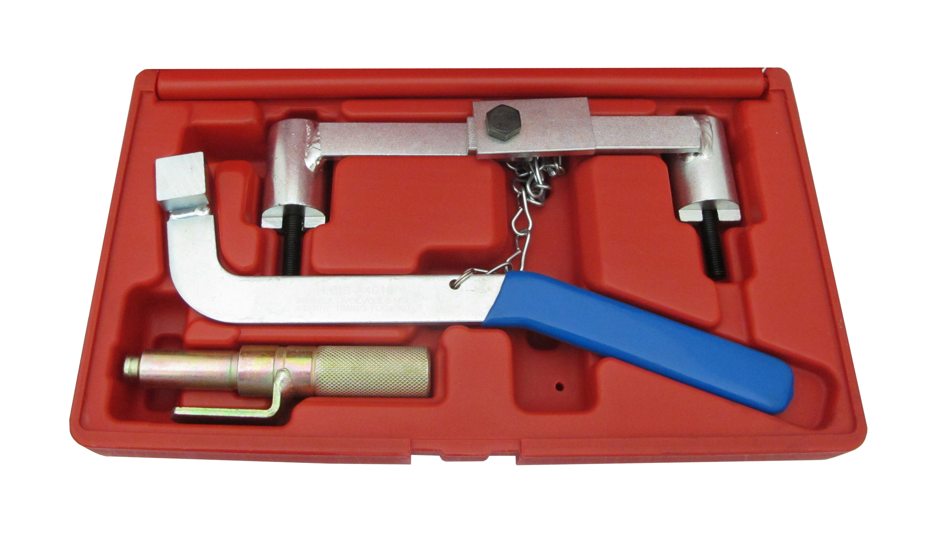
1
2
3

Parts No. | OEM no. ref. | Description
1 | MOT 1337 | Camshaft Setting Tool
2 | MOT 1348 | Tensioning Tool
3 | MOT 1340 | Crankshaft TDC Timing Pin

Models:
- Renault Laguna 2.0 16V/ 2.5 20V (1996-1999)
- Renault Laguna 2.0 16V/ 2.5 20V (1996-2001)
- Model Laguna(96-99) Safrane(96-01)
- Engine: N7Q 704/710/711 (2.0 16V), N7U 700/701 (2.5 20V)
- Volvo 850 (1992-1997)•C70 (1998-2002)•S40 (1996-2004)•V40 (1996-2004)•Volvo S60 (2001-2005)•S70 (1997-2000)•S80 (1999-2005)
- Engine Codes:
Volvo: B4164S, B4164S2, B4184S, B4184S2, B4184S3, B4184S9, B4184S10, B4194T, B4194T2, B4204S, B4204S2, B4204T, B4204T2, B4204T3, B4204T5, B5202Fs, B5204FT, B5204T2, B5204T3, B5204T4, B5204T5, B5234FS, B5204FT, B5234T3, B5234T4, B5234T5, B5234T6, B5234T7, B5234T8, B5234T9, B5244S, B5244S2, B5244SG, B5244SG2, B5244T, B5244T3, B5244T4, B5244T5, B5244T7, B5252FS, B5254T, B5254T2, B5254T4.

H.C.B-A4010
RENAULT/VOLVO 2.0 16V ENGINE TIMING TOOLS
1
2
3

Parts No. | OEM no. ref. | Description
1 | MOT 1337 | Camshaft Setting Tool
2 | MOT 1348 | Tensioning Tool
3 | MOT 1340 | Crankshaft TDC Timing Pin

Models:
- Renault Laguna 2.0 16V/ 2.5 20V (1996-1999)
- Renault Laguna 2.0 16V/ 2.5 20V (1996-2001)
- Model Laguna(96-99) Safrane(96-01)
- Engine: N7Q 704/710/711 (2.0 16V), N7U 700/701 (2.5 20V)
- Volvo 850 (1992-1997)•C70 (1998-2002)•S40 (1996-2004)•V40 (1996-2004)•Volvo S60 (2001-2005)•S70 (1997-2000)•S80 (1999-2005)
- Engine Codes:
Volvo: B4164S, B4164S2, B4184S, B4184S2, B4184S3, B4184S9, B4184S10, B4194T, B4194T2, B4204S, B4204S2, B4204T, B4204T2, B4204T3, B4204T5, B5202Fs, B5204FT, B5204T2, B5204T3, B5204T4, B5204T5, B5234FS, B5204FT, B5234T3, B5234T4, B5234T5, B5234T6, B5234T7, B5234T8, B5234T9, B5244S, B5244S2, B5244SG, B5244SG2, B5244T, B5244T3, B5244T4, B5244T5, B5244T7, B5252FS, B5254T, B5254T2, B5254T4.

