
H.C.B-A4009
RENAULT/VAUXHALL/OPEL/NISSAN
DIESEL ENGINE TIMING TOOL KIT
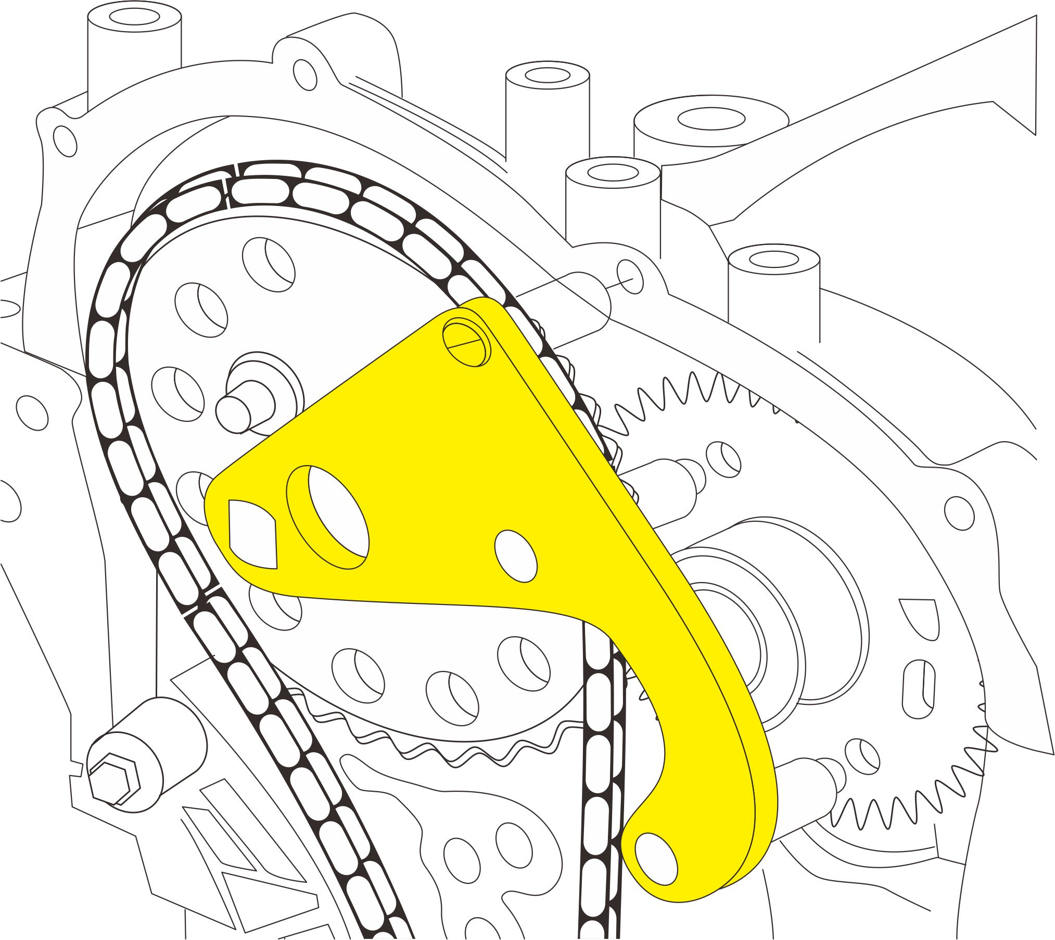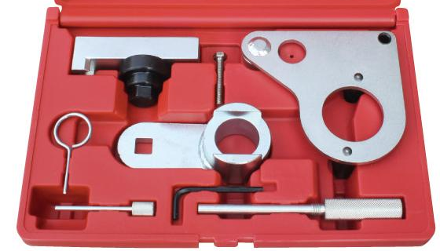

- For Renault 2. 0DCi chain drive diesel engines fitted to the Megane | Vel Satis | Espace | Scenic | Trafic | Laguna | Koleos, also fitted to the Nissan Qashqai and the Vauxhall | Opel Vivaro.
- Engine code M9R.
- OEM no. ref.: EN48334, EN48332, EN48331, EN48330

H.C.B-A4009
RENAULT/VAUXHALL/OPEL/NISSAN
DIESEL ENGINE TIMING TOOL KIT

- For Renault 2. 0DCi chain drive diesel engines fitted to the Megane | Vel Satis | Espace | Scenic | Trafic | Laguna | Koleos, also fitted to the Nissan Qashqai and the Vauxhall | Opel Vivaro.
- Engine code M9R.
- OEM no. ref.: EN48334, EN48332, EN48331, EN48330

