
H.C.B-A4001
RENAULT TIMING TOOL KIT
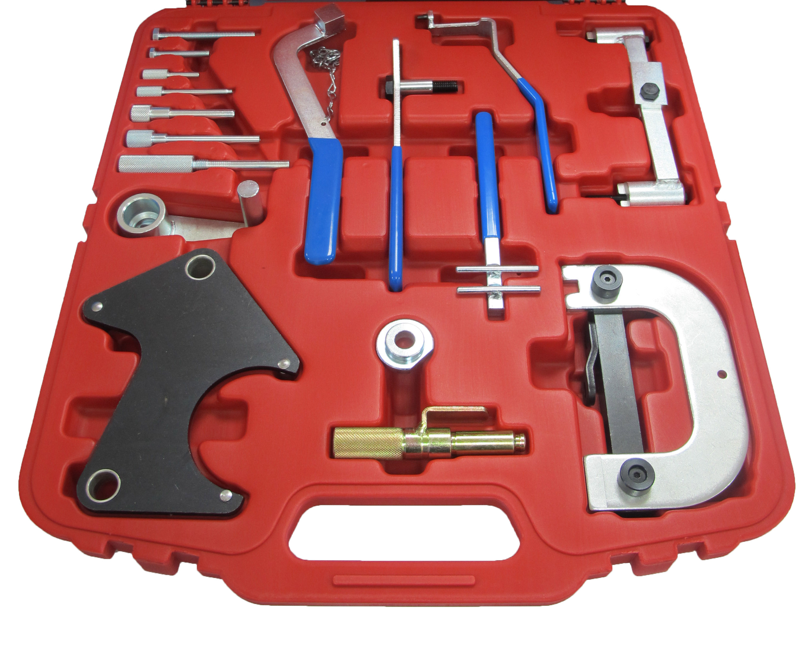

- To timing RENAULT engines.
- Application:
Clio 1.2/ 1.4, Clio 1.4/ 1.6/ 1.8 16V, Clio Sport 2.0 16V, Clio Williams 2.0 16V
Espace 2.0, Espace 2.0 16V, Espace 2.2 TD
Express1.4
Extra 1.4
Kangoo 1.2/ 1.4
Laguna 1.6 16V, Laguna 1.8/2.0, Laguna 1.8/ 2.0 16V, Laguna 2.2 D/TD, Laguna 2.5 D/ TD
Master 2.5 D/ TD
Megane 1.4/ 1.6/ 2.0 16V
R19 1.4, r19 1.4 Eco, R19 1.8 16V
Rapid 1.4
Safrane 2.0 16V, Safrane 2.2 TD, Safrane 2.5 20V
Scenic 1.4/ 1.6/ 2.0 16V
Trafic 2.5C
Twingo 1.2

H.C.B-A4001
RENAULT TIMING TOOL KIT

- To timing RENAULT engines.
- Application:
Clio 1.2/ 1.4, Clio 1.4/ 1.6/ 1.8 16V, Clio Sport 2.0 16V, Clio Williams 2.0 16V
Espace 2.0, Espace 2.0 16V, Espace 2.2 TD
Express1.4
Extra 1.4
Kangoo 1.2/ 1.4
Laguna 1.6 16V, Laguna 1.8/2.0, Laguna 1.8/ 2.0 16V, Laguna 2.2 D/TD, Laguna 2.5 D/ TD
Master 2.5 D/ TD
Megane 1.4/ 1.6/ 2.0 16V
R19 1.4, r19 1.4 Eco, R19 1.8 16V
Rapid 1.4
Safrane 2.0 16V, Safrane 2.2 TD, Safrane 2.5 20V
Scenic 1.4/ 1.6/ 2.0 16V
Trafic 2.5C
Twingo 1.2

