
H.C.B-A2345

FLEXIBLE HEAD CROW FOOT SPANNER KIT

(Dr. 1/2”) (9 PCS)
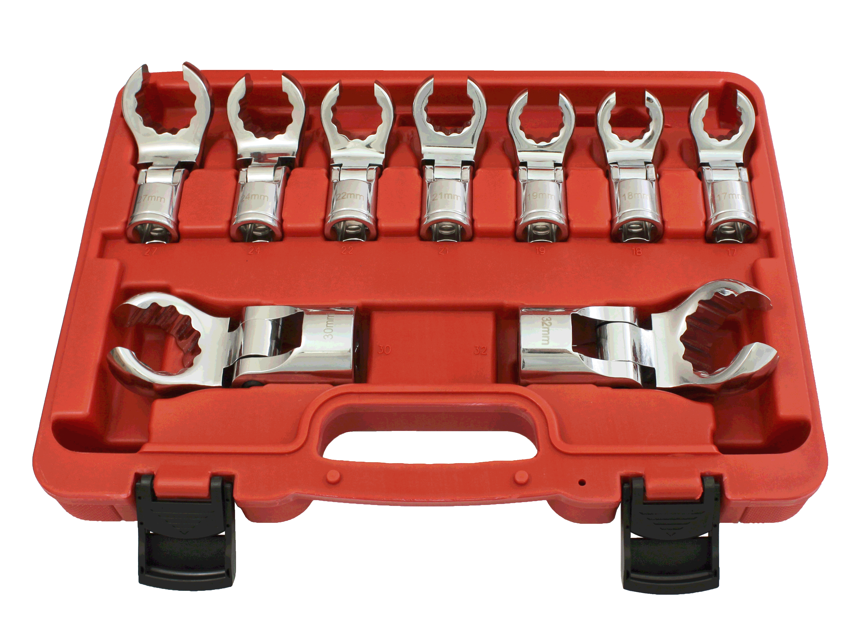

- 230 degree flexible head, plus can use with T-bar, F-Bar, extension bar, and ratchet wrench for accessing more limited space, such as fuel line in engine bay, fuel line, brake line, and so on.
- Heat treated, hardened and chrome plated with fully polished mirror finish.
- Special sizes for truck and trailer.
- Contents: Dr. 1/2", flexible head crow foot spanners:
17, 18, 19, 21, 22, 24, 27, 30, 32 mm

